IL Data

Charlotte Rye

2024-07-20

## All Data

First download all the required packages

#install.packages("tidyverse")  
#install.packages("rstatix")  
#install.packages("ggplot2")  
#install.packages("ggResidpanel")  
#install.packages("dplyr")  
#install.packages("pwr")  
#install.packages("ggpattern")  
#install.packages("broom")  
#install.packages("hrbrthemes")  
#install.packages("ggsignif")   
#install.packages("Rmisc")   
#install.packages("effectsize")   
#install.packages("corrplot")  
#install.packages("DescTools")  
#install.packages("Hmisc")  
  
library(ggsignif)   
library(tidyverse)

## ── Attaching core tidyverse packages ──────────────────────── tidyverse 2.0.0 ──  
## ✔ dplyr 1.1.4 ✔ readr 2.1.4  
## ✔ forcats 1.0.0 ✔ stringr 1.5.0  
## ✔ ggplot2 3.5.0 ✔ tibble 3.2.1  
## ✔ lubridate 1.9.3 ✔ tidyr 1.3.0  
## ✔ purrr 1.0.2   
## ── Conflicts ────────────────────────────────────────── tidyverse_conflicts() ──  
## ✖ dplyr::filter() masks stats::filter()  
## ✖ dplyr::lag() masks stats::lag()  
## ℹ Use the conflicted package (<http://conflicted.r-lib.org/>) to force all conflicts to become errors

library(rstatix)

##   
## Attaching package: 'rstatix'  
##   
## The following object is masked from 'package:stats':  
##   
## filter

library(ggplot2)  
library(ggResidpanel)  
library(dplyr)  
library(broom)  
library(pwr)  
library(ggpattern)  
library(broom)  
library(hrbrthemes)  
library(Rmisc)

## Loading required package: lattice  
## Loading required package: plyr  
## ------------------------------------------------------------------------------  
## You have loaded plyr after dplyr - this is likely to cause problems.  
## If you need functions from both plyr and dplyr, please load plyr first, then dplyr:  
## library(plyr); library(dplyr)  
## ------------------------------------------------------------------------------  
##   
## Attaching package: 'plyr'  
##   
## The following objects are masked from 'package:rstatix':  
##   
## desc, mutate  
##   
## The following objects are masked from 'package:dplyr':  
##   
## arrange, count, desc, failwith, id, mutate, rename, summarise,  
## summarize  
##   
## The following object is masked from 'package:purrr':  
##   
## compact

library(readxl)  
library(ggsci)  
library(effectsize)

##   
## Attaching package: 'effectsize'  
##   
## The following objects are masked from 'package:rstatix':  
##   
## cohens_d, eta_squared

library(ggpubr)

##   
## Attaching package: 'ggpubr'  
##   
## The following object is masked from 'package:plyr':  
##   
## mutate

library(corrplot)

## corrplot 0.92 loaded

library(DescTools)  
library(Hmisc)

## Warning: package 'Hmisc' was built under R version 4.3.3

##   
## Attaching package: 'Hmisc'  
##   
## The following objects are masked from 'package:DescTools':  
##   
## %nin%, Label, Mean, Quantile  
##   
## The following objects are masked from 'package:plyr':  
##   
## is.discrete, summarize  
##   
## The following objects are masked from 'package:dplyr':  
##   
## src, summarize  
##   
## The following objects are masked from 'package:base':  
##   
## format.pval, units

Read in the excel data for all behavioural and molecular data

AllData <- read_excel("~/Documents/Cambridge_University/Masters/Basic_and_Translational_Neuroscience/Research project/Western Blotting/WB Analysis/Rye & Milton 2024.xlsx",   
 sheet = "Sheet1", col_types = c("text",   
 "text", "text", "numeric", "numeric",   
 "numeric", "numeric", "numeric",   
 "numeric", "numeric", "numeric",   
 "numeric", "numeric", "numeric",   
 "numeric", "numeric"))  
View(AllData)  
  
AllData$Shock <- factor(AllData$Shock, levels=c('0-shock', '4-shock', '9-shock', "12-shock", "13-shock", "15-shock"))  
  
AllData$SEFL <- factor(AllData$SEFL, levels=c('Resilient', 'Susceptible'))

Brain Region Data

ILData <- select(AllData, c("Rat","SEFL","Shock", "Average_Freezing_Extinction_Session","Average_Freezing_Last_3_mins_Extinction", "Recovery_Index","Total_Freezing_During_Test", "ILGluN2B", "ILGluA1", "ILGluA2"))  
  
View(ILData)  
  
PLData <- select(AllData, c("Rat","SEFL","Shock","Average_Freezing_Extinction_Session","Average_Freezing_Last_3_mins_Extinction", "Recovery_Index","Total_Freezing_During_Test", "PLGluN2B", "PLGluA1", "PLGluA2"))  
  
View(PLData)  
  
dHpcData <- select(AllData, c("Rat","SEFL","Shock", "Average_Freezing_Extinction_Session","Average_Freezing_Last_3_mins_Extinction", "Recovery_Index","Total_Freezing_During_Test", "dHpcGluN2B", "dHpcGluA1", "dHpcGluA2"))  
  
View(dHpcData)

IL Analysis

ILGluN2BData <- select(AllData, c("Rat","SEFL","Shock", "ILGluN2B"))  
  
#first we visualise the data  
  
ggplot(ILGluN2BData,  
 aes( x = Shock, y = ILGluN2B)) +  
 geom_boxplot()

## Warning: Removed 26 rows containing non-finite outside the scale range  
## (`stat_boxplot()`).

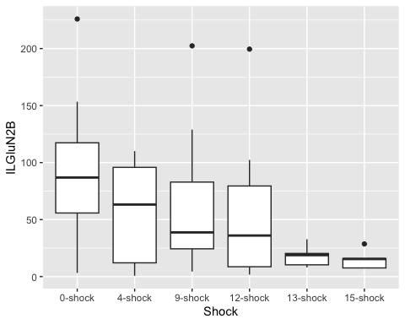

ggplot(ILGluN2BData,  
 aes( x = SEFL, y = ILGluN2B)) +  
 geom_boxplot()

## Warning: Removed 26 rows containing non-finite outside the scale range  
## (`stat_boxplot()`).

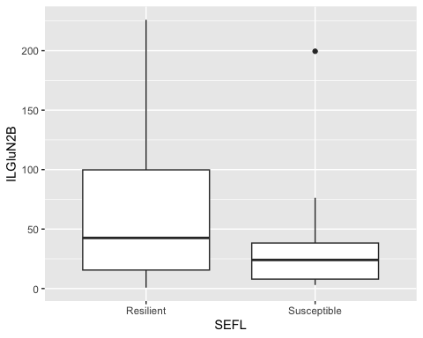

ggplot(ILGluN2BData,  
 aes( x = Shock, y = ILGluN2B, fill = SEFL)) +  
 geom_boxplot()

## Warning: Removed 26 rows containing non-finite outside the scale range  
## (`stat_boxplot()`).

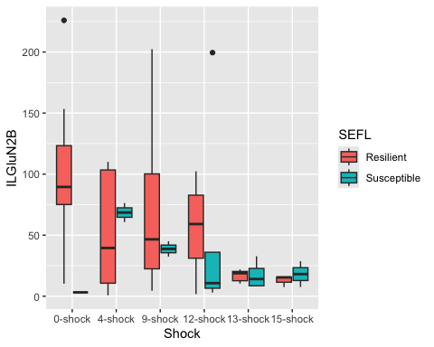

#Linear model for GluN2B data  
  
lm_ILGluN2B <- lm(ILGluN2B ~ Shock + SEFL + Shock:SEFL,  
 data = ILGluN2BData)  
  
#check assumptions  
  
resid_panel(lm_ILGluN2B,  
 plots = c("resid", "qq", "ls", "cookd"),  
 smoother = TRUE)

## Warning in sqrt((n - p - sr^2)/(n - p - 1)): NaNs produced

## `geom_smooth()` using formula = 'y ~ x'  
## `geom_smooth()` using formula = 'y ~ x'

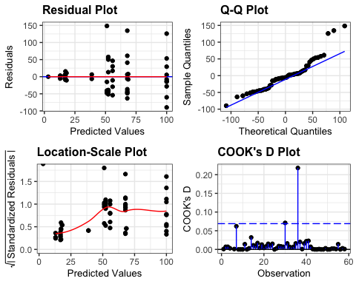

resid_ILGluN2B <- residuals(lm_ILGluN2B)  
  
shapiro.test(resid_ILGluN2B)

##   
## Shapiro-Wilk normality test  
##   
## data: resid_ILGluN2B  
## W = 0.90703, p-value = 0.0003053

levene_test(ILGluN2BData, ILGluN2B ~ Shock * SEFL)

## # A tibble: 1 × 4  
## df1 df2 statistic p  
## <int> <int> <dbl> <dbl>  
## 1 11 46 1.18 0.325

#data is not normal (shapiro test = significant)  
#but ANOVA is robust to these issues and we have homogeneity of variance  
  
anova(lm_ILGluN2B)

## Analysis of Variance Table  
##   
## Response: ILGluN2B  
## Df Sum Sq Mean Sq F value Pr(>F)   
## Shock 5 36126 7225.1 2.7469 0.02974 *  
## SEFL 1 1301 1301.3 0.4947 0.48537   
## Shock:SEFL 5 9146 1829.2 0.6954 0.62954   
## Residuals 46 120994 2630.3   
## ---  
## Signif. codes: 0 '***' 0.001 '**' 0.01 '*' 0.05 '.' 0.1 ' ' 1

options(es.use_symbols = TRUE)   
#significant main effect of shock on GluN2B   
eta_squared(lm_ILGluN2B, partial = FALSE)

## # Effect Size for ANOVA (Type I)  
##   
## Parameter | η² | 95% CI  
## ------------------------------------  
## Shock | 0.22 | [0.01, 1.00]  
## SEFL | 7.77e-03 | [0.00, 1.00]  
## Shock:SEFL | 0.05 | [0.00, 1.00]  
##   
## - One-sided CIs: upper bound fixed at [1.00].

#we now do pairwise comparisons  
tukILGluN2B <- tukey_hsd(lm_ILGluN2B)  
print(tukILGluN2B, n=82)

## # A tibble: 82 × 9  
## term group1 group2 null.value estimate conf.low conf.high p.adj  
## * <chr> <chr> <chr> <dbl> <dbl> <dbl> <dbl> <dbl>  
## 1 Shock 0-shock 4-sho… 0 -35.7 -102. 30.9 0.608   
## 2 Shock 0-shock 9-sho… 0 -28.2 -91.9 35.4 0.774   
## 3 Shock 0-shock 12-sh… 0 -37.5 -103. 27.5 0.529   
## 4 Shock 0-shock 13-sh… 0 -74.2 -143. -5.65 0.0269  
## 5 Shock 0-shock 15-sh… 0 -76.2 -158. 6.06 0.0839  
## 6 Shock 4-shock 9-sho… 0 7.46 -57.8 72.7 0.999   
## 7 Shock 4-shock 12-sh… 0 -1.84 -68.5 64.8 1   
## 8 Shock 4-shock 13-sh… 0 -38.5 -109. 31.5 0.581   
## 9 Shock 4-shock 15-sh… 0 -40.5 -124. 43.0 0.702   
## 10 Shock 9-shock 12-sh… 0 -9.29 -72.9 54.4 0.998   
## 11 Shock 9-shock 13-sh… 0 -46.0 -113. 21.3 0.34   
## 12 Shock 9-shock 15-sh… 0 -48.0 -129. 33.2 0.503   
## 13 Shock 12-shock 13-sh… 0 -36.7 -105. 31.9 0.608   
## 14 Shock 12-shock 15-sh… 0 -38.7 -121. 43.6 0.728   
## 15 Shock 13-shock 15-sh… 0 -1.99 -87.0 83.1 1   
## 16 SEFL Resilient Susce… 0 -10.0 -40.3 20.3 0.51   
## 17 Shock:SEFL 0-shock:Resi… 4-sho… 0 -47.7 -131. 36.0 0.715   
## 18 Shock:SEFL 0-shock:Resi… 9-sho… 0 -32.2 -111. 46.7 0.957   
## 19 Shock:SEFL 0-shock:Resi… 12-sh… 0 -44.2 -135. 46.9 0.873   
## 20 Shock:SEFL 0-shock:Resi… 13-sh… 0 -83.2 -180. 13.5 0.154   
## 21 Shock:SEFL 0-shock:Resi… 15-sh… 0 -87.1 -203. 29.1 0.321   
## 22 Shock:SEFL 0-shock:Resi… 0-sho… 0 -96.8 -282. 88.3 0.809   
## 23 Shock:SEFL 0-shock:Resi… 4-sho… 0 -31.5 -168. 105. 1   
## 24 Shock:SEFL 0-shock:Resi… 9-sho… 0 -61.2 -198. 75.5 0.92   
## 25 Shock:SEFL 0-shock:Resi… 12-sh… 0 -48.8 -146. 47.8 0.841   
## 26 Shock:SEFL 0-shock:Resi… 13-sh… 0 -82.8 -187. 21.7 0.246   
## 27 Shock:SEFL 0-shock:Resi… 15-sh… 0 -81.9 -219. 54.8 0.651   
## 28 Shock:SEFL 4-shock:Resi… 9-sho… 0 15.6 -68.2 99.3 1   
## 29 Shock:SEFL 4-shock:Resi… 12-sh… 0 3.52 -91.8 98.8 1   
## 30 Shock:SEFL 4-shock:Resi… 13-sh… 0 -35.5 -136. 65.2 0.985   
## 31 Shock:SEFL 4-shock:Resi… 15-sh… 0 -39.3 -159. 80.2 0.991   
## 32 Shock:SEFL 4-shock:Resi… 0-sho… 0 -49.1 -236. 138. 0.999   
## 33 Shock:SEFL 4-shock:Resi… 4-sho… 0 16.3 -123. 156. 1   
## 34 Shock:SEFL 4-shock:Resi… 9-sho… 0 -13.5 -153. 126. 1   
## 35 Shock:SEFL 4-shock:Resi… 12-sh… 0 -1.11 -102. 99.5 1   
## 36 Shock:SEFL 4-shock:Resi… 13-sh… 0 -35.0 -143. 73.1 0.992   
## 37 Shock:SEFL 4-shock:Resi… 15-sh… 0 -34.1 -174. 105. 0.999   
## 38 Shock:SEFL 9-shock:Resi… 12-sh… 0 -12.0 -103. 79.1 1   
## 39 Shock:SEFL 9-shock:Resi… 13-sh… 0 -51.0 -148. 45.7 0.801   
## 40 Shock:SEFL 9-shock:Resi… 15-sh… 0 -54.9 -171. 61.3 0.891   
## 41 Shock:SEFL 9-shock:Resi… 0-sho… 0 -64.7 -250. 120. 0.986   
## 42 Shock:SEFL 9-shock:Resi… 4-sho… 0 0.713 -136. 137. 1   
## 43 Shock:SEFL 9-shock:Resi… 9-sho… 0 -29.1 -166. 108. 1   
## 44 Shock:SEFL 9-shock:Resi… 12-sh… 0 -16.7 -113. 80.0 1   
## 45 Shock:SEFL 9-shock:Resi… 13-sh… 0 -50.6 -155. 53.8 0.874   
## 46 Shock:SEFL 9-shock:Resi… 15-sh… 0 -49.7 -186. 87.0 0.981   
## 47 Shock:SEFL 12-shock:Res… 13-sh… 0 -39.0 -146. 67.9 0.981   
## 48 Shock:SEFL 12-shock:Res… 15-sh… 0 -42.8 -168. 81.9 0.988   
## 49 Shock:SEFL 12-shock:Res… 0-sho… 0 -52.6 -243. 138. 0.998   
## 50 Shock:SEFL 12-shock:Res… 4-sho… 0 12.7 -131. 157. 1   
## 51 Shock:SEFL 12-shock:Res… 9-sho… 0 -17.0 -161. 127. 1   
## 52 Shock:SEFL 12-shock:Res… 12-sh… 0 -4.63 -111. 102. 1   
## 53 Shock:SEFL 12-shock:Res… 13-sh… 0 -38.5 -152. 75.4 0.989   
## 54 Shock:SEFL 12-shock:Res… 15-sh… 0 -37.7 -182. 106. 0.999   
## 55 Shock:SEFL 13-shock:Res… 15-sh… 0 -3.87 -133. 125. 1   
## 56 Shock:SEFL 13-shock:Res… 0-sho… 0 -13.7 -207. 180. 1   
## 57 Shock:SEFL 13-shock:Res… 4-sho… 0 51.7 -95.9 199. 0.986   
## 58 Shock:SEFL 13-shock:Res… 9-sho… 0 21.9 -126. 170. 1   
## 59 Shock:SEFL 13-shock:Res… 12-sh… 0 34.3 -77.3 146. 0.995   
## 60 Shock:SEFL 13-shock:Res… 13-sh… 0 0.432 -118. 119. 1   
## 61 Shock:SEFL 13-shock:Res… 15-sh… 0 1.31 -146. 149. 1   
## 62 Shock:SEFL 15-shock:Res… 0-sho… 0 -9.79 -214. 194. 1   
## 63 Shock:SEFL 15-shock:Res… 4-sho… 0 55.6 -106. 217. 0.987   
## 64 Shock:SEFL 15-shock:Res… 9-sho… 0 25.8 -135. 187. 1   
## 65 Shock:SEFL 15-shock:Res… 12-sh… 0 38.2 -90.7 167. 0.996   
## 66 Shock:SEFL 15-shock:Res… 13-sh… 0 4.30 -130. 139. 1   
## 67 Shock:SEFL 15-shock:Res… 15-sh… 0 5.17 -156. 166. 1   
## 68 Shock:SEFL 0-shock:Susc… 4-sho… 0 65.4 -151. 282. 0.996   
## 69 Shock:SEFL 0-shock:Susc… 9-sho… 0 35.6 -181. 252. 1   
## 70 Shock:SEFL 0-shock:Susc… 12-sh… 0 48.0 -145. 241. 0.999   
## 71 Shock:SEFL 0-shock:Susc… 13-sh… 0 14.1 -183. 211. 1   
## 72 Shock:SEFL 0-shock:Susc… 15-sh… 0 15.0 -201. 231. 1   
## 73 Shock:SEFL 4-shock:Susc… 9-sho… 0 -29.8 -206. 147. 1   
## 74 Shock:SEFL 4-shock:Susc… 12-sh… 0 -17.4 -165. 130. 1   
## 75 Shock:SEFL 4-shock:Susc… 13-sh… 0 -51.3 -204. 102. 0.99   
## 76 Shock:SEFL 4-shock:Susc… 15-sh… 0 -50.4 -227. 126. 0.997   
## 77 Shock:SEFL 9-shock:Susc… 12-sh… 0 12.4 -135. 160. 1   
## 78 Shock:SEFL 9-shock:Susc… 13-sh… 0 -21.5 -174. 131. 1   
## 79 Shock:SEFL 9-shock:Susc… 15-sh… 0 -20.6 -197. 156. 1   
## 80 Shock:SEFL 12-shock:Sus… 13-sh… 0 -33.9 -152. 84.5 0.997   
## 81 Shock:SEFL 12-shock:Sus… 15-sh… 0 -33.0 -181. 115. 1   
## 82 Shock:SEFL 13-shock:Sus… 15-sh… 0 0.876 -152. 154. 1   
## # ℹ 1 more variable: p.adj.signif <chr>

#significant difference between 0-shock and 13-shock group - This is the only significant difference  
  
ILsummaryGluN2B <- ILGluN2BData %>%  
 group_by(Shock, SEFL) %>%  
 get_summary_stats(type = "common")

## Warning: There was 1 warning in `mutate()`.  
## ℹ In argument: `ci = abs(stats::qt(alpha/2, .data$n - 1) * .data$se)`.  
## Caused by warning:  
## ! There was 1 warning in `mutate()`.  
## ℹ In argument: `ci = abs(stats::qt(alpha/2, .data$n - 1) * .data$se)`.  
## Caused by warning in `stats::qt()`:  
## ! NaNs produced

#first we visualise the data  
  
ILGluA1Data <- select(AllData, c("Rat","SEFL","Shock", "ILGluA1"))  
  
ggplot(ILGluA1Data,  
 aes( x = Shock, y = ILGluA1)) +  
 geom_boxplot()

## Warning: Removed 24 rows containing non-finite outside the scale range  
## (`stat_boxplot()`).

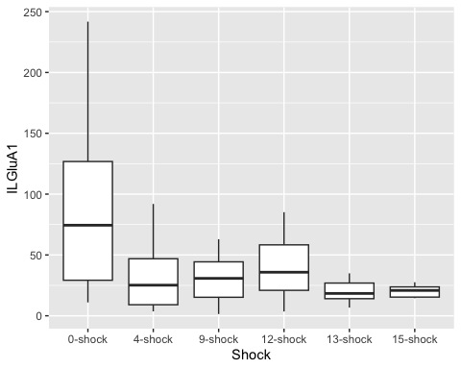

ggplot(ILGluA1Data,  
 aes( x = SEFL, y = ILGluA1)) +  
 geom_boxplot()

## Warning: Removed 24 rows containing non-finite outside the scale range  
## (`stat_boxplot()`).

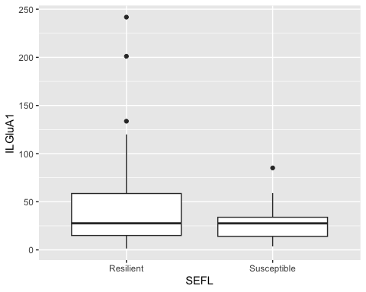

ggplot(ILGluA1Data,  
 aes( x = Shock, y = ILGluA1, fill = SEFL)) +  
 geom_boxplot()

## Warning: Removed 24 rows containing non-finite outside the scale range  
## (`stat_boxplot()`).

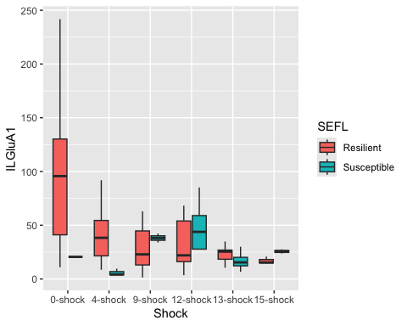

#Linear model for GluA1 data  
  
lm_ILGluA1 <- lm(ILGluA1 ~ Shock + SEFL + Shock:SEFL,  
 data = ILGluA1Data)  
  
#check assumptions  
  
resid_panel(lm_ILGluA1,  
 plots = c("resid", "qq", "ls", "cookd"),  
 smoother = TRUE)

## Warning in sqrt((n - p - sr^2)/(n - p - 1)): NaNs produced

## `geom_smooth()` using formula = 'y ~ x'  
## `geom_smooth()` using formula = 'y ~ x'

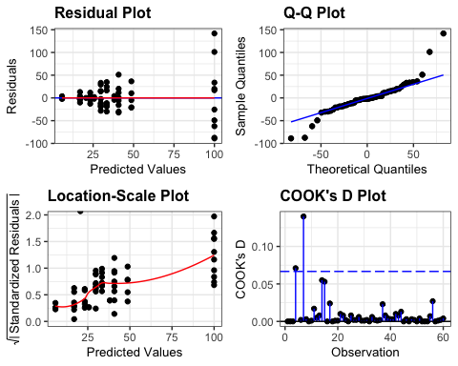

resid_ILGluA1 <- residuals(lm_ILGluA1)  
  
shapiro.test(resid_ILGluA1)

##   
## Shapiro-Wilk normality test  
##   
## data: resid_ILGluA1  
## W = 0.8755, p-value = 1.882e-05

levene_test(ILGluA1Data, ILGluA1 ~ Shock * SEFL)

## # A tibble: 1 × 4  
## df1 df2 statistic p  
## <int> <int> <dbl> <dbl>  
## 1 11 48 4.64 0.0000858

#data is not normal (shapiro test = significant)  
#but ANOVA is robust to these issues and we have homogeneity of variance  
  
anova(lm_ILGluA1)

## Analysis of Variance Table  
##   
## Response: ILGluA1  
## Df Sum Sq Mean Sq F value Pr(>F)   
## Shock 5 37642 7528.3 5.0888 0.0008019 ***  
## SEFL 1 791 790.5 0.5344 0.4683372   
## Shock:SEFL 5 8589 1717.8 1.1611 0.3419831   
## Residuals 48 71011 1479.4   
## ---  
## Signif. codes: 0 '***' 0.001 '**' 0.01 '*' 0.05 '.' 0.1 ' ' 1

eta_squared(lm_ILGluA1, partial = FALSE)

## # Effect Size for ANOVA (Type I)  
##   
## Parameter | η² | 95% CI  
## ------------------------------------  
## Shock | 0.32 | [0.10, 1.00]  
## SEFL | 6.70e-03 | [0.00, 1.00]  
## Shock:SEFL | 0.07 | [0.00, 1.00]  
##   
## - One-sided CIs: upper bound fixed at [1.00].

tukILA1 <- tukey_hsd(lm_ILGluA1)  
print(tukILA1, n=82)

## # A tibble: 82 × 9  
## term group1 group2 null.value estimate conf.low conf.high p.adj  
## * <chr> <chr> <chr> <dbl> <dbl> <dbl> <dbl> <dbl>  
## 1 Shock 0-shock 4-sho… 0 -61.5 -110. -12.9 0.00594  
## 2 Shock 0-shock 9-sho… 0 -61.7 -109. -14.0 0.00459  
## 3 Shock 0-shock 12-sh… 0 -53.0 -101. -5.35 0.0212   
## 4 Shock 0-shock 13-sh… 0 -72.4 -124. -21.1 0.00159  
## 5 Shock 0-shock 15-sh… 0 -72.4 -134. -10.8 0.0126   
## 6 Shock 4-shock 9-sho… 0 -0.105 -47.8 47.5 1   
## 7 Shock 4-shock 12-sh… 0 8.54 -39.1 56.2 0.995   
## 8 Shock 4-shock 13-sh… 0 -10.8 -62.1 40.5 0.989   
## 9 Shock 4-shock 15-sh… 0 -10.8 -72.4 50.7 0.995   
## 10 Shock 9-shock 12-sh… 0 8.65 -38.0 55.2 0.994   
## 11 Shock 9-shock 13-sh… 0 -10.7 -61.1 39.6 0.988   
## 12 Shock 9-shock 15-sh… 0 -10.7 -71.5 50.0 0.995   
## 13 Shock 12-shock 13-sh… 0 -19.4 -69.7 31.0 0.861   
## 14 Shock 12-shock 15-sh… 0 -19.4 -80.2 41.4 0.932   
## 15 Shock 13-shock 15-sh… 0 -0.0238 -63.7 63.6 1   
## 16 SEFL Resilient Susce… 0 -7.69 -29.8 14.5 0.489   
## 17 Shock:SEFL 0-shock:Res… 4-sho… 0 -59.2 -122. 3.42 0.0797   
## 18 Shock:SEFL 0-shock:Res… 9-sho… 0 -70.3 -129. -11.2 0.00819  
## 19 Shock:SEFL 0-shock:Res… 12-sh… 0 -66.6 -132. -1.49 0.0408   
## 20 Shock:SEFL 0-shock:Res… 13-sh… 0 -76.8 -149. -4.44 0.0287   
## 21 Shock:SEFL 0-shock:Res… 15-sh… 0 -83.1 -170. 3.82 0.0729   
## 22 Shock:SEFL 0-shock:Res… 0-sho… 0 -79.4 -218. 59.1 0.711   
## 23 Shock:SEFL 0-shock:Res… 4-sho… 0 -94.2 -181. -7.27 0.0233   
## 24 Shock:SEFL 0-shock:Res… 9-sho… 0 -61.9 -164. 40.4 0.64   
## 25 Shock:SEFL 0-shock:Res… 12-sh… 0 -51.3 -124. 21.0 0.403   
## 26 Shock:SEFL 0-shock:Res… 13-sh… 0 -83.1 -161. -4.96 0.0281   
## 27 Shock:SEFL 0-shock:Res… 15-sh… 0 -74.4 -177. 27.9 0.367   
## 28 Shock:SEFL 4-shock:Res… 9-sho… 0 -11.0 -73.7 51.6 1   
## 29 Shock:SEFL 4-shock:Res… 12-sh… 0 -7.35 -75.7 61.0 1   
## 30 Shock:SEFL 4-shock:Res… 13-sh… 0 -17.6 -92.8 57.7 1   
## 31 Shock:SEFL 4-shock:Res… 15-sh… 0 -23.9 -113. 65.5 0.999   
## 32 Shock:SEFL 4-shock:Res… 0-sho… 0 -20.2 -160. 120. 1   
## 33 Shock:SEFL 4-shock:Res… 4-sho… 0 -35.0 -124. 54.4 0.968   
## 34 Shock:SEFL 4-shock:Res… 9-sho… 0 -2.67 -107. 102. 1   
## 35 Shock:SEFL 4-shock:Res… 12-sh… 0 7.89 -67.4 83.2 1   
## 36 Shock:SEFL 4-shock:Res… 13-sh… 0 -23.9 -105. 57.0 0.997   
## 37 Shock:SEFL 4-shock:Res… 15-sh… 0 -15.1 -120. 89.3 1   
## 38 Shock:SEFL 9-shock:Res… 12-sh… 0 3.69 -61.4 68.8 1   
## 39 Shock:SEFL 9-shock:Res… 13-sh… 0 -6.52 -78.9 65.8 1   
## 40 Shock:SEFL 9-shock:Res… 15-sh… 0 -12.9 -99.8 74.1 1   
## 41 Shock:SEFL 9-shock:Res… 0-sho… 0 -9.15 -148. 129. 1   
## 42 Shock:SEFL 9-shock:Res… 4-sho… 0 -23.9 -111. 63.0 0.998   
## 43 Shock:SEFL 9-shock:Res… 9-sho… 0 8.37 -93.9 111. 1   
## 44 Shock:SEFL 9-shock:Res… 12-sh… 0 18.9 -53.4 91.3 0.999   
## 45 Shock:SEFL 9-shock:Res… 13-sh… 0 -12.8 -91.0 65.3 1   
## 46 Shock:SEFL 9-shock:Res… 15-sh… 0 -4.09 -106. 98.2 1   
## 47 Shock:SEFL 12-shock:Re… 13-sh… 0 -10.2 -87.5 67.1 1   
## 48 Shock:SEFL 12-shock:Re… 15-sh… 0 -16.5 -108. 74.6 1   
## 49 Shock:SEFL 12-shock:Re… 0-sho… 0 -12.8 -154. 128. 1   
## 50 Shock:SEFL 12-shock:Re… 4-sho… 0 -27.6 -119. 63.5 0.996   
## 51 Shock:SEFL 12-shock:Re… 9-sho… 0 4.68 -101. 111. 1   
## 52 Shock:SEFL 12-shock:Re… 12-sh… 0 15.2 -62.1 92.6 1   
## 53 Shock:SEFL 12-shock:Re… 13-sh… 0 -16.5 -99.3 66.3 1   
## 54 Shock:SEFL 12-shock:Re… 15-sh… 0 -7.78 -114. 98.1 1   
## 55 Shock:SEFL 13-shock:Re… 15-sh… 0 -6.34 -103. 90.1 1   
## 56 Shock:SEFL 13-shock:Re… 0-sho… 0 -2.64 -147. 142. 1   
## 57 Shock:SEFL 13-shock:Re… 4-sho… 0 -17.4 -114. 79.0 1   
## 58 Shock:SEFL 13-shock:Re… 9-sho… 0 14.9 -95.6 125. 1   
## 59 Shock:SEFL 13-shock:Re… 12-sh… 0 25.4 -58.1 109. 0.996   
## 60 Shock:SEFL 13-shock:Re… 13-sh… 0 -6.32 -94.9 82.3 1   
## 61 Shock:SEFL 13-shock:Re… 15-sh… 0 2.43 -108. 113. 1   
## 62 Shock:SEFL 15-shock:Re… 0-sho… 0 3.70 -149. 156. 1   
## 63 Shock:SEFL 15-shock:Re… 4-sho… 0 -11.1 -119. 96.7 1   
## 64 Shock:SEFL 15-shock:Re… 9-sho… 0 21.2 -99.3 142. 1   
## 65 Shock:SEFL 15-shock:Re… 12-sh… 0 31.8 -64.7 128. 0.992   
## 66 Shock:SEFL 15-shock:Re… 13-sh… 0 0.0215 -101. 101. 1   
## 67 Shock:SEFL 15-shock:Re… 15-sh… 0 8.77 -112. 129. 1   
## 68 Shock:SEFL 0-shock:Sus… 4-sho… 0 -14.8 -167. 138. 1   
## 69 Shock:SEFL 0-shock:Sus… 9-sho… 0 17.5 -144. 179. 1   
## 70 Shock:SEFL 0-shock:Sus… 12-sh… 0 28.1 -117. 173. 1   
## 71 Shock:SEFL 0-shock:Sus… 13-sh… 0 -3.68 -151. 144. 1   
## 72 Shock:SEFL 0-shock:Sus… 15-sh… 0 5.07 -157. 167. 1   
## 73 Shock:SEFL 4-shock:Sus… 9-sho… 0 32.3 -88.3 153. 0.999   
## 74 Shock:SEFL 4-shock:Sus… 12-sh… 0 42.9 -53.6 139. 0.926   
## 75 Shock:SEFL 4-shock:Sus… 13-sh… 0 11.1 -89.8 112. 1   
## 76 Shock:SEFL 4-shock:Sus… 15-sh… 0 19.9 -101. 140. 1   
## 77 Shock:SEFL 9-shock:Sus… 12-sh… 0 10.6 -99.9 121. 1   
## 78 Shock:SEFL 9-shock:Sus… 13-sh… 0 -21.2 -136. 93.2 1   
## 79 Shock:SEFL 9-shock:Sus… 15-sh… 0 -12.5 -145. 120. 1   
## 80 Shock:SEFL 12-shock:Su… 13-sh… 0 -31.8 -120. 56.8 0.984   
## 81 Shock:SEFL 12-shock:Su… 15-sh… 0 -23.0 -134. 87.5 1   
## 82 Shock:SEFL 13-shock:Su… 15-sh… 0 8.75 -106. 123. 1   
## # ℹ 1 more variable: p.adj.signif <chr>

#significant effect of shock   
#pairwise comparison revealed significant difference between 0-shock condition and all other shock levels  
  
ILsummaryGluA1 <- ILGluA1Data %>%  
 group_by(Shock, SEFL) %>%  
 get_summary_stats(type = "common")

## Warning: There was 1 warning in `mutate()`.  
## ℹ In argument: `ci = abs(stats::qt(alpha/2, .data$n - 1) * .data$se)`.  
## Caused by warning:  
## ! There was 1 warning in `mutate()`.  
## ℹ In argument: `ci = abs(stats::qt(alpha/2, .data$n - 1) * .data$se)`.  
## Caused by warning in `stats::qt()`:  
## ! NaNs produced

ILGluA2Data <- select(AllData, c("Rat","SEFL","Shock", "ILGluA2"))  
#remove outlier  
ILGluA2Data <- ILGluA2Data[-c(55), ]  
  
#first we visualise the data  
ggplot(ILGluA2Data,  
 aes( x = Shock, y = ILGluA2)) +  
 geom_boxplot()

## Warning: Removed 25 rows containing non-finite outside the scale range  
## (`stat_boxplot()`).

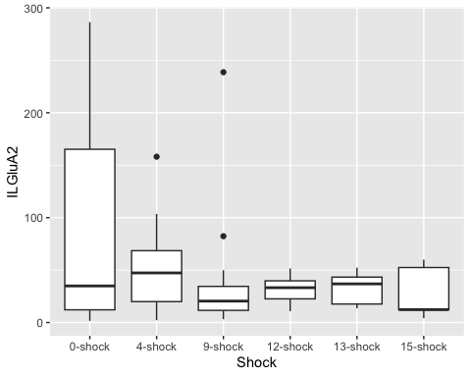

ggplot(ILGluA2Data,  
 aes( x = SEFL, y = ILGluA2)) +  
 geom_boxplot()

## Warning: Removed 25 rows containing non-finite outside the scale range  
## (`stat_boxplot()`).

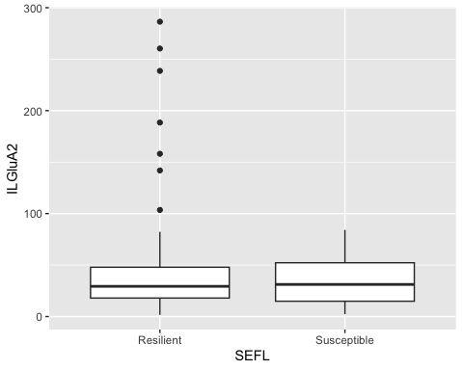

ggplot(ILGluA2Data,  
 aes( x = Shock, y = ILGluA2, fill = SEFL)) +  
 geom_boxplot()

## Warning: Removed 25 rows containing non-finite outside the scale range  
## (`stat_boxplot()`).

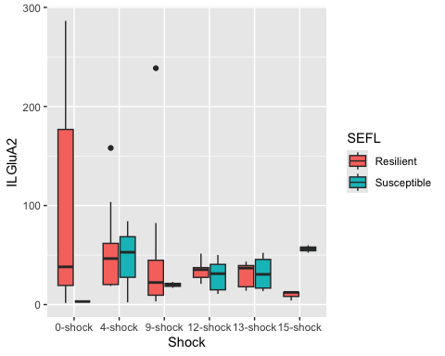

#Linear model for GluN2B data  
  
lm_ILGluA2 <- lm(ILGluA2 ~ Shock + SEFL + Shock:SEFL,  
 data = ILGluA2Data)  
  
#check assumptions  
  
resid_panel(lm_ILGluA2,  
 plots = c("resid", "qq", "ls", "cookd"),  
 smoother = TRUE)

## Warning in sqrt((n - p - sr^2)/(n - p - 1)): NaNs produced

## `geom_smooth()` using formula = 'y ~ x'  
## `geom_smooth()` using formula = 'y ~ x'

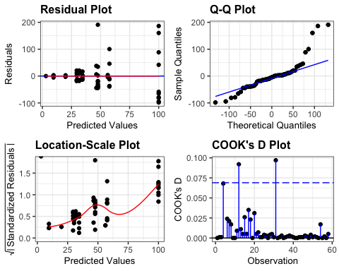

resid_ILGluA2 <- residuals(lm_ILGluA2)  
  
shapiro.test(resid_ILGluA2)

##   
## Shapiro-Wilk normality test  
##   
## data: resid_ILGluA2  
## W = 0.83883, p-value = 2.009e-06

levene_test(ILGluA2Data, ILGluA2 ~ Shock * SEFL)

## # A tibble: 1 × 4  
## df1 df2 statistic p  
## <int> <int> <dbl> <dbl>  
## 1 11 46 1.37 0.217

#data is not normal (shapiro test = significant)  
#but ANOVA is robust to these issues and we have homogeneity of variance  
  
anova(lm_ILGluA2)

## Analysis of Variance Table  
##   
## Response: ILGluA2  
## Df Sum Sq Mean Sq F value Pr(>F)  
## Shock 5 28341 5668.2 1.4590 0.2216  
## SEFL 1 1182 1182.3 0.3043 0.5839  
## Shock:SEFL 5 11598 2319.6 0.5971 0.7023  
## Residuals 46 178706 3884.9

tukILA2 <- tukey_hsd(lm_ILGluA2)  
print(tukILA2, n=82)

## # A tibble: 82 × 9  
## term group1 group2 null.value estimate conf.low conf.high p.adj p.adj.signif  
## * <chr> <chr> <chr> <dbl> <dbl> <dbl> <dbl> <dbl> <chr>   
## 1 Shock 0-sho… 4-sho… 0 -36.6 -116. 42.4 0.74 ns   
## 2 Shock 0-sho… 9-sho… 0 -48.1 -125. 29.2 0.445 ns   
## 3 Shock 0-sho… 12-sh… 0 -59.2 -140. 21.8 0.27 ns   
## 4 Shock 0-sho… 13-sh… 0 -60.3 -144. 23.0 0.28 ns   
## 5 Shock 0-sho… 15-sh… 0 -63.0 -163. 37.0 0.431 ns   
## 6 Shock 4-sho… 9-sho… 0 -11.5 -88.9 65.9 0.998 ns   
## 7 Shock 4-sho… 12-sh… 0 -22.6 -104. 58.4 0.96 ns   
## 8 Shock 4-sho… 13-sh… 0 -23.7 -107. 59.6 0.957 ns   
## 9 Shock 4-sho… 15-sh… 0 -26.4 -126. 73.6 0.969 ns   
## 10 Shock 9-sho… 12-sh… 0 -11.1 -90.4 68.3 0.998 ns   
## 11 Shock 9-sho… 13-sh… 0 -12.2 -93.9 69.5 0.998 ns   
## 12 Shock 9-sho… 15-sh… 0 -14.9 -113. 83.8 0.998 ns   
## 13 Shock 12-sh… 13-sh… 0 -1.08 -86.2 84.1 1 ns   
## 14 Shock 12-sh… 15-sh… 0 -3.77 -105. 97.7 1 ns   
## 15 Shock 13-sh… 15-sh… 0 -2.69 -106. 101. 1 ns   
## 16 SEFL Resil… Susce… 0 -9.35 -45.5 26.8 0.606 ns   
## 17 Shoc… 0-sho… 4-sho… 0 -42.4 -144. 59.4 0.95 ns   
## 18 Shoc… 0-sho… 9-sho… 0 -52.3 -148. 43.6 0.767 ns   
## 19 Shoc… 0-sho… 12-sh… 0 -65.5 -183. 51.9 0.741 ns   
## 20 Shoc… 0-sho… 13-sh… 0 -69.7 -187. 47.8 0.663 ns   
## 21 Shoc… 0-sho… 15-sh… 0 -90.4 -232. 50.8 0.555 ns   
## 22 Shoc… 0-sho… 0-sho… 0 -97.0 -322. 128. 0.938 ns   
## 23 Shoc… 0-sho… 4-sho… 0 -53.6 -195. 87.6 0.974 ns   
## 24 Shoc… 0-sho… 9-sho… 0 -80.1 -246. 86.0 0.877 ns   
## 25 Shoc… 0-sho… 12-sh… 0 -70.5 -188. 47.0 0.648 ns   
## 26 Shoc… 0-sho… 13-sh… 0 -68.3 -195. 58.6 0.78 ns   
## 27 Shoc… 0-sho… 15-sh… 0 -43.8 -210. 122. 0.999 ns   
## 28 Shoc… 4-sho… 9-sho… 0 -9.94 -112. 91.8 1 ns   
## 29 Shoc… 4-sho… 12-sh… 0 -23.2 -145. 99.1 1 ns   
## 30 Shoc… 4-sho… 13-sh… 0 -27.4 -150. 94.9 1 ns   
## 31 Shoc… 4-sho… 15-sh… 0 -48.1 -193. 97.1 0.991 ns   
## 32 Shoc… 4-sho… 0-sho… 0 -54.6 -282. 173. 0.999 ns   
## 33 Shoc… 4-sho… 4-sho… 0 -11.2 -156. 134. 1 ns   
## 34 Shoc… 4-sho… 9-sho… 0 -37.7 -207. 132. 1 ns   
## 35 Shoc… 4-sho… 12-sh… 0 -28.1 -150. 94.1 1 ns   
## 36 Shoc… 4-sho… 13-sh… 0 -26.0 -157. 105. 1 ns   
## 37 Shoc… 4-sho… 15-sh… 0 -1.47 -171. 168. 1 ns   
## 38 Shoc… 9-sho… 12-sh… 0 -13.2 -131. 104. 1 ns   
## 39 Shoc… 9-sho… 13-sh… 0 -17.4 -135. 100. 1 ns   
## 40 Shoc… 9-sho… 15-sh… 0 -38.1 -179. 103. 0.998 ns   
## 41 Shoc… 9-sho… 0-sho… 0 -44.7 -270. 180. 1 ns   
## 42 Shoc… 9-sho… 4-sho… 0 -1.30 -142. 140. 1 ns   
## 43 Shoc… 9-sho… 9-sho… 0 -27.8 -194. 138. 1 ns   
## 44 Shoc… 9-sho… 12-sh… 0 -18.2 -136. 99.3 1 ns   
## 45 Shoc… 9-sho… 13-sh… 0 -16.0 -143. 111. 1 ns   
## 46 Shoc… 9-sho… 15-sh… 0 8.47 -158. 175. 1 ns   
## 47 Shoc… 12-sh… 13-sh… 0 -4.19 -140. 131. 1 ns   
## 48 Shoc… 12-sh… 15-sh… 0 -24.9 -182. 132. 1 ns   
## 49 Shoc… 12-sh… 0-sho… 0 -31.4 -266. 204. 1 ns   
## 50 Shoc… 12-sh… 4-sho… 0 11.9 -145. 169. 1 ns   
## 51 Shoc… 12-sh… 9-sho… 0 -14.6 -194. 165. 1 ns   
## 52 Shoc… 12-sh… 12-sh… 0 -4.97 -141. 131. 1 ns   
## 53 Shoc… 12-sh… 13-sh… 0 -2.79 -147. 141. 1 ns   
## 54 Shoc… 12-sh… 15-sh… 0 21.7 -158. 201. 1 ns   
## 55 Shoc… 13-sh… 15-sh… 0 -20.7 -177. 136. 1 ns   
## 56 Shoc… 13-sh… 0-sho… 0 -27.2 -262. 208. 1 ns   
## 57 Shoc… 13-sh… 4-sho… 0 16.1 -141. 173. 1 ns   
## 58 Shoc… 13-sh… 9-sho… 0 -10.4 -190. 169. 1 ns   
## 59 Shoc… 13-sh… 12-sh… 0 -0.779 -136. 135. 1 ns   
## 60 Shoc… 13-sh… 13-sh… 0 1.40 -142. 145. 1 ns   
## 61 Shoc… 13-sh… 15-sh… 0 25.9 -154. 205. 1 ns   
## 62 Shoc… 15-sh… 0-sho… 0 -6.53 -254. 241. 1 ns   
## 63 Shoc… 15-sh… 4-sho… 0 36.8 -138. 212. 1 ns   
## 64 Shoc… 15-sh… 9-sho… 0 10.3 -185. 206. 1 ns   
## 65 Shoc… 15-sh… 12-sh… 0 19.9 -137. 177. 1 ns   
## 66 Shoc… 15-sh… 13-sh… 0 22.1 -142. 186. 1 ns   
## 67 Shoc… 15-sh… 15-sh… 0 46.6 -149. 242. 0.999 ns   
## 68 Shoc… 0-sho… 4-sho… 0 43.4 -204. 291. 1 ns   
## 69 Shoc… 0-sho… 9-sho… 0 16.9 -246. 280. 1 ns   
## 70 Shoc… 0-sho… 12-sh… 0 26.5 -208. 261. 1 ns   
## 71 Shoc… 0-sho… 13-sh… 0 28.6 -211. 268. 1 ns   
## 72 Shoc… 0-sho… 15-sh… 0 53.1 -210. 316. 1 ns   
## 73 Shoc… 4-sho… 9-sho… 0 -26.5 -222. 169. 1 ns   
## 74 Shoc… 4-sho… 12-sh… 0 -16.9 -174. 140. 1 ns   
## 75 Shoc… 4-sho… 13-sh… 0 -14.7 -179. 149. 1 ns   
## 76 Shoc… 4-sho… 15-sh… 0 9.77 -186. 206. 1 ns   
## 77 Shoc… 9-sho… 12-sh… 0 9.59 -170. 189. 1 ns   
## 78 Shoc… 9-sho… 13-sh… 0 11.8 -174. 198. 1 ns   
## 79 Shoc… 9-sho… 15-sh… 0 36.3 -178. 251. 1 ns   
## 80 Shoc… 12-sh… 13-sh… 0 2.18 -142. 146. 1 ns   
## 81 Shoc… 12-sh… 15-sh… 0 26.7 -153. 206. 1 ns   
## 82 Shoc… 13-sh… 15-sh… 0 24.5 -161. 210. 1 ns

#no significance  
  
ILsummaryGluA2 <- ILGluA2Data %>%  
 group_by(Shock, SEFL) %>%  
 get_summary_stats(type = "common")

## Warning: There was 1 warning in `mutate()`.  
## ℹ In argument: `ci = abs(stats::qt(alpha/2, .data$n - 1) * .data$se)`.  
## Caused by warning:  
## ! There was 1 warning in `mutate()`.  
## ℹ In argument: `ci = abs(stats::qt(alpha/2, .data$n - 1) * .data$se)`.  
## Caused by warning in `stats::qt()`:  
## ! NaNs produced

ILN2B <- ggplot(ILsummaryGluN2B, aes(y = mean, x=Shock, pattern = SEFL, fill = Shock)) +  
 geom_bar_pattern(stat = "identity",   
 pattern_density = .2,  
 pattern_spacing = .02,  
 pattern_fill = 'white',  
 pattern_color = "white",  
 aes(pattern = SEFL),   
 position = position_dodge(preserve = "single"),  
 width = 0.7,  
 show.legend = TRUE)+  
 scale_fill_nejm() +  
 scale_color_nejm() +  
 scale_pattern_manual(guide = "legend", values = c(Susceptible = "stripe", Resilient = "none")) +   
 labs(x="", y="GluN2B Expression Relative to Control (%)", pattern = "SEFL", subtitle = "GluN2B") +   
 guides(fill = guide_legend(override.aes = list(pattern = "none"))) +  
 scale_y_continuous(limits=c(0, 230), breaks = c(0,50,100,150,200), expand = c(0,0)) +   
 theme(axis.text.x=element_text(angle = 45, vjust = 1, hjust =1, size = 15, face="bold"), axis.text.y=element_text(size = 15, face="bold"), axis.title =element_text(size=18,face="bold"), title=element_text(size = 18, face = "bold"),plot.subtitle =element_text(size = 18), strip.text = element_text(size = 15, face = "bold")) +  
 theme(panel.grid.major = element_blank(), panel.grid.minor = element_blank(),  
 panel.background = element_rect(colour = "black", fill = "white"),   
 axis.line = element_line(colour = "black")) + theme(legend.title = element_blank()) +  
 geom_signif(comparisons = list(c("0-shock","13-shock")),  
 map_signif_level = TRUE,  
 annotations = c("*"),  
 y_position = c(200),  
 color = c("black","black","black"),  
 size = .7, textsize = 10) +  
 geom_errorbar(aes(ymin=mean-se, ymax=mean+se),  
 width= .5,   
 position=position_dodge(0.7),  
 color = "black") +  
 theme(legend.position="none") +  
 geom_point(data = ILGluN2BData, aes(x = Shock, y = ILGluN2B), position = position_jitterdodge(jitter.width = 0))  
  
ILN2B

## Warning: Removed 26 rows containing missing values or values outside the scale range  
## (`geom_point()`).

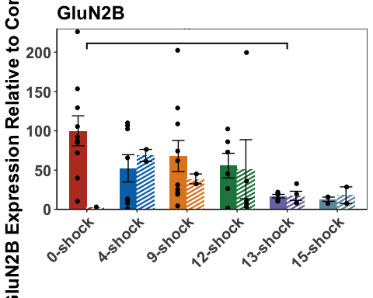

ILA1 <- ggplot(ILsummaryGluA1, aes(y = mean, x=Shock, pattern = SEFL, fill = Shock)) +  
 geom_bar_pattern(stat = "identity",   
 pattern_density = .2,  
 pattern_spacing = .02,  
 pattern_fill = 'white',  
 pattern_color = "white",  
 aes(pattern = SEFL),   
 position = position_dodge(preserve = "single"),  
 width = 0.7,  
 show.legend = TRUE)+  
 scale_fill_nejm() +  
 scale_color_nejm() +  
 scale_pattern_manual(guide = "legend", values = c(Susceptible = "stripe", Resilient = "none")) +   
 labs(x="", y="GluA1 Expression Relative to Control (%)", pattern = "SEFL", subtitle = "GluA1") +   
 guides(fill = guide_legend(override.aes = list(pattern = "none"))) +  
 scale_y_continuous(limits=c(0, 260),breaks = c(0,50,100,150,200,250), expand = c(0,0)) +   
 theme(axis.text.x=element_text(angle = 45, vjust = 1, hjust =1, size = 15, face="bold"), axis.text.y=element_text(size = 15, face="bold"), axis.title =element_text(size=18,face="bold"), title=element_text(size = 18, face = "bold"),plot.subtitle =element_text(size = 18), strip.text = element_text(size = 15, face = "bold")) +  
 theme(panel.grid.major = element_blank(), panel.grid.minor = element_blank(),  
 panel.background = element_rect(colour = "black", fill = "white"),   
 axis.line = element_line(colour = "black")) + theme(legend.title = element_blank()) +  
 geom_signif(comparisons = list(c("0-shock","15-shock")),  
 map_signif_level = TRUE,  
 annotations = c("*"),  
 y_position = c(220),  
 color = c("black","black","black"),  
 size = .7, textsize = 10) +  
 geom_signif(comparisons = list(c("0-shock","13-shock")),  
 map_signif_level = TRUE,  
 annotations = c("**"),  
 y_position = c(195),  
 color = c("black","black","black"),  
 size = .7, textsize = 10) +  
 geom_signif(comparisons = list(c("0-shock","12-shock")),  
 map_signif_level = TRUE,  
 annotations = c("*"),  
 y_position = c(170),  
 color = c("black","black","black"),  
 size = .7, textsize = 10) +  
 geom_signif(comparisons = list(c("0-shock","9-shock")),  
 map_signif_level = TRUE,  
 annotations = c("**"),  
 y_position = c(145),  
 color = c("black","black","black"),  
 size = .7, textsize = 10) +  
 geom_signif(comparisons = list(c("0-shock","4-shock")),  
 map_signif_level = TRUE,  
 annotations = c("**"),  
 y_position = c(120),  
 color = c("black","black","black"),  
 size = .7, textsize = 10) +  
 geom_errorbar(aes(ymin=mean-se, ymax=mean+se),  
 width= .5,   
 position=position_dodge(0.7),  
 color = "black") +  
 theme(legend.position="none") +  
 geom_point(data = ILGluA1Data, aes(x = Shock, y = ILGluA1), position = position_jitterdodge(jitter.width = 0))  
  
ILA1

## Warning: Removed 24 rows containing missing values or values outside the scale range  
## (`geom_point()`).

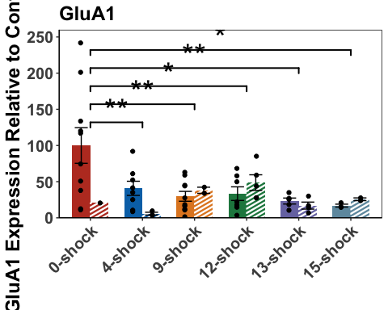

ILA2 <- ggplot(ILsummaryGluA2, aes(y = mean, x=Shock, pattern = SEFL, fill = Shock)) +  
 geom_bar_pattern(stat = "identity",   
 pattern_density = .2,  
 pattern_spacing = .02,  
 pattern_fill = 'white',  
 pattern_color = "white",  
 aes(pattern = SEFL),   
 position = position_dodge(preserve = "single"),  
 width = 0.7,  
 show.legend = TRUE)+  
 scale_fill_nejm() +  
 scale_color_nejm() +  
 scale_pattern_manual(guide = "legend", values = c(Susceptible = "stripe", Resilient = "none")) +   
 labs(x="", y="GluA2 Expression Relative to Control (%)", pattern = "SEFL", subtitle = "GluA2") +   
 guides(fill = guide_legend(override.aes = list(pattern = "none"))) +  
 scale_y_continuous(limits=c(0, 290),breaks = c(0,50,100,150,200,250), expand = c(0,0)) +   
 theme(axis.text.x=element_text(angle = 45, vjust = 1, hjust =1, size = 15, face="bold"), axis.text.y=element_text(size = 15, face="bold"), axis.title =element_text(size=18,face="bold"), title=element_text(size = 18, face = "bold"),plot.subtitle =element_text(size = 18), strip.text = element_text(size = 15, face = "bold")) +  
 theme(panel.grid.major = element_blank(), panel.grid.minor = element_blank(),  
 panel.background = element_rect(colour = "black", fill = "white"),   
 axis.line = element_line(colour = "black")) + theme(legend.title = element_blank()) +  
 geom_errorbar(aes(ymin=mean-se, ymax=mean+se),  
 width= .5,   
 position=position_dodge(0.7),  
 color = "black") +  
 theme(legend.position = c(0.86, 0.72), legend.key.size = unit(1, 'cm')) +   
 theme(legend.text=element_text(size=14, face = "bold")) +  
 geom_point(data = ILGluA2Data, aes(x = Shock, y = ILGluA2), position = position_jitterdodge(jitter.width = 0))

## Warning: A numeric `legend.position` argument in `theme()` was deprecated in ggplot2  
## 3.5.0.  
## ℹ Please use the `legend.position.inside` argument of `theme()` instead.  
## This warning is displayed once every 8 hours.  
## Call `lifecycle::last_lifecycle_warnings()` to see where this warning was  
## generated.

ILA2

## Warning: Removed 25 rows containing missing values or values outside the scale range  
## (`geom_point()`).

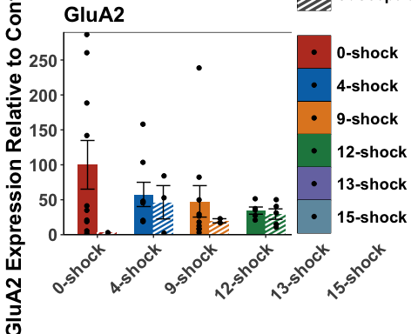

N2B_SEFL <- ggplot(ILGluN2BData,  
 aes( x = SEFL, y = ILGluN2B)) +  
 geom_boxplot() +  
 geom_jitter(color= c("#636363"), size=.7, alpha=.7) +   
 theme(panel.grid.major = element_blank(), panel.grid.minor = element_blank(),  
 panel.background = element_rect(colour = "black", fill = "white"),   
 axis.line = element_line(colour = "black")) + theme(legend.title = element_blank()) +  
 labs(X = "", y="GluN2B Expression Relative to Control (%)") +  
 geom_signif(comparisons = list(c("Resilient","Susceptible")),  
 map_signif_level = TRUE,  
 annotations = c("NS"),  
 y_position = c(300),  
 color = c("black","black","black"),  
 size = 1, textsize = 5) +   
 theme(axis.text.x=element_text(size = 15, face="bold"), axis.text.y=element_text(size = 15, face="bold"), axis.title =element_text(size=18,face="bold"), title=element_text(size = 18, face = "bold"),plot.subtitle =element_text(size = 18), strip.text = element_text(size = 15, face = "bold")) +  
 scale_y_continuous(limits=c(0, 325)) +  
 theme(legend.position="none")  
  
N2B_SEFL

## Warning: Removed 26 rows containing non-finite outside the scale range  
## (`stat_boxplot()`).

## Warning: Removed 26 rows containing non-finite outside the scale range  
## (`stat_signif()`).

## Warning: Removed 26 rows containing missing values or values outside the scale range  
## (`geom_point()`).

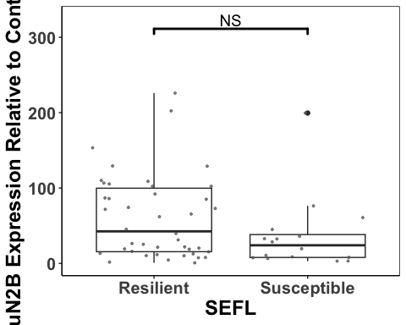

A1_SEFL <- ggplot(ILGluA1Data,  
 aes( x = SEFL, y = ILGluA1)) +  
 geom_boxplot() +  
 geom_jitter(color= c("#636363"), size=.7, alpha=.7) +   
 theme(panel.grid.major = element_blank(), panel.grid.minor = element_blank(),  
 panel.background = element_rect(colour = "black", fill = "white"),   
 axis.line = element_line(colour = "black")) + theme(legend.title = element_blank()) +  
 labs(X = "",y="GluA1 Expression Relative to Control (%)") +  
 geom_signif(comparisons = list(c("Resilient","Susceptible")),  
 map_signif_level = TRUE,  
 annotations = c("NS"),  
 y_position = c(300),  
 color = c("black","black","black"),  
 size = 1, textsize = 5) +   
 theme(axis.text.x=element_text(size = 15, face="bold"), axis.text.y=element_text(size = 15, face="bold"), axis.title =element_text(size=18,face="bold"), title=element_text(size = 18, face = "bold"),plot.subtitle =element_text(size = 18), strip.text = element_text(size = 15, face = "bold")) +  
 scale_y_continuous(limits=c(0, 325)) +  
 theme(legend.position="none")  
A1_SEFL

## Warning: Removed 24 rows containing non-finite outside the scale range  
## (`stat_boxplot()`).

## Warning: Removed 24 rows containing non-finite outside the scale range  
## (`stat_signif()`).

## Warning: Removed 24 rows containing missing values or values outside the scale range  
## (`geom_point()`).

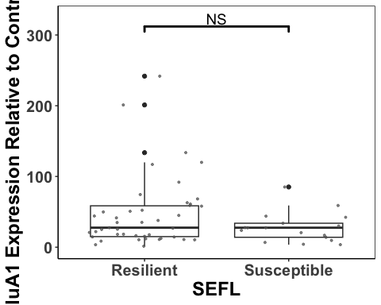

A2_SEFL <- ggplot(ILGluA2Data,  
 aes( x = SEFL, y = ILGluA2)) +  
 geom_boxplot() +  
 geom_jitter(color= c("#636363"), size=.7, alpha=.7) +   
 theme(panel.grid.major = element_blank(), panel.grid.minor = element_blank(),  
 panel.background = element_rect(colour = "black", fill = "white"),   
 axis.line = element_line(colour = "black")) + theme(legend.title = element_blank()) +  
 labs(X = "",y="GluA2 Expression Relative to Control (%)") +  
 geom_signif(comparisons = list(c("Resilient","Susceptible")),  
 map_signif_level = TRUE,  
 annotations = c("NS"),  
 y_position = c(325),  
 color = c("black","black","black"),  
 size = 1, textsize = 5) +   
 theme(axis.text.x=element_text(size = 15, face="bold"), axis.text.y=element_text(size = 15, face="bold"), axis.title =element_text(size=18,face="bold"), title=element_text(size = 18, face = "bold"),plot.subtitle =element_text(size = 18), strip.text = element_text(size = 15, face = "bold")) +  
 scale_y_continuous(limits=c(0, 350))  
A2_SEFL

## Warning: Removed 25 rows containing non-finite outside the scale range  
## (`stat_boxplot()`).

## Warning: Removed 25 rows containing non-finite outside the scale range  
## (`stat_signif()`).

## Warning: Removed 25 rows containing missing values or values outside the scale range  
## (`geom_point()`).

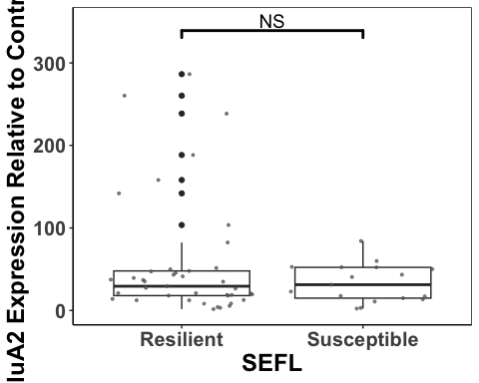

ILplot <- ggarrange(ILN2B, ILA1, ILA2, N2B_SEFL,A1_SEFL, A2_SEFL,  
 labels = c("a", "", "", "b", "", ""),  
 font.label = list(size = 26, face = "bold"),  
 ncol = 3, nrow = 2) +  
 theme(plot.margin = margin(0.1,1.5,0.1,1.5, "cm"))

## Warning: Removed 26 rows containing missing values or values outside the scale range  
## (`geom_point()`).

## Warning: Removed 24 rows containing missing values or values outside the scale range  
## (`geom_point()`).

## Warning: Removed 25 rows containing missing values or values outside the scale range  
## (`geom_point()`).

## Warning: Removed 26 rows containing non-finite outside the scale range  
## (`stat_boxplot()`).

## Warning: Removed 26 rows containing non-finite outside the scale range  
## (`stat_signif()`).

## Warning: Removed 26 rows containing missing values or values outside the scale range  
## (`geom_point()`).

## Warning: Removed 24 rows containing non-finite outside the scale range  
## (`stat_boxplot()`).

## Warning: Removed 24 rows containing non-finite outside the scale range  
## (`stat_signif()`).

## Warning: Removed 24 rows containing missing values or values outside the scale range  
## (`geom_point()`).

## Warning: Removed 25 rows containing non-finite outside the scale range  
## (`stat_boxplot()`).

## Warning: Removed 25 rows containing non-finite outside the scale range  
## (`stat_signif()`).

## Warning: Removed 25 rows containing missing values or values outside the scale range  
## (`geom_point()`).

ILplot

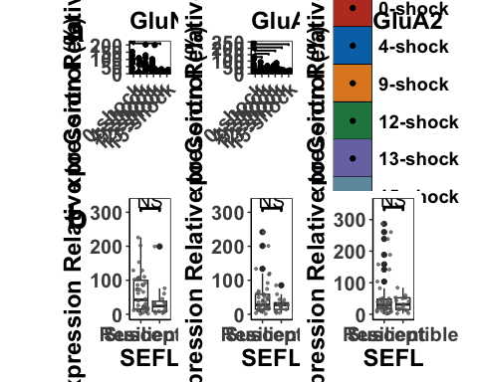

ggsave('ILplot', ILplot, width=23, height=18, units='in', device = "tiff", dpi = 600)

Correlations between subunit expression in the IL

#first we work out the regression lines for the resilient and susceptible groups  
  
resilientIL <- select(ILData, c("Rat","SEFL","Shock", "Average_Freezing_Extinction_Session","Average_Freezing_Last_3_mins_Extinction", "Recovery_Index","Total_Freezing_During_Test","ILGluN2B", "ILGluA1", "ILGluA2"))  
resilientIL <- resilientIL[ which(resilientIL$SEFL=="Resilient"), ]  
  
susceptibleIL <- select(ILData, c("Rat","SEFL","Shock", "Average_Freezing_Extinction_Session","Average_Freezing_Last_3_mins_Extinction", "Recovery_Index","Total_Freezing_During_Test","ILGluN2B", "ILGluA1", "ILGluA2"))  
susceptibleIL <- susceptibleIL[ which(susceptibleIL$SEFL=="Susceptible"), ]  
  
  
ILResilient1 <- lm(ILGluN2B ~ ILGluA1, data = resilientIL, na.action=na.omit)  
ILResilient1

##   
## Call:  
## lm(formula = ILGluN2B ~ ILGluA1, data = resilientIL, na.action = na.omit)  
##   
## Coefficients:  
## (Intercept) ILGluA1   
## 31.2460 0.6188

#y = 0.6188x + 31.2460  
  
ILSusceptible1 <- lm(ILGluN2B ~ ILGluA1, data = susceptibleIL, na.action=na.omit)  
ILSusceptible1

##   
## Call:  
## lm(formula = ILGluN2B ~ ILGluA1, data = susceptibleIL, na.action = na.omit)  
##   
## Coefficients:  
## (Intercept) ILGluA1   
## -3.328 1.338

#y = 1.338x - 3.328  
  
ILA1_N2B <- ggplot(ILData,  
 aes(x = ILGluA1,  
 y = ILGluN2B, color = Shock, shape = SEFL)) +  
 geom_point(aes(color = ILData$Shock), size = 4) +  
 scale_fill_nejm() +  
 scale_color_nejm() +  
 theme(panel.grid.major = element_blank(), panel.grid.minor = element_blank(),  
 panel.background = element_rect(colour = "black", fill = "white"),   
 axis.line = element_line(colour = "black")) + theme(legend.title = element_blank()) +  
 geom_abline(intercept = 31.2460, slope = 0.6188, size = 1.2) +  
 geom_abline(intercept = -3.328, slope = 1.338, linetype = "dashed", size = 1.2) +  
 theme(legend.position="none") +  
 theme(axis.text.x=element_text(size = 15, face = "bold"),axis.text.y=element_text(size = 15, face = "bold"), axis.title =element_text(size=15,face="bold")) +  
 labs(x="GluA1 Expression Relative to Control (%)", y="GluN2B Expression Relative to Control (%)")

## Warning: Using `size` aesthetic for lines was deprecated in ggplot2 3.4.0.  
## ℹ Please use `linewidth` instead.  
## This warning is displayed once every 8 hours.  
## Call `lifecycle::last_lifecycle_warnings()` to see where this warning was  
## generated.

ILA1_N2B

## Warning: Use of `ILData$Shock` is discouraged.  
## ℹ Use `Shock` instead.

## Warning: Removed 26 rows containing missing values or values outside the scale range  
## (`geom_point()`).

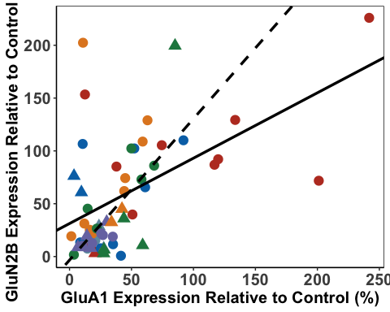

ILResilient2 <- lm(ILGluN2B ~ ILGluA2, data = resilientIL, na.action=na.omit)  
ILResilient2

##   
## Call:  
## lm(formula = ILGluN2B ~ ILGluA2, data = resilientIL, na.action = na.omit)  
##   
## Coefficients:  
## (Intercept) ILGluA2   
## 41.0312 0.3608

#y = 0.3608x + 41.0312  
  
ILSusceptible2 <- lm(ILGluN2B ~ ILGluA2, data = susceptibleIL, na.action=na.omit)  
ILSusceptible2

##   
## Call:  
## lm(formula = ILGluN2B ~ ILGluA2, data = susceptibleIL, na.action = na.omit)  
##   
## Coefficients:  
## (Intercept) ILGluA2   
## 45.9953 -0.3047

#y = -0.3047x + 45.9953  
  
ILA2_N2B<- ggplot(ILData,  
 aes(x = ILGluA2,  
 y = ILGluN2B, color = Shock, shape = SEFL)) +  
 geom_point(aes(color = ILData$Shock), size = 4) +  
 scale_fill_nejm() +  
 scale_color_nejm() +  
 theme(panel.grid.major = element_blank(), panel.grid.minor = element_blank(),  
 panel.background = element_rect(colour = "black", fill = "white"),   
 axis.line = element_line(colour = "black")) + theme(legend.title = element_blank()) +  
 geom_abline(intercept = 41.1943, slope = 0.3597, size = 1.2) +  
 geom_abline(intercept = 45.9953, slope = -0.3047, linetype = "dashed",size = 1.2) +  
 geom_segment(aes(x=230, xend=250,y=25,yend=25), size =1.3, color = "black") +  
 geom_segment(aes(x=230, xend=250,y=15,yend=15), size = 1.3,color = "black", linetype = "dashed") +   
 annotate(geom="text", x=275, y=25, label="Resilient",  
 color="black", size = 6, fontface = "bold") +  
 annotate(geom="text", x=283, y=15, label="Susceptible",  
 color="black", size = 6, fontface = "bold") +  
 theme(axis.text.x=element_text(size = 15, face = "bold"),axis.text.y=element_text(size = 15, face = "bold"), axis.title =element_text(size=15,face="bold")) +  
 theme(legend.position="none") +  
 scale_x_continuous(limits=c(0, 320), breaks = c(0,100,200,300), expand = c(0,0)) +  
 labs(x="GluA2 Expression Relative to Control (%)", y="GluN2B Expression Relative to Control (%)")   
  
ILA2_N2B

## Warning: Use of `ILData$Shock` is discouraged.  
## ℹ Use `Shock` instead.

## Warning: Removed 27 rows containing missing values or values outside the scale range  
## (`geom_point()`).

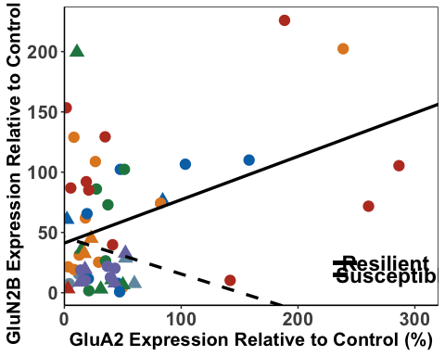

ILResilient3 <- lm(ILGluA1 ~ ILGluA2, data = resilientIL, na.action=na.omit)  
ILResilient3

##   
## Call:  
## lm(formula = ILGluA1 ~ ILGluA2, data = resilientIL, na.action = na.omit)  
##   
## Coefficients:  
## (Intercept) ILGluA2   
## 31.9848 0.2659

#y = 0.3216x + 30.6209  
  
ILSusceptible3 <- lm(ILGluA1 ~ ILGluA2, data = susceptibleIL, na.action=na.omit)  
ILSusceptible3

##   
## Call:  
## lm(formula = ILGluA1 ~ ILGluA2, data = susceptibleIL, na.action = na.omit)  
##   
## Coefficients:  
## (Intercept) ILGluA2   
## 35.9742 -0.2378

#y = -0.2378x + 35.9742  
  
ILA2_A1<- ggplot(ILData,  
 aes(x = ILGluA2,  
 y = ILGluA1, color = Shock, shape = SEFL)) +  
 geom_point(aes(color = ILData$Shock), size = 4) +  
 scale_fill_nejm() +  
 scale_color_nejm() +  
 theme(panel.grid.major = element_blank(), panel.grid.minor = element_blank(),  
 panel.background = element_rect(colour = "black", fill = "white"),   
 axis.line = element_line(colour = "black")) + theme(legend.title = element_blank()) +  
 geom_abline(intercept = 31.3282, slope = 0.2702, size = 1.2) +  
 geom_abline(intercept = 35.9742, slope = -0.2378, linetype = "dashed", size = 1.2) +  
 theme(legend.position = c(0.13, 0.80), legend.key.size = unit(0.8, 'cm')) +  
 theme(axis.text.x=element_text(size = 15, face = "bold"),axis.text.y=element_text(size = 15, face = "bold"), axis.title =element_text(size=15,face="bold")) +   
 theme(legend.text=element_text(size=12, face = "bold")) +  
 scale_x_continuous(limits=c(0, 320), breaks = c(0,100,200,300), expand = c(0,0)) +  
 labs(x="GluA2 Expression Relative to Control (%)", y="GluA1 Expression Relative to Control (%)")  
ILA2_A1

## Warning: Use of `ILData$Shock` is discouraged.  
## ℹ Use `Shock` instead.

## Warning: Removed 25 rows containing missing values or values outside the scale range  
## (`geom_point()`).

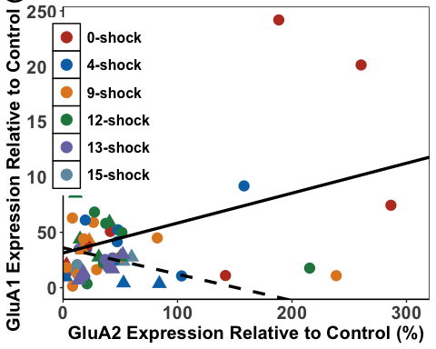

ILsubunits <- ggarrange(ILA2_A1, ILA1_N2B, ILA2_N2B,  
 labels = c("a", "b", "c"),  
 font.label = list(size = 24, face = "bold"),  
 ncol = 3, nrow = 1) +  
 theme(plot.margin = margin(1,1,1,1, "cm"))

## Warning: Use of `ILData$Shock` is discouraged.  
## ℹ Use `Shock` instead.

## Warning: Removed 25 rows containing missing values or values outside the scale range  
## (`geom_point()`).

## Warning: Use of `ILData$Shock` is discouraged.  
## ℹ Use `Shock` instead.

## Warning: Removed 26 rows containing missing values or values outside the scale range  
## (`geom_point()`).

## Warning: Use of `ILData$Shock` is discouraged.  
## ℹ Use `Shock` instead.

## Warning: Removed 27 rows containing missing values or values outside the scale range  
## (`geom_point()`).

ILsubunits

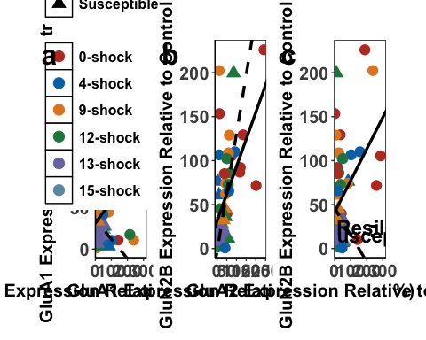

ggsave('ILsubunits', ILsubunits, width=25, height=9, units='in', device = "tiff", dpi = 600)

Comparing the regressions

ILA1_A2<- ILData %>%   
 group_by(SEFL) %>%  
 cor_test(ILGluA2, ILGluA1, method="pearson")  
  
#resilient - r=0.45, p <.01  
#susceptible = r=-0.26, p=0.31

ILA1_N2B<- ILData %>%   
 group_by(SEFL) %>%  
 cor_test(ILGluN2B, ILGluA1, method="pearson")  
  
#resilient - r=0.57, p <.0001  
#susceptible = r=0.57, p<.05

ILA2_N2B <- ILData %>%   
 group_by(SEFL) %>%  
 cor_test(ILGluN2B, ILGluA2, method="pearson")  
  
#resilient - r=0.46, p<0.01  
#susceptible = r=-0.15, p=.59

Fisher’s Z-Scores

ILResilientA1_A2 <- FisherZ(0.45)  
ILSusceptibleA1_A2 <- FisherZ(-0.26)  
  
ILResilientA1_N2B <- FisherZ(0.57)  
ILSusceptibleA1_N2B <- FisherZ(0.57)  
  
ILResilientA2_N2B <- FisherZ(0.46)  
ILSusceptibleA2_N2B <- FisherZ(-0.15)

#n resilient = 43  
#n susceptible = 17  
#one outlier removed  
  
  
N1 <- 1/(44-3)  
N2 <- 1/(18-3)  
  
N <- N1 + N2  
  
Z1 <- (ILResilientA1_A2 -ILSusceptibleA1_A2)  
  
ILZdiffA1_A2 <- Z1/sqrt(N)  
  
#=2.488  
#greater than z-crit = significant

#1 lost in each group for GluN2B due to over-exposure  
  
N1b <- 1/(43-3)  
N2b <- 1/(17-3)  
  
Nb <- N1b + N2b  
  
Z2 <- (ILResilientA1_N2B -ILSusceptibleA1_N2B)  
  
ILZdiffA1_N2B <- Z2/sqrt(Nb)  
  
#=0

#one outlier removed  
Z3 <- (ILResilientA2_N2B -ILSusceptibleA2_N2B)  
  
ILZdiffA2_N2B <- Z3/sqrt(Nb)  
  
#=2.33  
#greater than z crit = significant

Behavioural Correlations with IL Data

#first we work out the correlations  
  
  
ILResGluN2B <- lm(Average_Freezing_Extinction_Session ~ ILGluN2B, data = resilientIL)  
ILResGluN2B

##   
## Call:  
## lm(formula = Average_Freezing_Extinction_Session ~ ILGluN2B,   
## data = resilientIL)  
##   
## Coefficients:  
## (Intercept) ILGluN2B   
## 9.25207 -0.03512

ILSusGluN2B <- lm(Average_Freezing_Extinction_Session ~ ILGluN2B, data = susceptibleIL)  
ILSusGluN2B

##   
## Call:  
## lm(formula = Average_Freezing_Extinction_Session ~ ILGluN2B,   
## data = susceptibleIL)  
##   
## Coefficients:  
## (Intercept) ILGluN2B   
## 32.33847 -0.02823

ILResGluA1 <- lm(Average_Freezing_Extinction_Session ~ ILGluA1, data = resilientIL)  
ILResGluA1

##   
## Call:  
## lm(formula = Average_Freezing_Extinction_Session ~ ILGluA1, data = resilientIL)  
##   
## Coefficients:  
## (Intercept) ILGluA1   
## 9.53343 -0.04292

ILSusGluA1 <- lm(Average_Freezing_Extinction_Session ~ ILGluA1, data = susceptibleIL)  
ILSusGluA1

##   
## Call:  
## lm(formula = Average_Freezing_Extinction_Session ~ ILGluA1, data = susceptibleIL)  
##   
## Coefficients:  
## (Intercept) ILGluA1   
## 36.1862 -0.1435

ILResGluA2 <- lm(Average_Freezing_Extinction_Session~ ILGluA2, data = resilientIL)  
ILResGluA2

##   
## Call:  
## lm(formula = Average_Freezing_Extinction_Session ~ ILGluA2, data = resilientIL)  
##   
## Coefficients:  
## (Intercept) ILGluA2   
## 8.190845 -0.009632

ILSusGluA2 <- lm(Average_Freezing_Extinction_Session ~ ILGluA2, data = susceptibleIL)  
ILSusGluA2

##   
## Call:  
## lm(formula = Average_Freezing_Extinction_Session ~ ILGluA2, data = susceptibleIL)  
##   
## Coefficients:  
## (Intercept) ILGluA2   
## 29.32928 0.08479

ILFF_A1 <- ggplot(ILData,  
 aes(x = ILGluA1,  
 y = Average_Freezing_Extinction_Session, color = Shock, shape = SEFL)) +  
 geom_point(aes(color = Shock), size = 4) +  
 scale_fill_nejm() +  
 scale_color_nejm() +  
 theme(panel.grid.major = element_blank(), panel.grid.minor = element_blank(),  
 panel.background = element_rect(colour = "black", fill = "white"),   
 axis.line = element_line(colour = "black")) + theme(legend.title = element_blank()) +   
 geom_abline(intercept = 9.53, slope = -0.043, size = 1.2) +  
 geom_abline(intercept = 36.19, slope = -0.14, linetype = "dashed", size = 1.2) +  
 theme(legend.position="none") +  
 theme(axis.text.x=element_text(size = 12, face = "bold"),axis.text.y=element_text(size = 12, face = "bold"), axis.title =element_text(size=15,face="bold")) +  
 labs(x="GluA1 Expression Relative to Control (%)", y="Mean Freezing During Extinction Session (%)") +  
 scale_x_continuous(limits=c(0, 270), breaks = c(0,50,100,150,200,250), expand = c(0,0))  
  
ILFF_N2B <- ggplot(ILData,  
 aes(x = ILGluN2B,  
 y = Average_Freezing_Extinction_Session, color = Shock, shape = SEFL)) +  
 geom_point(aes(color = Shock), size = 4) +  
 scale_fill_nejm() +  
 scale_color_nejm() +  
 theme(panel.grid.major = element_blank(), panel.grid.minor = element_blank(),  
 panel.background = element_rect(colour = "black", fill = "white"),   
 axis.line = element_line(colour = "black")) + theme(legend.title = element_blank()) +   
 geom_abline(intercept = 9.25, slope = -0.035, size = 1.2) +  
 geom_abline(intercept = 32.34, slope = -0.028, linetype = "dashed", size = 1.2) +  
 theme(axis.text.x=element_text(size = 12, face = "bold"),axis.text.y=element_text(size = 12, face = "bold"), axis.title =element_text(size=15,face="bold")) +  
 labs(x="GluN2B Expression Relative to Control (%)", y="Mean Freezing During Extinction Session (%)") +   
 theme(legend.position = c(0.85, 0.78), legend.key.size = unit(1, 'cm'), legend.text = element_text(size=14, face = "bold")) +  
 scale_x_continuous(limits=c(0, 220), breaks = c(0,50,100,150,200), expand = c(0,0)) +  
 geom_segment(aes(x=10, xend=35,y=50,yend=50),size =1.3, color = "black") +  
 geom_segment(aes(x=10, xend=35,y=48,yend=48), size =1.3, color = "black", linetype = "dashed") +  
 annotate(geom="text", x=60, y=50, label="Resilient",  
 color="black",size = 6, fontface = "bold") +  
 annotate(geom="text", x=65, y=48, label="Susceptible",  
 color="black", size = 6,fontface = "bold")   
  
ILFF_A2 <- ggplot(ILData,  
 aes(x = ILGluA2,  
 y = Average_Freezing_Extinction_Session, color = Shock, shape = SEFL)) +  
 geom_point(aes(color = Shock), size = 4) +  
 scale_fill_nejm() +  
 scale_color_nejm() +  
 theme(panel.grid.major = element_blank(), panel.grid.minor = element_blank(),  
 panel.background = element_rect(colour = "black", fill = "white"),   
 axis.line = element_line(colour = "black")) + theme(legend.title = element_blank()) +   
 geom_abline(intercept = 8.53, slope = -0.024, size = 1.2) +  
 geom_abline(intercept = 29.33, slope = 0.085, linetype = "dashed", size = 1.2) +  
 theme(legend.position="none") +  
 theme(axis.text.x=element_text(size = 12, face = "bold"),axis.text.y=element_text(size = 12, face = "bold"), axis.title =element_text(size=15,face="bold")) +  
 labs(x="GluA2 Expression Relative to Control (%)", y="Mean Freezing During Extinction Session (%)") +  
 scale_x_continuous(limits=c(0, 320), breaks = c(0,50,100,150,200,250,300), expand = c(0,0))  
   
  
ILFF_A2

## Warning: Removed 25 rows containing missing values or values outside the scale range  
## (`geom_point()`).

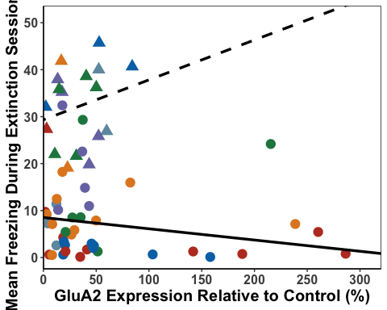

ILFF_A1

## Warning: Removed 24 rows containing missing values or values outside the scale range  
## (`geom_point()`).

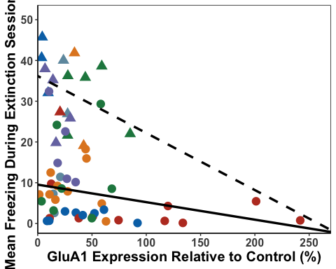

ILFF_N2B

## Warning: Removed 27 rows containing missing values or values outside the scale range  
## (`geom_point()`).

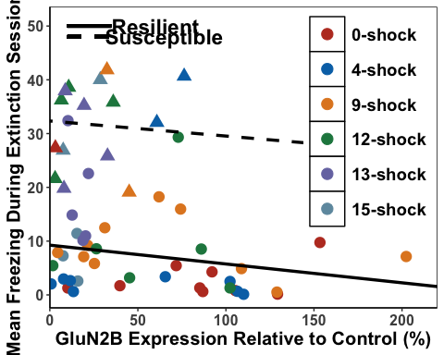

ILFF_A1cor<- ILData %>%   
 group_by(SEFL) %>%  
 cor_test(Average_Freezing_Extinction_Session, ILGluA1, method="pearson")  
  
#resilient - r=-0.27, p=0.07  
#susceptible = r=-0.35, p=0.16  
  
ILFF_A2cor<- ILData %>%   
 group_by(SEFL) %>%  
 cor_test(Average_Freezing_Extinction_Session, ILGluA2, method="pearson")  
  
#resilient - r=-0.22, p=0.16  
#susceptible = r=0.23, p=0.37  
  
ILFF_N2Bcor<- ILData %>%   
 group_by(SEFL) %>%  
 cor_test(Average_Freezing_Extinction_Session, ILGluN2B, method="pearson")  
  
#resilient - r=-0.26, p=0.10  
#susceptible = r=-0.17, p=0.53  
  
ILResilientFF_A1 <- FisherZ(-0.27)  
ILSusceptibleFF_A1 <- FisherZ(-0.35)  
  
ILResilientFF_A2 <- FisherZ(-0.22)  
ILSusceptibleFF_A2 <- FisherZ(0.23)  
  
ILResilientFF_N2B <- FisherZ(-0.26)  
ILSusceptibleFF_N2B <- FisherZ(-0.17)  
  
  
#z diff for A1  
  
#n resilient = 44  
#n susceptible = 18  
  
N1 <- 1/(44-3)  
N2 <- 1/(18-3)  
  
N <- N1 + N2  
  
Z1 <- (ILResilientFF_A1 -ILSusceptibleFF_A1)  
  
ILZdiffFF_A1 <- Z1/sqrt(N)  
ILZdiffFF_A1

## [1] 0.2935478

# 0.29 not significant  
  
#Z diff for A2  
  
#N resilient = 43  
  
N1a <- 1/(43-3)  
  
Na <- N1a + N2  
  
Z2 <- (ILResilientFF_A2 -ILSusceptibleFF_A2)  
  
ILZdiffFF_A2 <- Z2/sqrt(Na)  
ILZdiffFF_A2

## [1] -1.512214

#-1.51 not significant  
  
#Z diff for N2B  
  
#One lost from each group due to over exposure  
  
N3 <- 1/(43-3)  
N4 <- 1/(17-3)  
  
N5 <- N3 + N4  
  
Z3 <- (ILResilientFF_N2B -ILSusceptibleFF_N2B)  
  
ILZdiffFF_N2B <- Z3/sqrt(N5)  
ILZdiffFF_N2B

## [1] -0.3041313

#-0.30 not significant

ILRes3GluN2B <- lm(Average_Freezing_Last_3_mins_Extinction ~ ILGluN2B, data = resilientIL)  
ILRes3GluN2B

##   
## Call:  
## lm(formula = Average_Freezing_Last_3_mins_Extinction ~ ILGluN2B,   
## data = resilientIL)  
##   
## Coefficients:  
## (Intercept) ILGluN2B   
## 4.89042 -0.01975

#y = -0.020x + 4.89  
  
  
ILSus3GluN2B <- lm(Average_Freezing_Last_3_mins_Extinction ~ ILGluN2B, data = susceptibleIL)  
ILSus3GluN2B

##   
## Call:  
## lm(formula = Average_Freezing_Last_3_mins_Extinction ~ ILGluN2B,   
## data = susceptibleIL)  
##   
## Coefficients:  
## (Intercept) ILGluN2B   
## 17.8442 -0.1216

#y = -0.12x + 17.84  
  
  
ILRes3GluA1 <- lm(Average_Freezing_Last_3_mins_Extinction ~ ILGluA1, data = resilientIL)  
ILRes3GluA1

##   
## Call:  
## lm(formula = Average_Freezing_Last_3_mins_Extinction ~ ILGluA1,   
## data = resilientIL)  
##   
## Coefficients:  
## (Intercept) ILGluA1   
## 4.94726 -0.02218

ILSus3GluA1 <- lm(Average_Freezing_Last_3_mins_Extinction ~ ILGluA1, data = susceptibleIL)  
ILSus3GluA1

##   
## Call:  
## lm(formula = Average_Freezing_Last_3_mins_Extinction ~ ILGluA1,   
## data = susceptibleIL)  
##   
## Coefficients:  
## (Intercept) ILGluA1   
## 17.6891 -0.1494

ILRes3GluA2 <- lm(Average_Freezing_Last_3_mins_Extinction ~ ILGluA2, data = resilientIL)  
ILRes3GluA2

##   
## Call:  
## lm(formula = Average_Freezing_Last_3_mins_Extinction ~ ILGluA2,   
## data = resilientIL)  
##   
## Coefficients:  
## (Intercept) ILGluA2   
## 4.54945 -0.01049

ILSus3GluA2 <- lm(Average_Freezing_Last_3_mins_Extinction ~ ILGluA2, data = susceptibleIL)  
ILSus3GluA2

##   
## Call:  
## lm(formula = Average_Freezing_Last_3_mins_Extinction ~ ILGluA2,   
## data = susceptibleIL)  
##   
## Coefficients:  
## (Intercept) ILGluA2   
## 26.2070 -0.3798

ILE3_A1 <- ggplot(ILData,  
 aes(x = ILGluA1,  
 y = Average_Freezing_Last_3_mins_Extinction, color = Shock, shape = SEFL)) +  
 geom_point(aes(color = Shock), size = 4) +  
 scale_fill_nejm() +  
 scale_color_nejm() +  
 theme(panel.grid.major = element_blank(), panel.grid.minor = element_blank(),  
 panel.background = element_rect(colour = "black", fill = "white"),   
 axis.line = element_line(colour = "black")) + theme(legend.title = element_blank()) +   
 geom_abline(intercept = 4.95, slope = -0.022, size = 1.2) +  
 geom_abline(intercept = 17.69, slope = -0.15, linetype = "dashed", size = 1.2) +  
 theme(legend.position="none") +  
 theme(axis.text.x=element_text(size = 12), axis.title =element_text(size=15,face="bold")) +  
 labs(x="GluA1 Expression Relative to Control (%)", y="Mean Freezing During Final 3 mins Extinction (%)") +  
 scale_x_continuous(limits=c(0, 270), breaks = c(0,50,100,150,200,250), expand = c(0,0))  
  
ILE3_N2B <- ggplot(ILData,  
 aes(x = ILGluN2B,  
 y = Average_Freezing_Last_3_mins_Extinction, color = Shock, shape = SEFL)) +  
 geom_point(aes(color = Shock), size = 4) +  
 scale_fill_nejm() +  
 scale_color_nejm() +  
 theme(panel.grid.major = element_blank(), panel.grid.minor = element_blank(),  
 panel.background = element_rect(colour = "black", fill = "white"),   
 axis.line = element_line(colour = "black")) + theme(legend.title = element_blank()) +   
 geom_abline(intercept = 4.89, slope = -0.020, size = 1.2) +  
 geom_abline(intercept = 17.84, slope = -0.12, linetype = "dashed", size = 1.2) +  
 theme(legend.position="none") +  
 theme(axis.text.x=element_text(size = 12), axis.title =element_text(size=15,face="bold")) +  
 labs(x="GluN2B Expression Relative to Control (%)", y="Mean Freezing During Final 3 mins Extinction (%)") +  
 scale_x_continuous(limits=c(0, 220), breaks = c(0,50,100,150,200), expand = c(0,0))  
  
ILE3_A2 <- ggplot(ILData,  
 aes(x = ILGluA2,  
 y = Average_Freezing_Last_3_mins_Extinction, color = Shock, shape = SEFL)) +  
 geom_point(aes(color = Shock), size = 4) +  
 scale_fill_nejm() +  
 scale_color_nejm() +  
 theme(panel.grid.major = element_blank(), panel.grid.minor = element_blank(),  
 panel.background = element_rect(colour = "black", fill = "white"),   
 axis.line = element_line(colour = "black")) + theme(legend.title = element_blank()) +   
 geom_abline(intercept = 4.75, slope = -0.018, size = 1.2) +  
 geom_abline(intercept = 26.21, slope = 0.38, linetype = "dashed", size = 1.2) +  
 theme(legend.position="none") +  
 theme(axis.text.x=element_text(size = 12), axis.title =element_text(size=15,face="bold")) +  
 labs(x="GluA2 Expression Relative to Control (%)", y="Mean Freezing During Final 3 mins Extinction (%)") +  
 scale_x_continuous(limits=c(0, 320), breaks = c(0,50,100,150,200,250,300), expand = c(0,0)) +  
 theme(legend.position="none")  
  
  
ILE3_A2

## Warning: Removed 25 rows containing missing values or values outside the scale range  
## (`geom_point()`).

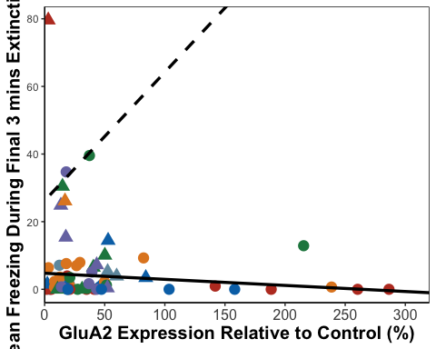

ILE3_A1

## Warning: Removed 24 rows containing missing values or values outside the scale range  
## (`geom_point()`).

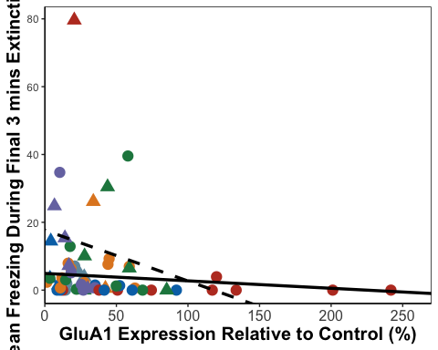

ILE3_N2B

## Warning: Removed 27 rows containing missing values or values outside the scale range  
## (`geom_point()`).

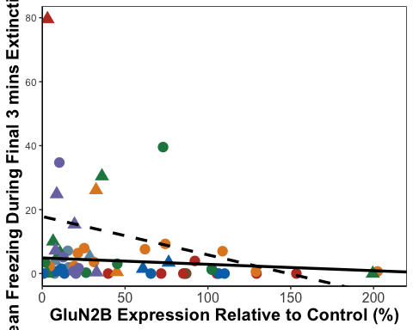

ILTF_A1<- ILData %>%   
 group_by(SEFL) %>%  
 cor_test(Average_Freezing_Last_3_mins_Extinction, ILGluA1, method="pearson")  
  
#resilient - r=-0.14, p=0.38  
#susceptible = r=-0.16, p=0.54  
  
ILTF_A2<- ILData %>%   
 group_by(SEFL) %>%  
 cor_test(Average_Freezing_Last_3_mins_Extinction, ILGluA2, method="pearson")  
  
#resilient - r=-0.16, p=0.30  
#susceptible = r=-0.45, p=0.07  
  
ILTF_N2B<- ILData %>%   
 group_by(SEFL) %>%  
 cor_test(Average_Freezing_Last_3_mins_Extinction, ILGluN2B, method="pearson")  
  
#resilient - r=-0.14, p=0.39  
#susceptible = r=-0.29, p=0.27  
  
ILResilientTF_A1 <- FisherZ(-0.14)  
ILSusceptibleTF_A1 <- FisherZ(-0.16)  
  
ILResilientTF_A2 <- FisherZ(-0.16)  
ILSusceptibleTF_A2 <- FisherZ(0.45)  
  
ILResilientTF_N2B <- FisherZ(-0.14)  
ILSusceptibleTF_N2B <- FisherZ(-0.29)  
  
#A1  
  
#n resilient = 44  
#n susceptible = 18  
  
N1 <- 1/(44-3)  
N2 <- 1/(18-3)  
  
N <- N1 + N2  
  
Z3_1 <- (ILResilientTF_A1 -ILSusceptibleTF_A1)  
  
ILZdiffTF_A1 <- Z3_1/sqrt(N)  
ILZdiffTF_A1

## [1] 0.06780675

# 0.067 not significant  
  
#A2  
  
N1a <- 1/(43-3)  
N2 <- 1/(18-3)  
  
Na <- N1a + N2  
  
Z3_2 <- (ILResilientTF_A2 -ILSusceptibleTF_A2)  
  
ILZdiffTF_A2 <- Z3_2/sqrt(Na)  
ILZdiffTF_A2

## [1] -2.133955

#-2.13 significant at p < 0.05  
  
#N2B  
  
#One lost from each group due to over exposure  
  
N3 <- 1/(43-3)  
N4 <- 1/(17-3)  
  
N5 <- N3 + N4  
  
Z3_3 <- (ILResilientTF_N2B -ILSusceptibleTF_N2B)  
  
ILZdiffTF_N2B <- Z3_3/sqrt(N5)  
ILZdiffTF_N2B

## [1] 0.5076512

# 0.51 not significant

ILResTGluN2B <- lm(Total_Freezing_During_Test ~ ILGluN2B, data = resilientIL)  
ILResTGluN2B

##   
## Call:  
## lm(formula = Total_Freezing_During_Test ~ ILGluN2B, data = resilientIL)  
##   
## Coefficients:  
## (Intercept) ILGluN2B   
## 2.68364 -0.01405

#y = -0.01405x + 2.68  
  
  
ILSusTGluN2B <- lm(Total_Freezing_During_Test~ ILGluN2B, data = susceptibleIL)  
ILSusTGluN2B

##   
## Call:  
## lm(formula = Total_Freezing_During_Test ~ ILGluN2B, data = susceptibleIL)  
##   
## Coefficients:  
## (Intercept) ILGluN2B   
## 21.4507 -0.0616

#y = -0.06 + 21.45  
  
  
ILResTGluA1 <- lm(Total_Freezing_During_Test ~ ILGluA1, data = resilientIL)  
ILResTGluA1

##   
## Call:  
## lm(formula = Total_Freezing_During_Test ~ ILGluA1, data = resilientIL)  
##   
## Coefficients:  
## (Intercept) ILGluA1   
## 2.83945 -0.01699

#y = -0.017 + 2.84  
  
ILSusTGluA1 <- lm(Total_Freezing_During_Test ~ ILGluA1, data = susceptibleIL)  
ILSusTGluA1

##   
## Call:  
## lm(formula = Total_Freezing_During_Test ~ ILGluA1, data = susceptibleIL)  
##   
## Coefficients:  
## (Intercept) ILGluA1   
## 29.9102 -0.3122

#y = -0.31 + 29.91  
  
ILResTGluA2 <- lm(Total_Freezing_During_Test ~ ILGluA2, data = resilientIL)  
ILResTGluA2

##   
## Call:  
## lm(formula = Total_Freezing_During_Test ~ ILGluA2, data = resilientIL)  
##   
## Coefficients:  
## (Intercept) ILGluA2   
## 2.280068 -0.003289

#y = -0.011 + 2.46  
  
ILSusTGluA2 <- lm(Total_Freezing_During_Test ~ ILGluA2, data = susceptibleIL)  
ILSusTGluA2

##   
## Call:  
## lm(formula = Total_Freezing_During_Test ~ ILGluA2, data = susceptibleIL)  
##   
## Coefficients:  
## (Intercept) ILGluA2   
## 11.8332 0.2789

#y = 0.28 + 11.83  
  
ILTest_A1 <- ggplot(ILData,  
 aes(x = ILGluA1,  
 y = Total_Freezing_During_Test, color = Shock, shape = SEFL)) +  
 geom_point(aes(color = Shock), size = 4) +  
 scale_fill_nejm() +  
 scale_color_nejm() +  
 theme(panel.grid.major = element_blank(), panel.grid.minor = element_blank(),  
 panel.background = element_rect(colour = "black", fill = "white"),   
 axis.line = element_line(colour = "black")) + theme(legend.title = element_blank()) +   
 geom_abline(intercept = 2.84, slope = -0.017, size = 1.2) +  
 geom_abline(intercept = 29.91, slope = -0.31, linetype = "dashed", size = 1.2) +  
 theme(legend.position="none") +  
 theme(axis.text.x=element_text(size = 12), axis.title =element_text(size=15,face="bold")) +  
 labs(x="GluA1 Expression Relative to Control (%)", y="Mean Freezing During Test (%)") +  
 scale_x_continuous(limits=c(0, 270), breaks = c(0,50,100,150,200,250), expand = c(0,0))  
  
ILTest_N2B <- ggplot(ILData,  
 aes(x = ILGluN2B,  
 y = Total_Freezing_During_Test, color = Shock, shape = SEFL)) +  
 geom_point(aes(color = Shock), size = 4) +  
 scale_fill_nejm() +  
 scale_color_nejm() +  
 theme(panel.grid.major = element_blank(), panel.grid.minor = element_blank(),  
 panel.background = element_rect(colour = "black", fill = "white"),   
 axis.line = element_line(colour = "black")) + theme(legend.title = element_blank()) +   
 geom_abline(intercept = 2.68, slope = -0.014, size = 1.2) +  
 geom_abline(intercept = 21.45, slope = -0.06, linetype = "dashed", size = 1.2) +  
 theme(legend.position="none") +  
 theme(axis.text.x=element_text(size = 12), axis.title =element_text(size=15,face="bold")) +  
 labs(x="GluN2B Expression Relative to Control (%)", y="Mean Freezing During Test (%)") +  
 scale_x_continuous(limits=c(0, 220), breaks = c(0,50,100,150,200), expand = c(0,0))  
  
ILTest_A2 <- ggplot(ILData,  
 aes(x = ILGluA2,  
 y = Total_Freezing_During_Test, color = Shock, shape = SEFL)) +  
 geom_point(aes(color = Shock), size = 4) +  
 scale_fill_nejm() +  
 scale_color_nejm() +  
 theme(panel.grid.major = element_blank(), panel.grid.minor = element_blank(),  
 panel.background = element_rect(colour = "black", fill = "white"),   
 axis.line = element_line(colour = "black")) + theme(legend.title = element_blank()) +   
 geom_abline(intercept = 2.46, slope = -0.011, size = 1.2) +  
 geom_abline(intercept = 11.83, slope = 0.28, linetype = "dashed", size = 1.2) +  
 theme(legend.position="none") +  
 theme(axis.text.x=element_text(size = 12), axis.title =element_text(size=15,face="bold")) +  
 labs(x="GluA2 Expression Relative to Control (%)", y="Mean Freezing During Test (%)") +  
 scale_x_continuous(limits=c(0, 320), breaks = c(0,50,100,150,200,250,300), expand = c(0,0))  
  
  
ILTest_A2

## Warning: Removed 25 rows containing missing values or values outside the scale range  
## (`geom_point()`).

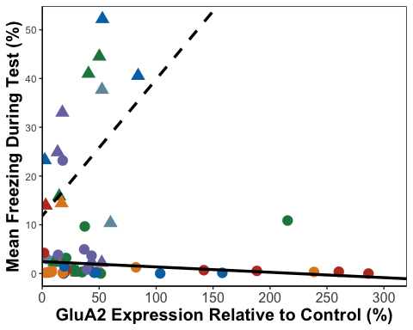

ILTest_A1

## Warning: Removed 24 rows containing missing values or values outside the scale range  
## (`geom_point()`).

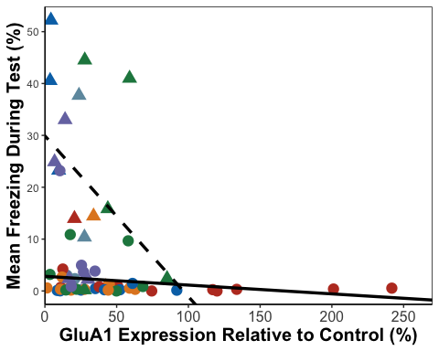

ILTest_N2B

## Warning: Removed 27 rows containing missing values or values outside the scale range  
## (`geom_point()`).

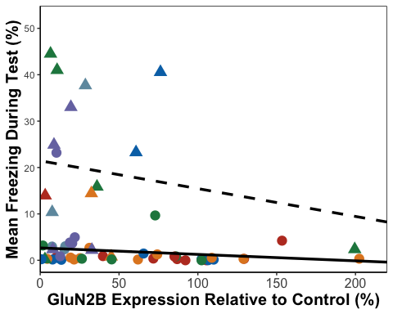

ILT_A1<- ILData %>%   
 group_by(SEFL) %>%  
 cor_test(Total_Freezing_During_Test, ILGluA1, method="pearson")  
  
#resilient - r=-0.21, p=0.18  
#susceptible = r=-0.38, p=0.14  
  
ILT_A2<- ILData %>%   
 group_by(SEFL) %>%  
 cor_test(Total_Freezing_During_Test, ILGluA2, method="pearson")  
  
#resilient - r=-0.14, p=0.23  
#susceptible = r=-0.17, p=0.14  
  
ILT_N2B<- ILData %>%   
 group_by(SEFL) %>%  
 cor_test(Total_Freezing_During_Test, ILGluN2B, method="pearson")  
  
#resilient - r=-0.20, p=0.20  
#susceptible = r=-0.19, p=0.49  
  
#no significance so we don't check for differences

ILResRGluN2B <- lm(Recovery_Index ~ ILGluN2B, data = resilientIL)  
ILResRGluN2B

##   
## Call:  
## lm(formula = Recovery_Index ~ ILGluN2B, data = resilientIL)  
##   
## Coefficients:  
## (Intercept) ILGluN2B   
## -4.42880 0.02696

#y = 0.03x - 4.43  
  
ILSusRGluN2B <- lm(Recovery_Index ~ ILGluN2B, data = susceptibleIL)  
ILSusRGluN2B

##   
## Call:  
## lm(formula = Recovery_Index ~ ILGluN2B, data = susceptibleIL)  
##   
## Coefficients:  
## (Intercept) ILGluN2B   
## 7.175856 -0.002846

#y = -0.003 + 7.18  
  
ILResRGluA1 <- lm(Recovery_Index ~ ILGluA1, data = resilientIL)  
ILResRGluA1

##   
## Call:  
## lm(formula = Recovery_Index ~ ILGluA1, data = resilientIL)  
##   
## Coefficients:  
## (Intercept) ILGluA1   
## -4.29252 0.03075

#y = 0.03x - 4.30  
  
ILSusRGluA1 <- lm(Recovery_Index ~ ILGluA1, data = susceptibleIL)  
ILSusRGluA1

##   
## Call:  
## lm(formula = Recovery_Index ~ ILGluA1, data = susceptibleIL)  
##   
## Coefficients:  
## (Intercept) ILGluA1   
## 6.61093 0.07966

#y = 0.08x + 6.61  
  
ILResRGluA2 <- lm(Recovery_Index ~ ILGluA2, data = resilientIL)  
ILResRGluA2

##   
## Call:  
## lm(formula = Recovery_Index ~ ILGluA2, data = resilientIL)  
##   
## Coefficients:  
## (Intercept) ILGluA2   
## -3.92285 0.01693

#y = 0.02x - 4.02  
  
ILSusRGluA2 <- lm(Recovery_Index ~ ILGluA2, data = susceptibleIL)  
ILSusRGluA2

##   
## Call:  
## lm(formula = Recovery_Index ~ ILGluA2, data = susceptibleIL)  
##   
## Coefficients:  
## (Intercept) ILGluA2   
## -9.1036 0.5366

#y = 0.54x - 9.1  
  
  
ILRec_A1 <- ggplot(ILData,  
 aes(x = ILGluA1,  
 y = Recovery_Index, color = Shock, shape = SEFL)) +  
 geom_point(aes(color = Shock), size = 4) +  
 scale_fill_nejm() +  
 scale_color_nejm() +  
 theme(panel.grid.major = element_blank(), panel.grid.minor = element_blank(),  
 panel.background = element_rect(colour = "black", fill = "white"),   
 axis.line = element_line(colour = "black")) + theme(legend.title = element_blank()) +   
 geom_abline(intercept = -4.30, slope = 0.03, size = 1.2) +  
 geom_abline(intercept = 6.61, slope = 0.08, linetype = "dashed", size = 1.2) +  
 theme(legend.position="none") +  
 theme(axis.text.x=element_text(size = 12), axis.title =element_text(size=15,face="bold")) +  
 labs(x="GluA1 Expression Relative to Control (%)", y="Recovery Index (%)") +  
 scale_x_continuous(limits=c(0, 270), breaks = c(0,50,100,150,200,250), expand = c(0,0))  
  
ILRec_N2B <- ggplot(ILData,  
 aes(x = ILGluN2B,  
 y = Recovery_Index, color = Shock, shape = SEFL)) +  
 geom_point(aes(color = Shock), size = 4) +  
 scale_fill_nejm() +  
 scale_color_nejm() +  
 theme(panel.grid.major = element_blank(), panel.grid.minor = element_blank(),  
 panel.background = element_rect(colour = "black", fill = "white"),   
 axis.line = element_line(colour = "black")) + theme(legend.title = element_blank()) +   
 geom_abline(intercept = -4.43, slope = 0.03, size = 1.2) +  
 geom_abline(intercept = 7.18, slope = -0.003, linetype = "dashed", size = 1.2) +  
 theme(legend.position="none") +  
 theme(axis.text.x=element_text(size = 12), axis.title =element_text(size=15,face="bold")) +  
 labs(x="GluN2B Expression Relative to Control (%)", y="Recovery Index (%)") +  
 scale_x_continuous(limits=c(0, 220), breaks = c(0,50,100,150,200), expand = c(0,0))  
  
ILRec_A2 <- ggplot(ILData,  
 aes(x = ILGluA2,  
 y = Recovery_Index, color = Shock, shape = SEFL)) +  
 geom_point(aes(color = Shock), size = 4) +  
 scale_fill_nejm() +  
 scale_color_nejm() +  
 theme(panel.grid.major = element_blank(), panel.grid.minor = element_blank(),  
 panel.background = element_rect(colour = "black", fill = "white"),   
 axis.line = element_line(colour = "black")) + theme(legend.title = element_blank()) +   
 geom_abline(intercept = -4.02, slope = 0.02, size = 1.2) +  
 geom_abline(intercept = -9.1, slope = 0.54, linetype = "dashed", size = 1.2) +  
 theme(legend.position="none") +  
 theme(axis.text.x=element_text(size = 12), axis.title =element_text(size=15,face="bold")) +  
 labs(x="GluA2 Expression Relative to Control (%)", y="Recovery Index (%)") +  
 scale_x_continuous(limits=c(0, 320), breaks = c(0,50,100,150,200,250,300), expand = c(0,0)) +  
 theme(legend.position="none")   
  
  
ILRec_A2

## Warning: Removed 25 rows containing missing values or values outside the scale range  
## (`geom_point()`).

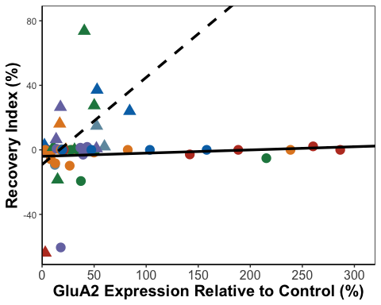

ILRec_A1

## Warning: Removed 24 rows containing missing values or values outside the scale range  
## (`geom_point()`).

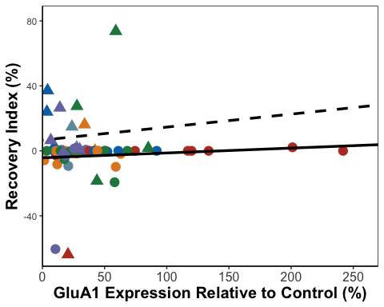

ILRec_N2B

## Warning: Removed 27 rows containing missing values or values outside the scale range  
## (`geom_point()`).

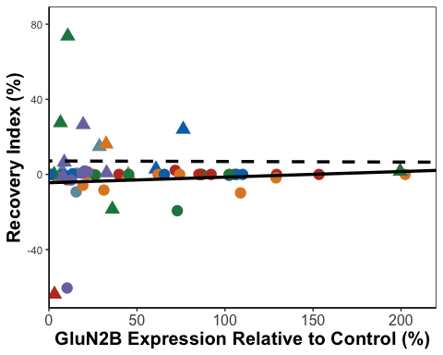

ILR_A1<- ILData %>%   
 group_by(SEFL) %>%  
 cor_test(Recovery_Index, ILGluA1, method="pearson")  
  
#resilient - r=0.16, p=0.31  
#susceptible = r=0.06, p=0.82  
  
ILR_A2<- ILData %>%   
 group_by(SEFL) %>%  
 cor_test(Recovery_Index, ILGluA2, method="pearson")  
  
#resilient - r=0.15, p=0.36  
#susceptible = r=0.45, p=0.07  
  
ILR_N2B<- ILData %>%   
 group_by(SEFL) %>%  
 cor_test(Recovery_Index, ILGluN2B, method="pearson")  
  
#resilient - r=0.15, p=0.34  
#susceptible = r=-0.005, p=0.99  
  
#no significance so we don't check for differences

ILcorGraph <- ggarrange(ILFF_N2B, ILFF_A1, ILFF_A2, ILE3_N2B, ILE3_A1, ILE3_A2, ILTest_N2B, ILTest_A1, ILTest_A2, ILRec_N2B, ILRec_A1, ILRec_A2,  
 labels = c("a", "", "","b", "", "","c", "", "","d", "", ""),  
 font.label = list(size = 24, face = "bold"),  
 ncol = 3, nrow = 4) +  
 theme(plot.margin = margin(0.1,1.5,0.1,1.5, "cm"))

## Warning: Removed 27 rows containing missing values or values outside the scale range  
## (`geom_point()`).

## Warning: Removed 24 rows containing missing values or values outside the scale range  
## (`geom_point()`).

## Warning: Removed 25 rows containing missing values or values outside the scale range  
## (`geom_point()`).

## Warning: Removed 27 rows containing missing values or values outside the scale range  
## (`geom_point()`).

## Warning: Removed 24 rows containing missing values or values outside the scale range  
## (`geom_point()`).

## Warning: Removed 25 rows containing missing values or values outside the scale range  
## (`geom_point()`).

## Warning: Removed 27 rows containing missing values or values outside the scale range  
## (`geom_point()`).

## Warning: Removed 24 rows containing missing values or values outside the scale range  
## (`geom_point()`).

## Warning: Removed 25 rows containing missing values or values outside the scale range  
## (`geom_point()`).

## Warning: Removed 27 rows containing missing values or values outside the scale range  
## (`geom_point()`).

## Warning: Removed 24 rows containing missing values or values outside the scale range  
## (`geom_point()`).

## Warning: Removed 25 rows containing missing values or values outside the scale range  
## (`geom_point()`).

ILcorGraph

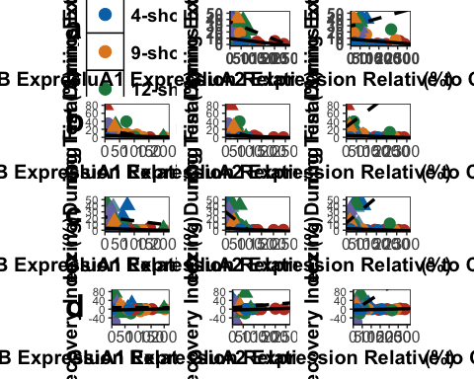

ggsave('ILcorGraph', ILcorGraph, width=25, height=36, units='in', device = "tiff", dpi = 300)

PL Analysis

PLGluN2BData <- select(AllData, c("Rat","SEFL","Shock", "PLGluN2B"))  
#remove outliers  
PLGluN2BData <- PLGluN2BData[-c(15,55), ]  
  
#first we visualise the data  
  
ggplot(PLGluN2BData,  
 aes( x = Shock, y = PLGluN2B)) +  
 geom_boxplot()

## Warning: Removed 10 rows containing non-finite outside the scale range  
## (`stat_boxplot()`).

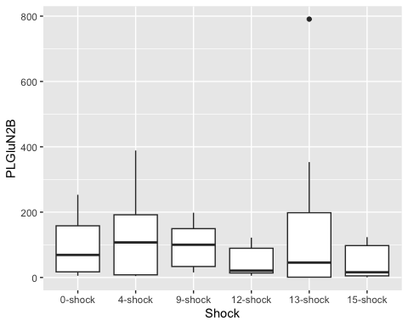

ggplot(PLGluN2BData,  
 aes( x = SEFL, y = PLGluN2B)) +  
 geom_boxplot()

## Warning: Removed 10 rows containing non-finite outside the scale range  
## (`stat_boxplot()`).

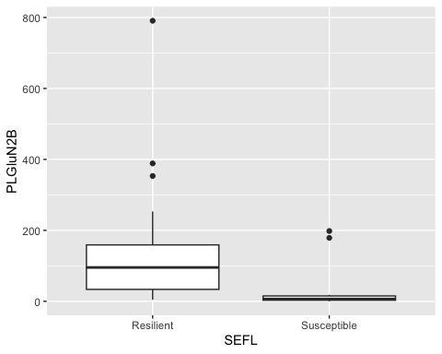

ggplot(PLGluN2BData,  
 aes( x = Shock, y = PLGluN2B, fill = SEFL)) +  
 geom_boxplot()

## Warning: Removed 10 rows containing non-finite outside the scale range  
## (`stat_boxplot()`).

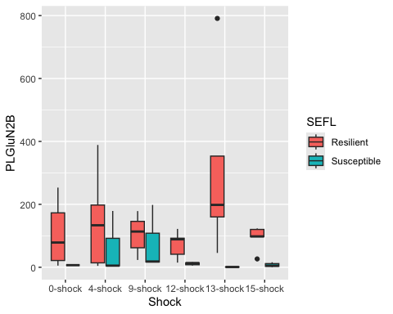

#Linear model for GluN2B data  
  
lm_PLGluN2B <- lm(PLGluN2B ~ Shock + SEFL + Shock:SEFL,  
 data = PLGluN2BData)  
  
#check assumptions  
  
resid_panel(lm_PLGluN2B,  
 plots = c("resid", "qq", "ls", "cookd"),  
 smoother = TRUE)

## Warning in sqrt((n - p - sr^2)/(n - p - 1)): NaNs produced

## `geom_smooth()` using formula = 'y ~ x'  
## `geom_smooth()` using formula = 'y ~ x'

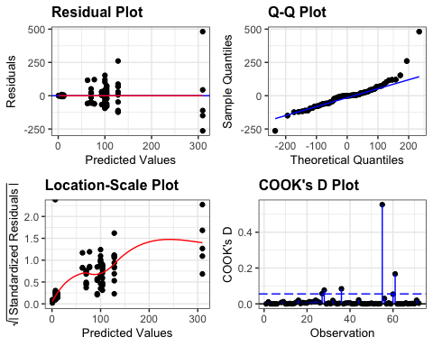

resid_PLGluN2B <- residuals(lm_PLGluN2B)  
  
shapiro.test(resid_PLGluN2B)

##   
## Shapiro-Wilk normality test  
##   
## data: resid_PLGluN2B  
## W = 0.85532, p-value = 7.449e-07

levene_test(PLGluN2BData, PLGluN2B ~ Shock * SEFL)

## # A tibble: 1 × 4  
## df1 df2 statistic p  
## <int> <int> <dbl> <dbl>  
## 1 11 60 2.45 0.0134

#data is not normal (shapiro test = significant)  
#but ANOVA is robust to these issues and we have homogeneity of variance  
  
anova(lm_PLGluN2B)

## Analysis of Variance Table  
##   
## Response: PLGluN2B  
## Df Sum Sq Mean Sq F value Pr(>F)   
## Shock 5 114153 22831 2.0984 0.0779635 .   
## SEFL 1 144184 144184 13.2520 0.0005686 ***  
## Shock:SEFL 5 117654 23531 2.1627 0.0701566 .   
## Residuals 60 652814 10880   
## ---  
## Signif. codes: 0 '***' 0.001 '**' 0.01 '*' 0.05 '.' 0.1 ' ' 1

#significant main effect of SEFL on GluN2B  
  
#effect sizes  
options(es.use_symbols = TRUE)   
  
eta_squared(lm_PLGluN2B, partial = FALSE)

## # Effect Size for ANOVA (Type I)  
##   
## Parameter | η² | 95% CI  
## --------------------------------  
## Shock | 0.11 | [0.00, 1.00]  
## SEFL | 0.14 | [0.03, 1.00]  
## Shock:SEFL | 0.11 | [0.00, 1.00]  
##   
## - One-sided CIs: upper bound fixed at [1.00].

#F(1,60) = 13.25, p<.001, eta2 = 0.14  
  
#we now do pairwise comparisons  
tukPLGluN2B <- tukey_hsd(lm_PLGluN2B)  
print(tukPLGluN2B, n=82)

## # A tibble: 82 × 9  
## term group1 group2 null.value estimate conf.low conf.high p.adj  
## * <chr> <chr> <chr> <dbl> <dbl> <dbl> <dbl> <dbl>  
## 1 Shock 0-shock 4-sho… 0 21.9 -98.9 143. 9.95e-1  
## 2 Shock 0-shock 9-sho… 0 5.94 -115. 127. 1 e+0  
## 3 Shock 0-shock 12-sh… 0 -46.4 -172. 79.0 8.84e-1  
## 4 Shock 0-shock 13-sh… 0 80.1 -55.3 216. 5.1 e-1  
## 5 Shock 0-shock 15-sh… 0 -46.0 -174. 82.2 8.96e-1  
## 6 Shock 4-shock 9-sho… 0 -16.0 -132. 100. 9.99e-1  
## 7 Shock 4-shock 12-sh… 0 -68.4 -189. 52.4 5.59e-1  
## 8 Shock 4-shock 13-sh… 0 58.2 -73.0 189. 7.81e-1  
## 9 Shock 4-shock 15-sh… 0 -68.0 -192. 55.8 5.91e-1  
## 10 Shock 9-shock 12-sh… 0 -52.3 -173. 68.4 7.97e-1  
## 11 Shock 9-shock 13-sh… 0 74.2 -57.0 205. 5.6 e-1  
## 12 Shock 9-shock 15-sh… 0 -52.0 -176. 71.8 8.17e-1  
## 13 Shock 12-shock 13-sh… 0 127. -8.85 262. 8 e-2  
## 14 Shock 12-shock 15-sh… 0 0.388 -128. 129. 1 e+0  
## 15 Shock 13-shock 15-sh… 0 -126. -264. 11.8 9.21e-2  
## 16 SEFL Resilient Susce… 0 -91.3 -145. -37.9 1.13e-3  
## 17 Shock:SEFL 0-shock:Res… 4-sho… 0 28.2 -123. 179. 1 e+0  
## 18 Shock:SEFL 0-shock:Res… 9-sho… 0 3.86 -147. 155. 1 e+0  
## 19 Shock:SEFL 0-shock:Res… 12-sh… 0 -29.6 -201. 142. 1 e+0  
## 20 Shock:SEFL 0-shock:Res… 13-sh… 0 210. 18.3 401. 2.02e-2  
## 21 Shock:SEFL 0-shock:Res… 15-sh… 0 -6.91 -198. 184. 1 e+0  
## 22 Shock:SEFL 0-shock:Res… 0-sho… 0 -93.3 -464. 277. 9.99e-1  
## 23 Shock:SEFL 0-shock:Res… 4-sho… 0 -37.3 -268. 194. 1 e+0  
## 24 Shock:SEFL 0-shock:Res… 9-sho… 0 -22.7 -254. 208. 1 e+0  
## 25 Shock:SEFL 0-shock:Res… 12-sh… 0 -88.6 -280. 103. 9.11e-1  
## 26 Shock:SEFL 0-shock:Res… 13-sh… 0 -99.1 -306. 108. 8.92e-1  
## 27 Shock:SEFL 0-shock:Res… 15-sh… 0 -92.9 -273. 87.1 8.35e-1  
## 28 Shock:SEFL 4-shock:Res… 9-sho… 0 -24.3 -176. 127. 1 e+0  
## 29 Shock:SEFL 4-shock:Res… 12-sh… 0 -57.8 -229. 114. 9.91e-1  
## 30 Shock:SEFL 4-shock:Res… 13-sh… 0 181. -9.90 373. 7.87e-2  
## 31 Shock:SEFL 4-shock:Res… 15-sh… 0 -35.1 -226. 156. 1 e+0  
## 32 Shock:SEFL 4-shock:Res… 0-sho… 0 -122. -492. 249. 9.93e-1  
## 33 Shock:SEFL 4-shock:Res… 4-sho… 0 -65.4 -296. 166. 9.98e-1  
## 34 Shock:SEFL 4-shock:Res… 9-sho… 0 -50.9 -282. 180. 1 e+0  
## 35 Shock:SEFL 4-shock:Res… 12-sh… 0 -117. -308. 74.5 6.41e-1  
## 36 Shock:SEFL 4-shock:Res… 13-sh… 0 -127. -334. 79.8 6.31e-1  
## 37 Shock:SEFL 4-shock:Res… 15-sh… 0 -121. -301. 58.9 4.97e-1  
## 38 Shock:SEFL 9-shock:Res… 12-sh… 0 -33.4 -205. 138. 1 e+0  
## 39 Shock:SEFL 9-shock:Res… 13-sh… 0 206. 14.4 397. 2.46e-2  
## 40 Shock:SEFL 9-shock:Res… 15-sh… 0 -10.8 -202. 181. 1 e+0  
## 41 Shock:SEFL 9-shock:Res… 0-sho… 0 -97.2 -468. 273. 9.99e-1  
## 42 Shock:SEFL 9-shock:Res… 4-sho… 0 -41.1 -272. 190. 1 e+0  
## 43 Shock:SEFL 9-shock:Res… 9-sho… 0 -26.6 -258. 204. 1 e+0  
## 44 Shock:SEFL 9-shock:Res… 12-sh… 0 -92.5 -284. 98.8 8.85e-1  
## 45 Shock:SEFL 9-shock:Res… 13-sh… 0 -103. -310. 104. 8.65e-1  
## 46 Shock:SEFL 9-shock:Res… 15-sh… 0 -96.7 -277. 83.3 7.97e-1  
## 47 Shock:SEFL 12-shock:Re… 13-sh… 0 239. 31.5 447. 1.15e-2  
## 48 Shock:SEFL 12-shock:Re… 15-sh… 0 22.7 -185. 230. 1 e+0  
## 49 Shock:SEFL 12-shock:Re… 0-sho… 0 -63.8 -443. 315. 1 e+0  
## 50 Shock:SEFL 12-shock:Re… 4-sho… 0 -7.66 -252. 237. 1 e+0  
## 51 Shock:SEFL 12-shock:Re… 9-sho… 0 6.89 -238. 252. 1 e+0  
## 52 Shock:SEFL 12-shock:Re… 12-sh… 0 -59.0 -267. 149. 9.98e-1  
## 53 Shock:SEFL 12-shock:Re… 13-sh… 0 -69.5 -292. 153. 9.95e-1  
## 54 Shock:SEFL 12-shock:Re… 15-sh… 0 -63.3 -261. 134. 9.94e-1  
## 55 Shock:SEFL 13-shock:Re… 15-sh… 0 -216. -441. 7.82 6.81e-2  
## 56 Shock:SEFL 13-shock:Re… 0-sho… 0 -303. -691. 85.6 2.76e-1  
## 57 Shock:SEFL 13-shock:Re… 4-sho… 0 -247. -506. 12.2 7.56e-2  
## 58 Shock:SEFL 13-shock:Re… 9-sho… 0 -232. -491. 26.7 1.2 e-1  
## 59 Shock:SEFL 13-shock:Re… 12-sh… 0 -298. -522. -73.9 1.64e-3  
## 60 Shock:SEFL 13-shock:Re… 13-sh… 0 -309. -547. -70.8 2.36e-3  
## 61 Shock:SEFL 13-shock:Re… 15-sh… 0 -302. -517. -87.7 6.53e-4  
## 62 Shock:SEFL 15-shock:Re… 0-sho… 0 -86.4 -475. 302. 1 e+0  
## 63 Shock:SEFL 15-shock:Re… 4-sho… 0 -30.3 -289. 229. 1 e+0  
## 64 Shock:SEFL 15-shock:Re… 9-sho… 0 -15.8 -275. 243. 1 e+0  
## 65 Shock:SEFL 15-shock:Re… 12-sh… 0 -81.7 -306. 143. 9.83e-1  
## 66 Shock:SEFL 15-shock:Re… 13-sh… 0 -92.2 -330. 146. 9.73e-1  
## 67 Shock:SEFL 15-shock:Re… 15-sh… 0 -86.0 -301. 129. 9.67e-1  
## 68 Shock:SEFL 0-shock:Sus… 4-sho… 0 56.1 -353. 466. 1 e+0  
## 69 Shock:SEFL 0-shock:Sus… 9-sho… 0 70.6 -339. 480. 1 e+0  
## 70 Shock:SEFL 0-shock:Sus… 12-sh… 0 4.73 -384. 393. 1 e+0  
## 71 Shock:SEFL 0-shock:Sus… 13-sh… 0 -5.79 -402. 391. 1 e+0  
## 72 Shock:SEFL 0-shock:Sus… 15-sh… 0 0.485 -383. 384. 1 e+0  
## 73 Shock:SEFL 4-shock:Sus… 9-sho… 0 14.5 -275. 304. 1 e+0  
## 74 Shock:SEFL 4-shock:Sus… 12-sh… 0 -51.4 -310. 208. 1 e+0  
## 75 Shock:SEFL 4-shock:Sus… 13-sh… 0 -61.9 -333. 209. 1 e+0  
## 76 Shock:SEFL 4-shock:Sus… 15-sh… 0 -55.6 -306. 195. 1 e+0  
## 77 Shock:SEFL 9-shock:Sus… 12-sh… 0 -65.9 -325. 193. 9.99e-1  
## 78 Shock:SEFL 9-shock:Sus… 13-sh… 0 -76.4 -347. 194. 9.98e-1  
## 79 Shock:SEFL 9-shock:Sus… 15-sh… 0 -70.2 -321. 181. 9.98e-1  
## 80 Shock:SEFL 12-shock:Su… 13-sh… 0 -10.5 -248. 227. 1 e+0  
## 81 Shock:SEFL 12-shock:Su… 15-sh… 0 -4.25 -219. 211. 1 e+0  
## 82 Shock:SEFL 13-shock:Su… 15-sh… 0 6.27 -223. 235. 1 e+0  
## # ℹ 1 more variable: p.adj.signif <chr>

#significant difference between 13 shock resilient and susceptible p < 0.01  
  
PLsummaryGluN2B <- PLGluN2BData %>%  
 group_by(Shock, SEFL) %>%  
 get_summary_stats(type = "common")

## Warning: There was 1 warning in `mutate()`.  
## ℹ In argument: `ci = abs(stats::qt(alpha/2, .data$n - 1) * .data$se)`.  
## Caused by warning:  
## ! There was 1 warning in `mutate()`.  
## ℹ In argument: `ci = abs(stats::qt(alpha/2, .data$n - 1) * .data$se)`.  
## Caused by warning in `stats::qt()`:  
## ! NaNs produced

#first we visualise the data  
  
PLGluA1Data <- select(AllData, c("Rat","SEFL","Shock", "PLGluA1"))  
#remove otulier  
PLGluA1Data <- PLGluA1Data[-c(38), ]  
  
ggplot(PLGluA1Data,  
 aes( x = Shock, y = PLGluA1)) +  
 geom_boxplot()

## Warning: Removed 10 rows containing non-finite outside the scale range  
## (`stat_boxplot()`).

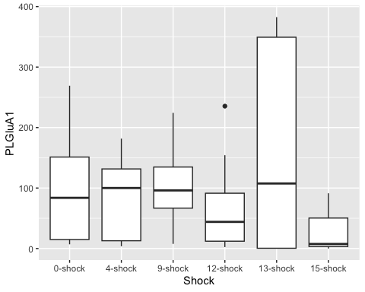

ggplot(PLGluA1Data,  
 aes( x = SEFL, y = PLGluA1)) +  
 geom_boxplot()

## Warning: Removed 10 rows containing non-finite outside the scale range  
## (`stat_boxplot()`).

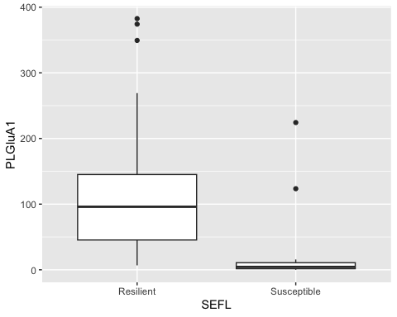

ggplot(PLGluA1Data,  
 aes( x = Shock, y = PLGluA1, fill = SEFL)) +  
 geom_boxplot()

## Warning: Removed 10 rows containing non-finite outside the scale range  
## (`stat_boxplot()`).

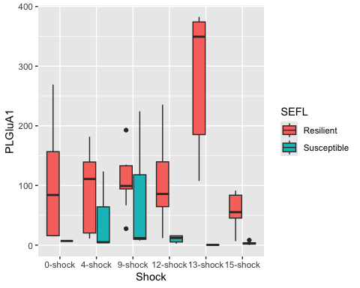

#Linear model for GluA1 data  
  
lm_PLGluA1 <- lm(PLGluA1 ~ Shock + SEFL + Shock:SEFL,  
 data = PLGluA1Data)  
  
#check assumptions  
  
resid_panel(lm_PLGluA1,  
 plots = c("resid", "qq", "ls", "cookd"),  
 smoother = TRUE)

## Warning in sqrt((n - p - sr^2)/(n - p - 1)): NaNs produced

## `geom_smooth()` using formula = 'y ~ x'  
## `geom_smooth()` using formula = 'y ~ x'

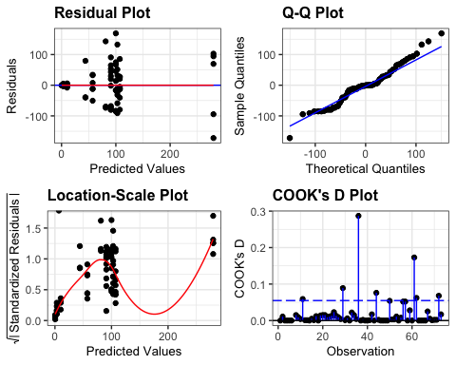

resid_PLGluA1 <- residuals(lm_PLGluA1)  
  
shapiro.test(resid_PLGluA1)

##   
## Shapiro-Wilk normality test  
##   
## data: resid_PLGluA1  
## W = 0.9729, p-value = 0.1171

levene_test(PLGluA1Data, PLGluA1 ~ Shock * SEFL)

## # A tibble: 1 × 4  
## df1 df2 statistic p  
## <int> <int> <dbl> <dbl>  
## 1 11 61 1.94 0.0508

#data is normaland we have homogeneity of variance  
  
anova(lm_PLGluA1)

## Analysis of Variance Table  
##   
## Response: PLGluA1  
## Df Sum Sq Mean Sq F value Pr(>F)   
## Shock 5 89247 17849 3.9994 0.003337 **   
## SEFL 1 126259 126259 28.2900 1.572e-06 ***  
## Shock:SEFL 5 97015 19403 4.3475 0.001894 **   
## Residuals 61 272245 4463   
## ---  
## Signif. codes: 0 '***' 0.001 '**' 0.01 '*' 0.05 '.' 0.1 ' ' 1

eta_squared(lm_PLGluA1, partial = FALSE)

## # Effect Size for ANOVA (Type I)  
##   
## Parameter | η² | 95% CI  
## --------------------------------  
## Shock | 0.15 | [0.00, 1.00]  
## SEFL | 0.22 | [0.08, 1.00]  
## Shock:SEFL | 0.17 | [0.00, 1.00]  
##   
## - One-sided CIs: upper bound fixed at [1.00].

#Shock F(5,61) = 4.00, p<0.01, eta2 = 0.15  
#SEFL F(1,61) = 28.29, p<0.0001, eta2 = 0.22  
#Shock:SEFL F(5,61) = 4.35, p<0.01, eta2 = 0.17  
  
tukPLA1 <- tukey_hsd(lm_PLGluA1)  
print(tukPLA1, n=82)

## # A tibble: 82 × 9  
## term group1 group2 null.value estimate conf.low conf.high p.adj  
## * <chr> <chr> <chr> <dbl> <dbl> <dbl> <dbl> <dbl>  
## 1 Shock 0-shock 4-sho… 0 -11.4 -88.8 65.9 9.98e-1  
## 2 Shock 0-shock 9-sho… 0 9.01 -69.7 87.7 9.99e-1  
## 3 Shock 0-shock 12-sh… 0 -25.0 -104. 53.7 9.36e-1  
## 4 Shock 0-shock 13-sh… 0 63.4 -23.3 150. 2.76e-1  
## 5 Shock 0-shock 15-sh… 0 -62.0 -142. 18.3 2.21e-1  
## 6 Shock 4-shock 9-sho… 0 20.4 -55.3 96.2 9.67e-1  
## 7 Shock 4-shock 12-sh… 0 -13.6 -89.3 62.1 9.95e-1  
## 8 Shock 4-shock 13-sh… 0 74.8 -9.17 159. 1.08e-1  
## 9 Shock 4-shock 15-sh… 0 -50.5 -128. 26.8 3.98e-1  
## 10 Shock 9-shock 12-sh… 0 -34.0 -111. 43.1 7.85e-1  
## 11 Shock 9-shock 13-sh… 0 54.4 -30.9 140. 4.26e-1  
## 12 Shock 9-shock 15-sh… 0 -71.0 -150. 7.69 9.98e-2  
## 13 Shock 12-shock 13-sh… 0 88.4 3.15 174. 3.78e-2  
## 14 Shock 12-shock 15-sh… 0 -37.0 -116. 41.7 7.37e-1  
## 15 Shock 13-shock 15-sh… 0 -125. -212. -38.7 9.93e-4  
## 16 SEFL Resilient Susce… 0 -86.1 -120. -52.1 4.20e-6  
## 17 Shock:SEFL 0-shock:Res… 4-sho… 0 -9.15 -106. 87.6 1 e+0  
## 18 Shock:SEFL 0-shock:Res… 9-sho… 0 7.27 -91.9 106. 1 e+0  
## 19 Shock:SEFL 0-shock:Res… 12-sh… 0 2.88 -103. 108. 1 e+0  
## 20 Shock:SEFL 0-shock:Res… 13-sh… 0 180. 57.3 302. 3.13e-4  
## 21 Shock:SEFL 0-shock:Res… 15-sh… 0 -42.7 -158. 72.5 9.81e-1  
## 22 Shock:SEFL 0-shock:Res… 0-sho… 0 -93.1 -330. 144. 9.71e-1  
## 23 Shock:SEFL 0-shock:Res… 4-sho… 0 -56.0 -204. 91.9 9.78e-1  
## 24 Shock:SEFL 0-shock:Res… 9-sho… 0 -18.8 -167. 129. 1 e+0  
## 25 Shock:SEFL 0-shock:Res… 12-sh… 0 -89.8 -212. 32.6 3.64e-1  
## 26 Shock:SEFL 0-shock:Res… 13-sh… 0 -99.6 -232. 33.0 3.29e-1  
## 27 Shock:SEFL 0-shock:Res… 15-sh… 0 -96.8 -212. 18.5 1.84e-1  
## 28 Shock:SEFL 4-shock:Res… 9-sho… 0 16.4 -82.8 116. 1 e+0  
## 29 Shock:SEFL 4-shock:Res… 12-sh… 0 12.0 -93.5 118. 1 e+0  
## 30 Shock:SEFL 4-shock:Res… 13-sh… 0 189. 66.5 311. 1.25e-4  
## 31 Shock:SEFL 4-shock:Res… 15-sh… 0 -33.6 -149. 81.6 9.97e-1  
## 32 Shock:SEFL 4-shock:Res… 0-sho… 0 -83.9 -321. 153. 9.87e-1  
## 33 Shock:SEFL 4-shock:Res… 4-sho… 0 -46.8 -195. 101. 9.95e-1  
## 34 Shock:SEFL 4-shock:Res… 9-sho… 0 -9.63 -157. 138. 1 e+0  
## 35 Shock:SEFL 4-shock:Res… 12-sh… 0 -80.6 -203. 41.8 5.3 e-1  
## 36 Shock:SEFL 4-shock:Res… 13-sh… 0 -90.4 -223. 42.1 4.76e-1  
## 37 Shock:SEFL 4-shock:Res… 15-sh… 0 -87.6 -203. 27.6 3.11e-1  
## 38 Shock:SEFL 9-shock:Res… 12-sh… 0 -4.39 -112. 103. 1 e+0  
## 39 Shock:SEFL 9-shock:Res… 13-sh… 0 173. 48.2 297. 8.26e-4  
## 40 Shock:SEFL 9-shock:Res… 15-sh… 0 -50.0 -167. 67.2 9.48e-1  
## 41 Shock:SEFL 9-shock:Res… 0-sho… 0 -100. -338. 138. 9.52e-1  
## 42 Shock:SEFL 9-shock:Res… 4-sho… 0 -63.3 -213. 86.2 9.51e-1  
## 43 Shock:SEFL 9-shock:Res… 9-sho… 0 -26.0 -175. 123. 1 e+0  
## 44 Shock:SEFL 9-shock:Res… 12-sh… 0 -97.1 -221. 27.3 2.75e-1  
## 45 Shock:SEFL 9-shock:Res… 13-sh… 0 -107. -241. 27.5 2.5 e-1  
## 46 Shock:SEFL 9-shock:Res… 15-sh… 0 -104. -221. 13.2 1.29e-1  
## 47 Shock:SEFL 12-shock:Re… 13-sh… 0 177. 47.5 306. 1.05e-3  
## 48 Shock:SEFL 12-shock:Re… 15-sh… 0 -45.6 -168. 77.0 9.81e-1  
## 49 Shock:SEFL 12-shock:Re… 0-sho… 0 -95.9 -337. 145. 9.68e-1  
## 50 Shock:SEFL 12-shock:Re… 4-sho… 0 -58.9 -213. 94.8 9.76e-1  
## 51 Shock:SEFL 12-shock:Re… 9-sho… 0 -21.7 -175. 132. 1 e+0  
## 52 Shock:SEFL 12-shock:Re… 12-sh… 0 -92.7 -222. 36.7 4.01e-1  
## 53 Shock:SEFL 12-shock:Re… 13-sh… 0 -102. -241. 36.6 3.57e-1  
## 54 Shock:SEFL 12-shock:Re… 15-sh… 0 -99.6 -222. 23.0 2.23e-1  
## 55 Shock:SEFL 13-shock:Re… 15-sh… 0 -222. -360. -85.0 4.84e-5  
## 56 Shock:SEFL 13-shock:Re… 0-sho… 0 -273. -522. -24.2 1.99e-2  
## 57 Shock:SEFL 13-shock:Re… 4-sho… 0 -236. -402. -70.0 5.47e-4  
## 58 Shock:SEFL 13-shock:Re… 9-sho… 0 -199. -364. -32.8 7.03e-3  
## 59 Shock:SEFL 13-shock:Re… 12-sh… 0 -270. -413. -126. 1.69e-6  
## 60 Shock:SEFL 13-shock:Re… 13-sh… 0 -279. -432. -127. 2.98e-6  
## 61 Shock:SEFL 13-shock:Re… 15-sh… 0 -277. -414. -139. 2.84e-7  
## 62 Shock:SEFL 15-shock:Re… 0-sho… 0 -50.3 -296. 195. 1 e+0  
## 63 Shock:SEFL 15-shock:Re… 4-sho… 0 -13.3 -174. 147. 1 e+0  
## 64 Shock:SEFL 15-shock:Re… 9-sho… 0 23.9 -137. 184. 1 e+0  
## 65 Shock:SEFL 15-shock:Re… 12-sh… 0 -47.1 -185. 90.4 9.9 e-1  
## 66 Shock:SEFL 15-shock:Re… 13-sh… 0 -56.9 -203. 89.7 9.73e-1  
## 67 Shock:SEFL 15-shock:Re… 15-sh… 0 -54.0 -185. 77.0 9.59e-1  
## 68 Shock:SEFL 0-shock:Sus… 4-sho… 0 37.1 -225. 299. 1 e+0  
## 69 Shock:SEFL 0-shock:Sus… 9-sho… 0 74.3 -188. 336. 9.98e-1  
## 70 Shock:SEFL 0-shock:Sus… 12-sh… 0 3.26 -245. 252. 1 e+0  
## 71 Shock:SEFL 0-shock:Sus… 13-sh… 0 -6.51 -260. 247. 1 e+0  
## 72 Shock:SEFL 0-shock:Sus… 15-sh… 0 -3.69 -249. 241. 1 e+0  
## 73 Shock:SEFL 4-shock:Sus… 9-sho… 0 37.2 -148. 223. 1 e+0  
## 74 Shock:SEFL 4-shock:Sus… 12-sh… 0 -33.8 -200. 132. 1 e+0  
## 75 Shock:SEFL 4-shock:Sus… 13-sh… 0 -43.6 -217. 130. 9.99e-1  
## 76 Shock:SEFL 4-shock:Sus… 15-sh… 0 -40.8 -201. 120. 9.99e-1  
## 77 Shock:SEFL 9-shock:Sus… 12-sh… 0 -71.0 -237. 94.8 9.47e-1  
## 78 Shock:SEFL 9-shock:Sus… 13-sh… 0 -80.8 -254. 92.6 9.08e-1  
## 79 Shock:SEFL 9-shock:Sus… 15-sh… 0 -78.0 -238. 82.5 8.83e-1  
## 80 Shock:SEFL 12-shock:Su… 13-sh… 0 -9.78 -162. 142. 1 e+0  
## 81 Shock:SEFL 12-shock:Su… 15-sh… 0 -6.96 -144. 130. 1 e+0  
## 82 Shock:SEFL 13-shock:Su… 15-sh… 0 2.82 -144. 149. 1 e+0  
## # ℹ 1 more variable: p.adj.signif <chr>

#Shock  
#12 and 13 p.adj<0.05  
#13 and 15 p.adj<0.001  
  
#Shock:SEFL  
#0-shock resilient - 13-shock susceptible p.adj<0.001  
#4-shock resilient - 13-shock susceptible p.adj<0.001  
#9-shock resilient - 13-shock susceptible p.adj<0.001  
#12-shock resilient - 13-shock susceptible p.adj<0.01  
  
#13-shock resilient - 15-shock susceptible p.adj<0.0001  
  
#SEFL  
#13 shock resilient versus susceptible  
  
PLsummaryGluA1 <- PLGluA1Data %>%  
 group_by(Shock, SEFL) %>%  
 get_summary_stats(type = "common")

## Warning: There was 1 warning in `mutate()`.  
## ℹ In argument: `ci = abs(stats::qt(alpha/2, .data$n - 1) * .data$se)`.  
## Caused by warning:  
## ! There was 1 warning in `mutate()`.  
## ℹ In argument: `ci = abs(stats::qt(alpha/2, .data$n - 1) * .data$se)`.  
## Caused by warning in `stats::qt()`:  
## ! NaNs produced

PLGluA2Data <- select(AllData, c("Rat","SEFL","Shock", "PLGluA2"))  
  
#first we visualise the data  
ggplot(PLGluA2Data,  
 aes( x = Shock, y = PLGluA2)) +  
 geom_boxplot()

## Warning: Removed 10 rows containing non-finite outside the scale range  
## (`stat_boxplot()`).

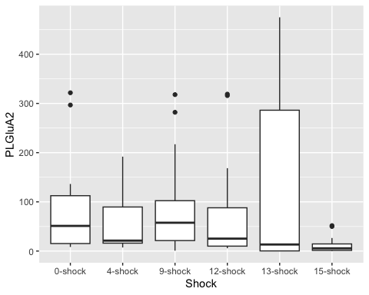

ggplot(PLGluA2Data,  
 aes( x = SEFL, y = PLGluA2)) +  
 geom_boxplot()

## Warning: Removed 10 rows containing non-finite outside the scale range  
## (`stat_boxplot()`).

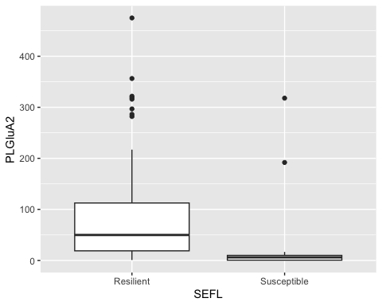

ggplot(PLGluA2Data,  
 aes( x = Shock, y = PLGluA2, fill = SEFL)) +  
 geom_boxplot()

## Warning: Removed 10 rows containing non-finite outside the scale range  
## (`stat_boxplot()`).

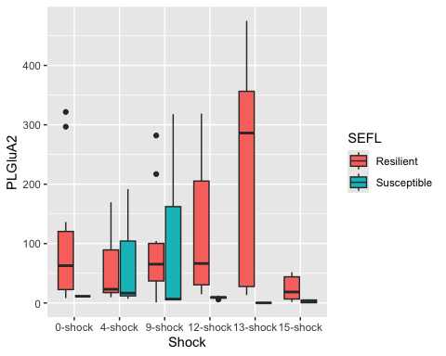

#Linear model for GluN2B data  
  
lm_PLGluA2 <- lm(PLGluA2 ~ Shock + SEFL + Shock:SEFL,  
 data = PLGluA2Data)  
  
#check assumptions  
  
resid_panel(lm_PLGluA2,  
 plots = c("resid", "qq", "ls", "cookd"),  
 smoother = TRUE)

## Warning in sqrt((n - p - sr^2)/(n - p - 1)): NaNs produced

## `geom_smooth()` using formula = 'y ~ x'  
## `geom_smooth()` using formula = 'y ~ x'

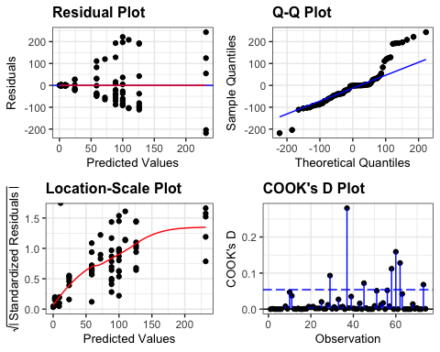

resid_PLGluA2 <- residuals(lm_PLGluA2)  
  
shapiro.test(resid_PLGluA2)

##   
## Shapiro-Wilk normality test  
##   
## data: resid_PLGluA2  
## W = 0.9101, p-value = 6.385e-05

levene_test(PLGluA2Data, PLGluA2 ~ Shock * SEFL)

## # A tibble: 1 × 4  
## df1 df2 statistic p  
## <int> <int> <dbl> <dbl>  
## 1 11 62 2.13 0.0307

#data is not normal (shapiro test = significant)  
#but ANOVA is robust to these issues and we have homogeneity of variance  
  
anova(lm_PLGluA2)

## Analysis of Variance Table  
##   
## Response: PLGluA2  
## Df Sum Sq Mean Sq F value Pr(>F)   
## Shock 5 82755 16551 1.7090 0.14582   
## SEFL 1 63404 63404 6.5467 0.01296 *  
## Shock:SEFL 5 107829 21566 2.2268 0.06268 .  
## Residuals 62 600464 9685   
## ---  
## Signif. codes: 0 '***' 0.001 '**' 0.01 '*' 0.05 '.' 0.1 ' ' 1

eta_squared(lm_PLGluA2, partial = FALSE)

## # Effect Size for ANOVA (Type I)  
##   
## Parameter | η² | 95% CI  
## --------------------------------  
## Shock | 0.10 | [0.00, 1.00]  
## SEFL | 0.07 | [0.00, 1.00]  
## Shock:SEFL | 0.13 | [0.00, 1.00]  
##   
## - One-sided CIs: upper bound fixed at [1.00].

#SEFL F(1,62) = 6.55, p<0.05, eta2 = 0.07  
  
tukPLA2 <- tukey_hsd(lm_PLGluA2)  
print(tukPLA2, n=82) #13 shock resilient versus susceptible p.adj<0.05

## # A tibble: 82 × 9  
## term group1 group2 null.value estimate conf.low conf.high p.adj  
## * <chr> <chr> <chr> <dbl> <dbl> <dbl> <dbl> <dbl>  
## 1 Shock 0-shock 4-sho… 0 -31.1 -145. 82.7 0.966   
## 2 Shock 0-shock 9-sho… 0 0.582 -113. 114. 1   
## 3 Shock 0-shock 12-sh… 0 -11.5 -127. 104. 1   
## 4 Shock 0-shock 13-sh… 0 36.2 -91.4 164. 0.96   
## 5 Shock 0-shock 15-sh… 0 -79.1 -197. 39.0 0.371   
## 6 Shock 4-shock 9-sho… 0 31.7 -77.7 141. 0.956   
## 7 Shock 4-shock 12-sh… 0 19.6 -91.9 131. 0.995   
## 8 Shock 4-shock 13-sh… 0 67.3 -56.3 191. 0.601   
## 9 Shock 4-shock 15-sh… 0 -48.0 -162. 65.8 0.815   
## 10 Shock 9-shock 12-sh… 0 -12.1 -124. 99.4 1   
## 11 Shock 9-shock 13-sh… 0 35.6 -88.0 159. 0.957   
## 12 Shock 9-shock 15-sh… 0 -79.7 -194. 34.1 0.322   
## 13 Shock 12-shock 13-sh… 0 47.7 -77.8 173. 0.872   
## 14 Shock 12-shock 15-sh… 0 -67.6 -183. 48.2 0.526   
## 15 Shock 13-shock 15-sh… 0 -115. -243. 12.3 0.0987  
## 16 SEFL Resilient Susce… 0 -60.8 -111. -10.8 0.0181  
## 17 Shock:SEFL 0-shock:Resi… 4-sho… 0 -41.3 -184. 101. 0.998   
## 18 Shock:SEFL 0-shock:Resi… 9-sho… 0 -11.3 -154. 131. 1   
## 19 Shock:SEFL 0-shock:Resi… 12-sh… 0 26.1 -129. 181. 1   
## 20 Shock:SEFL 0-shock:Resi… 13-sh… 0 132. -48.5 312. 0.37   
## 21 Shock:SEFL 0-shock:Resi… 15-sh… 0 -75.7 -245. 93.9 0.93   
## 22 Shock:SEFL 0-shock:Resi… 0-sho… 0 -88.7 -438. 260. 0.999   
## 23 Shock:SEFL 0-shock:Resi… 4-sho… 0 -28.1 -246. 190. 1   
## 24 Shock:SEFL 0-shock:Resi… 9-sho… 0 9.57 -208. 227. 1   
## 25 Shock:SEFL 0-shock:Resi… 12-sh… 0 -90.8 -271. 89.4 0.856   
## 26 Shock:SEFL 0-shock:Resi… 13-sh… 0 -99.8 -295. 95.3 0.844   
## 27 Shock:SEFL 0-shock:Resi… 15-sh… 0 -97.3 -267. 72.3 0.725   
## 28 Shock:SEFL 4-shock:Resi… 9-sho… 0 30.1 -112. 173. 1   
## 29 Shock:SEFL 4-shock:Resi… 12-sh… 0 67.4 -87.9 223. 0.942   
## 30 Shock:SEFL 4-shock:Resi… 13-sh… 0 173. -7.16 353. 0.071   
## 31 Shock:SEFL 4-shock:Resi… 15-sh… 0 -34.4 -204. 135. 1   
## 32 Shock:SEFL 4-shock:Resi… 0-sho… 0 -47.4 -396. 302. 1   
## 33 Shock:SEFL 4-shock:Resi… 4-sho… 0 13.3 -204. 231. 1   
## 34 Shock:SEFL 4-shock:Resi… 9-sho… 0 50.9 -167. 269. 1   
## 35 Shock:SEFL 4-shock:Resi… 12-sh… 0 -49.5 -230. 131. 0.998   
## 36 Shock:SEFL 4-shock:Resi… 13-sh… 0 -58.5 -254. 137. 0.997   
## 37 Shock:SEFL 4-shock:Resi… 15-sh… 0 -56.0 -226. 114. 0.993   
## 38 Shock:SEFL 9-shock:Resi… 12-sh… 0 37.3 -118. 193. 1   
## 39 Shock:SEFL 9-shock:Resi… 13-sh… 0 143. -37.2 323. 0.253   
## 40 Shock:SEFL 9-shock:Resi… 15-sh… 0 -64.5 -234. 105. 0.977   
## 41 Shock:SEFL 9-shock:Resi… 0-sho… 0 -77.4 -426. 272. 1   
## 42 Shock:SEFL 9-shock:Resi… 4-sho… 0 -16.8 -234. 201. 1   
## 43 Shock:SEFL 9-shock:Resi… 9-sho… 0 20.8 -197. 239. 1   
## 44 Shock:SEFL 9-shock:Resi… 12-sh… 0 -79.5 -260. 101. 0.935   
## 45 Shock:SEFL 9-shock:Resi… 13-sh… 0 -88.5 -284. 107. 0.923   
## 46 Shock:SEFL 9-shock:Resi… 15-sh… 0 -86.0 -256. 83.6 0.851   
## 47 Shock:SEFL 12-shock:Res… 13-sh… 0 106. -84.8 296. 0.764   
## 48 Shock:SEFL 12-shock:Res… 15-sh… 0 -102. -282. 78.7 0.745   
## 49 Shock:SEFL 12-shock:Res… 0-sho… 0 -115. -469. 240. 0.994   
## 50 Shock:SEFL 12-shock:Res… 4-sho… 0 -54.1 -280. 172. 1   
## 51 Shock:SEFL 12-shock:Res… 9-sho… 0 -16.5 -243. 210. 1   
## 52 Shock:SEFL 12-shock:Res… 12-sh… 0 -117. -307. 73.6 0.636   
## 53 Shock:SEFL 12-shock:Res… 13-sh… 0 -126. -331. 78.8 0.632   
## 54 Shock:SEFL 12-shock:Res… 15-sh… 0 -123. -304. 57.1 0.473   
## 55 Shock:SEFL 13-shock:Res… 15-sh… 0 -207. -410. -5.13 0.0396  
## 56 Shock:SEFL 13-shock:Res… 0-sho… 0 -220. -587. 146. 0.662   
## 57 Shock:SEFL 13-shock:Res… 4-sho… 0 -160. -404. 84.2 0.54   
## 58 Shock:SEFL 13-shock:Res… 9-sho… 0 -122. -366. 122. 0.861   
## 59 Shock:SEFL 13-shock:Res… 12-sh… 0 -223. -434. -11.2 0.0305  
## 60 Shock:SEFL 13-shock:Res… 13-sh… 0 -232. -456. -7.38 0.0369  
## 61 Shock:SEFL 13-shock:Res… 15-sh… 0 -229. -431. -26.7 0.014   
## 62 Shock:SEFL 15-shock:Res… 0-sho… 0 -13.0 -374. 348. 1   
## 63 Shock:SEFL 15-shock:Res… 4-sho… 0 47.7 -189. 284. 1   
## 64 Shock:SEFL 15-shock:Res… 9-sho… 0 85.3 -151. 322. 0.985   
## 65 Shock:SEFL 15-shock:Res… 12-sh… 0 -15.1 -217. 187. 1   
## 66 Shock:SEFL 15-shock:Res… 13-sh… 0 -24.1 -240. 192. 1   
## 67 Shock:SEFL 15-shock:Res… 15-sh… 0 -21.6 -215. 171. 1   
## 68 Shock:SEFL 0-shock:Susc… 4-sho… 0 60.6 -325. 447. 1   
## 69 Shock:SEFL 0-shock:Susc… 9-sho… 0 98.3 -288. 484. 0.999   
## 70 Shock:SEFL 0-shock:Susc… 12-sh… 0 -2.13 -368. 364. 1   
## 71 Shock:SEFL 0-shock:Susc… 13-sh… 0 -11.1 -385. 363. 1   
## 72 Shock:SEFL 0-shock:Susc… 15-sh… 0 -8.62 -370. 352. 1   
## 73 Shock:SEFL 4-shock:Susc… 9-sho… 0 37.6 -235. 311. 1   
## 74 Shock:SEFL 4-shock:Susc… 12-sh… 0 -62.7 -307. 181. 0.999   
## 75 Shock:SEFL 4-shock:Susc… 13-sh… 0 -71.7 -327. 184. 0.998   
## 76 Shock:SEFL 4-shock:Susc… 15-sh… 0 -69.2 -306. 167. 0.997   
## 77 Shock:SEFL 9-shock:Susc… 12-sh… 0 -100. -344. 144. 0.96   
## 78 Shock:SEFL 9-shock:Susc… 13-sh… 0 -109. -365. 146. 0.947   
## 79 Shock:SEFL 9-shock:Susc… 15-sh… 0 -107. -343. 129. 0.924   
## 80 Shock:SEFL 12-shock:Sus… 13-sh… 0 -8.99 -233. 215. 1   
## 81 Shock:SEFL 12-shock:Sus… 15-sh… 0 -6.49 -209. 196. 1   
## 82 Shock:SEFL 13-shock:Sus… 15-sh… 0 2.50 -213. 218. 1   
## # ℹ 1 more variable: p.adj.signif <chr>

PLsummaryGluA2 <- PLGluA2Data %>%  
 group_by(Shock, SEFL) %>%  
 get_summary_stats(type = "common")

## Warning: There was 1 warning in `mutate()`.  
## ℹ In argument: `ci = abs(stats::qt(alpha/2, .data$n - 1) * .data$se)`.  
## Caused by warning:  
## ! There was 1 warning in `mutate()`.  
## ℹ In argument: `ci = abs(stats::qt(alpha/2, .data$n - 1) * .data$se)`.  
## Caused by warning in `stats::qt()`:  
## ! NaNs produced

PLN2B <- ggplot(PLsummaryGluN2B, aes(y = mean, x=Shock, pattern = SEFL, fill = Shock)) +  
 geom_bar_pattern(stat = "identity",   
 pattern_density = .2,  
 pattern_spacing = .02,  
 pattern_fill = 'white',  
 pattern_color = "white",  
 aes(pattern = SEFL),   
 position = position_dodge(preserve = "single"),  
 width = 0.7,  
 show.legend = TRUE)+  
 scale_fill_nejm() +  
 scale_color_nejm() +  
 scale_pattern_manual(guide = "legend", values = c(Susceptible = "stripe", Resilient = "none")) +   
 theme(legend.key.size = unit(0.8, 'cm')) +   
 labs(x="", y="GluN2B Expression Relative to Control (%)", pattern = "SEFL", subtitle = "GluN2B") +   
 guides(fill = guide_legend(override.aes = list(pattern = "none"))) +  
 scale_y_continuous(limits=c(0, 800), breaks = c(0,100,200,300,400,500,600,700,800), expand = c(0,0)) +   
 theme(axis.text.x=element_text(angle = 45, vjust = 1, hjust =1, size = 15, face="bold"), axis.text.y=element_text(size = 15, face="bold"), axis.title =element_text(size=18,face="bold"), title=element_text(size = 18, face = "bold"),plot.subtitle =element_text(size = 18), strip.text = element_text(size = 15, face = "bold")) +  
 theme(panel.grid.major = element_blank(), panel.grid.minor = element_blank(),  
 panel.background = element_rect(colour = "black", fill = "white"),   
 axis.line = element_line(colour = "black")) + theme(legend.title = element_blank()) +  
 geom_signif(y_position = c(500), xmin = c(4.82), xmax = c(5.17), annotation = c("**"),  
 tip_length = 0.02, color = "black", size = .7, textsize = 10) +  
 geom_errorbar(aes(ymin=mean-se, ymax=mean+se),  
 width= .5,   
 position=position_dodge(0.7),  
 color = "black") +  
 geom_point(data = PLGluN2BData, aes(x = Shock, y = PLGluN2B), position = position_jitterdodge(jitter.width = 0)) +  
 theme(legend.position = c(0.15, 0.75), legend.key.size = unit(1, 'cm')) +   
 theme(legend.text=element_text(size=14, face = "bold"))  
  
PLN2B

## Warning: Removed 10 rows containing missing values or values outside the scale range  
## (`geom_point()`).

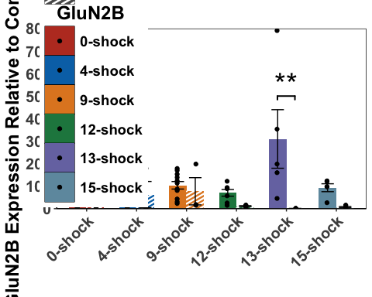

PLA1 <- ggplot(PLsummaryGluA1, aes(y = mean, x=Shock, pattern = SEFL, fill = Shock)) +  
 geom_bar_pattern(stat = "identity",   
 pattern_density = .2,  
 pattern_spacing = .02,  
 pattern_fill = 'white',  
 pattern_color = "white",  
 aes(pattern = SEFL),   
 position = position_dodge(preserve = "single"),  
 width = 0.7,  
 show.legend = TRUE)+  
 scale_fill_nejm() +  
 scale_color_nejm() +  
 scale_pattern_manual(guide = "legend", values = c(Susceptible = "stripe", Resilient = "none")) +   
 labs(x="", y="GluA1 Expression Relative to Control (%)", pattern = "SEFL", subtitle = "GluA1") +   
 guides(fill = guide_legend(override.aes = list(pattern = "none"))) +  
 scale_y_continuous(limits=c(0, 460),breaks = c(0,50,100,150,200,250,300,350,400,450), expand = c(0,0)) +   
 theme(axis.text.x=element_text(angle = 45, vjust = 1, hjust =1, size = 15, face="bold"), axis.text.y=element_text(size = 15, face="bold"), axis.title =element_text(size=18,face="bold"), title=element_text(size = 18, face = "bold"),plot.subtitle =element_text(size = 18), strip.text = element_text(size = 15, face = "bold")) +  
 theme(panel.grid.major = element_blank(), panel.grid.minor = element_blank(),  
 panel.background = element_rect(colour = "black", fill = "white"),   
 axis.line = element_line(colour = "black")) + theme(legend.title = element_blank()) +  
 geom_signif(comparisons = list(c("12-shock","13-shock")),  
 map_signif_level = TRUE,  
 annotations = c("*"),  
 y_position = c(405),  
 color = c("black","black","black"),  
 size = .7, textsize = 10) +  
 geom_signif(comparisons = list(c("13-shock","15-shock")),  
 map_signif_level = TRUE,  
 annotations = c("***"),  
 y_position = c(385),  
 color = c("black","black","black"),  
 size = .7, textsize = 10) +  
 geom_signif(y_position = c(350), xmin = c(4.82), xmax = c(5.17), annotation = c("****"),  
 tip_length = 0.02, color = "black", size = .7, textsize = 10) +  
 geom_errorbar(aes(ymin=mean-se, ymax=mean+se),  
 width= .5,   
 position=position_dodge(0.7),  
 color = "black") +  
 theme(legend.position="none") +  
 geom_point(data = PLGluA1Data, aes(x = Shock, y = PLGluA1), position = position_jitterdodge(jitter.width = 0))  
  
  
PLA1

## Warning: Removed 10 rows containing missing values or values outside the scale range  
## (`geom_point()`).

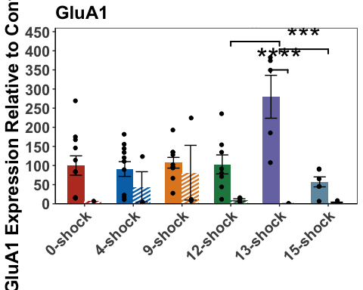

PLA2 <- ggplot(PLsummaryGluA2, aes(y = mean, x=Shock, pattern = SEFL, fill = Shock)) +  
 geom_bar_pattern(stat = "identity",   
 pattern_density = .2,  
 pattern_spacing = .02,  
 pattern_fill = 'white',  
 pattern_color = "white",  
 aes(pattern = SEFL),   
 position = position_dodge(preserve = "single"),  
 width = 0.7,  
 show.legend = TRUE)+  
 scale_fill_nejm() +  
 scale_color_nejm() +  
 scale_pattern_manual(guide = "legend", values = c(Susceptible = "stripe", Resilient = "none")) +   
 labs(x="", y="GluA2 Expression Relative to Control (%)", pattern = "SEFL", subtitle = "GluA2") +   
 guides(fill = guide_legend(override.aes = list(pattern = "none"))) +  
 scale_y_continuous(limits=c(0, 510),breaks = c(0,50,100,150,200,250,300,350,400,450,500), expand = c(0,0)) +   
 theme(axis.text.x=element_text(angle = 45, vjust = 1, hjust =1, size = 15, face="bold"), axis.text.y=element_text(size = 15, face="bold"), axis.title =element_text(size=18,face="bold"), title=element_text(size = 18, face = "bold"),plot.subtitle =element_text(size = 18), strip.text = element_text(size = 15, face = "bold")) +  
 theme(panel.grid.major = element_blank(), panel.grid.minor = element_blank(),  
 panel.background = element_rect(colour = "black", fill = "white"),   
 axis.line = element_line(colour = "black")) + theme(legend.title = element_blank()) +  
 geom_errorbar(aes(ymin=mean-se, ymax=mean+se),  
 width= .5,   
 position=position_dodge(0.7),  
 color = "black") +  
 geom_point(data = PLGluA2Data, aes(x = Shock, y = PLGluA2), position = position_jitterdodge(jitter.width = 0)) +  
 geom_signif(y_position = c(380), xmin = c(4.82), xmax = c(5.17), annotation = c("*"),  
 tip_length = 0.02, color = "black", size = .7, textsize = 10) +  
 theme(legend.position="none")  
  
  
PLA2

## Warning: Removed 10 rows containing missing values or values outside the scale range  
## (`geom_point()`).

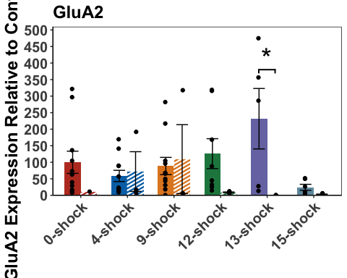

PLN2B_SEFL <- ggplot(PLGluN2BData,  
 aes( x = SEFL, y = PLGluN2B)) +  
 geom_boxplot() +  
 geom_jitter(color= c("#636363"), size=.7, alpha=.7) +   
 theme(panel.grid.major = element_blank(), panel.grid.minor = element_blank(),  
 panel.background = element_rect(colour = "black", fill = "white"),   
 axis.line = element_line(colour = "black")) + theme(legend.title = element_blank()) +  
 labs(X = "", y="GluN2B Expression Relative to Control (%)") +  
 geom_signif(comparisons = list(c("Resilient","Susceptible")),  
 map_signif_level = TRUE,  
 annotations = c("***"),  
 y_position = c(600),  
 color = c("black","black","black"),  
 size = 1, textsize = 10) +   
 theme(axis.text.x=element_text(size = 15, face="bold"), axis.text.y=element_text(size = 15, face="bold"), axis.title =element_text(size=18,face="bold"), title=element_text(size = 18, face = "bold"),plot.subtitle =element_text(size = 18), strip.text = element_text(size = 15, face = "bold")) +  
 scale_y_continuous(limits=c(0, 800)) +  
 theme(legend.position="none")  
  
PLN2B_SEFL

## Warning: Removed 10 rows containing non-finite outside the scale range  
## (`stat_boxplot()`).

## Warning: Removed 10 rows containing non-finite outside the scale range  
## (`stat_signif()`).

## Warning: Removed 10 rows containing missing values or values outside the scale range  
## (`geom_point()`).

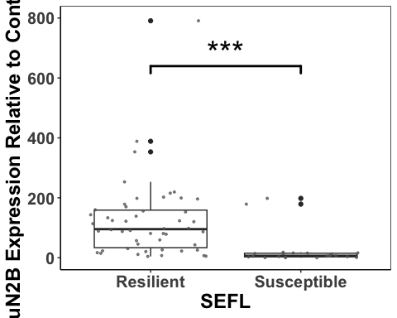

PLA1_SEFL <- ggplot(PLGluA1Data,  
 aes( x = SEFL, y = PLGluA1)) +  
 geom_boxplot() +  
 geom_jitter(color= c("#636363"), size=.7, alpha=.7) +   
 theme(panel.grid.major = element_blank(), panel.grid.minor = element_blank(),  
 panel.background = element_rect(colour = "black", fill = "white"),   
 axis.line = element_line(colour = "black")) + theme(legend.title = element_blank()) +  
 labs(X = "",y="GluA1 Expression Relative to Control (%)") +  
 geom_signif(comparisons = list(c("Resilient","Susceptible")),  
 map_signif_level = TRUE,  
 annotations = c("****"),  
 y_position = c(300),  
 color = c("black","black","black"),  
 size = 1, textsize = 10) +   
 theme(axis.text.x=element_text(size = 15, face="bold"), axis.text.y=element_text(size = 15, face="bold"), axis.title =element_text(size=18,face="bold"), title=element_text(size = 18, face = "bold"),plot.subtitle =element_text(size = 18), strip.text = element_text(size = 15, face = "bold")) +  
 scale_y_continuous(limits=c(0, 400)) +  
 theme(legend.position="none")  
PLA1_SEFL

## Warning: Removed 10 rows containing non-finite outside the scale range  
## (`stat_boxplot()`).

## Warning: Removed 10 rows containing non-finite outside the scale range  
## (`stat_signif()`).

## Warning: Removed 10 rows containing missing values or values outside the scale range  
## (`geom_point()`).

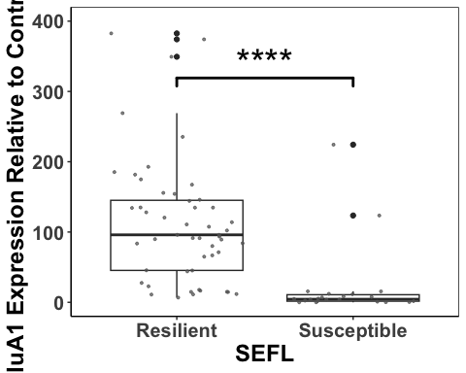

PLA2_SEFL <- ggplot(PLGluA2Data,  
 aes( x = SEFL, y = PLGluA2)) +  
 geom_boxplot() +  
 geom_jitter(color= c("#636363"), size=.7, alpha=.7) +   
 theme(panel.grid.major = element_blank(), panel.grid.minor = element_blank(),  
 panel.background = element_rect(colour = "black", fill = "white"),   
 axis.line = element_line(colour = "black")) + theme(legend.title = element_blank()) +  
 labs(X = "",y="GluA2 Expression Relative to Control (%)") +  
 geom_signif(comparisons = list(c("Resilient","Susceptible")),  
 map_signif_level = TRUE,  
 annotations = c("*"),  
 y_position = c(400),  
 color = c("black","black","black"),  
 size = 1, textsize = 10) +   
 theme(axis.text.x=element_text(size = 15, face="bold"), axis.text.y=element_text(size = 15, face="bold"), axis.title =element_text(size=18,face="bold"), title=element_text(size = 18, face = "bold"),plot.subtitle =element_text(size = 18), strip.text = element_text(size = 15, face = "bold")) +  
 scale_y_continuous(limits=c(0, 500))  
PLA2_SEFL

## Warning: Removed 10 rows containing non-finite outside the scale range  
## (`stat_boxplot()`).

## Warning: Removed 10 rows containing non-finite outside the scale range  
## (`stat_signif()`).

## Warning: Removed 10 rows containing missing values or values outside the scale range  
## (`geom_point()`).

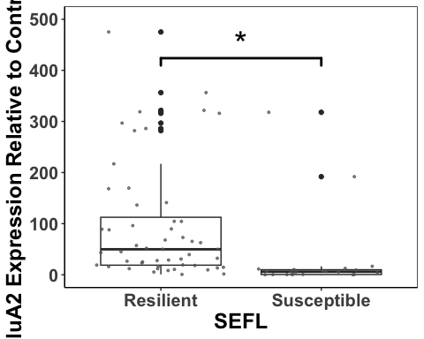

PLplot <- ggarrange(PLN2B, PLA1, PLA2, PLN2B_SEFL,PLA1_SEFL, PLA2_SEFL,  
 labels = c("a", "", "", "b", "", ""),  
 font.label = list(size = 26, face = "bold"),  
 ncol = 3, nrow = 2) +  
 theme(plot.margin = margin(0.1,1.5,0.1,1.5, "cm"))

## Warning: Removed 10 rows containing missing values or values outside the scale range  
## (`geom_point()`).  
## Removed 10 rows containing missing values or values outside the scale range  
## (`geom_point()`).  
## Removed 10 rows containing missing values or values outside the scale range  
## (`geom_point()`).

## Warning: Removed 10 rows containing non-finite outside the scale range  
## (`stat_boxplot()`).

## Warning: Removed 10 rows containing non-finite outside the scale range  
## (`stat_signif()`).

## Warning: Removed 10 rows containing missing values or values outside the scale range  
## (`geom_point()`).

## Warning: Removed 10 rows containing non-finite outside the scale range  
## (`stat_boxplot()`).

## Warning: Removed 10 rows containing non-finite outside the scale range  
## (`stat_signif()`).

## Warning: Removed 10 rows containing missing values or values outside the scale range  
## (`geom_point()`).

## Warning: Removed 10 rows containing non-finite outside the scale range  
## (`stat_boxplot()`).

## Warning: Removed 10 rows containing non-finite outside the scale range  
## (`stat_signif()`).

## Warning: Removed 10 rows containing missing values or values outside the scale range  
## (`geom_point()`).

PLplot

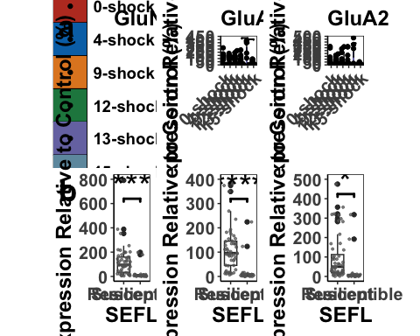

ggsave('PLplot', PLplot, width=23, height=18, units='in', device = "tiff", dpi = 600)

interaction.plot(x.factor = PLGluA1Data$Shock,  
 trace.factor = PLGluA1Data$SEFL,  
 response = PLGluA1Data$PLGluA1,  
 fun = mean,  
 col = c("red","blue"),  
 lty = 1,  
 lwd = 3,  
 ylab = "Relative Expression of GluA1 (%)", xlab = "Shock", trace.label = "SEFL")

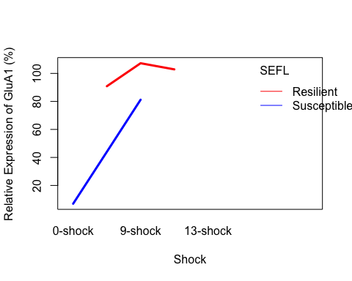

Correlations between subunit expression in the PL

#first we work out the regression lines for the resilient and susceptible groups  
  
resilientPL <- select(PLData, c("Rat","SEFL","Shock", "Average_Freezing_Extinction_Session","Average_Freezing_Last_3_mins_Extinction", "Recovery_Index","Total_Freezing_During_Test","PLGluN2B", "PLGluA1", "PLGluA2"))  
resilientPL <- resilientPL[ which(resilientPL$SEFL=="Resilient"), ]  
  
susceptiblePL <- select(PLData, c("Rat","SEFL","Shock", "Average_Freezing_Extinction_Session","Average_Freezing_Last_3_mins_Extinction", "Recovery_Index","Total_Freezing_During_Test","PLGluN2B", "PLGluA1", "PLGluA2"))  
susceptiblePL <- susceptiblePL[ which(susceptiblePL$SEFL=="Susceptible"), ]  
  
  
PLResilient1 <- lm(PLGluN2B ~ PLGluA1, data = resilientPL, na.action=na.omit)  
PLResilient1

##   
## Call:  
## lm(formula = PLGluN2B ~ PLGluA1, data = resilientPL, na.action = na.omit)  
##   
## Coefficients:  
## (Intercept) PLGluA1   
## 32.0971 0.8423

#y = 0.96X + 17.32  
  
PLSusceptible1 <- lm(PLGluN2B ~ PLGluA1, data = susceptiblePL, na.action=na.omit)  
PLSusceptible1

##   
## Call:  
## lm(formula = PLGluN2B ~ PLGluA1, data = susceptiblePL, na.action = na.omit)  
##   
## Coefficients:  
## (Intercept) PLGluA1   
## 3.5257 0.9945

#y = 0.9945x + 3.5257  
  
  
PLA1_N2B <- ggplot(PLData,  
 aes(x = PLGluA1,  
 y = PLGluN2B, color = Shock, shape = SEFL)) +  
 geom_point(aes(color = PLData$Shock), size = 4) +  
 scale_fill_nejm() +  
 scale_color_nejm() +  
 theme(panel.grid.major = element_blank(), panel.grid.minor = element_blank(),  
 panel.background = element_rect(colour = "black", fill = "white"),   
 axis.line = element_line(colour = "black")) + theme(legend.title = element_blank()) +  
 geom_abline(intercept = 17.32, slope = 0.96, size = 1.2) +  
 geom_abline(intercept = 3.53, slope = 0.99, linetype = "dashed", size = 1.2) +  
 theme(legend.position="none") +  
 theme(axis.text.x=element_text(size = 15, face = "bold"),axis.text.y=element_text(size = 15, face = "bold"), axis.title =element_text(size=15,face="bold")) +  
 labs(x="GluA1 Expression Relative to Control (%)", y="GluN2B Expression Relative to Control (%)")  
PLA1_N2B

## Warning: Use of `PLData$Shock` is discouraged.  
## ℹ Use `Shock` instead.

## Warning: Removed 10 rows containing missing values or values outside the scale range  
## (`geom_point()`).

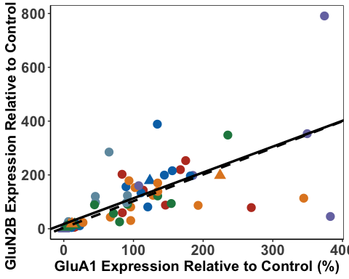

PLResilient2 <- lm(PLGluN2B ~ PLGluA2, data = resilientPL)  
PLResilient2

##   
## Call:  
## lm(formula = PLGluN2B ~ PLGluA2, data = resilientPL)  
##   
## Coefficients:  
## (Intercept) PLGluA2   
## 80.7130 0.5154

#y = 0.49X + 77.50  
  
PLSusceptible2 <- lm(PLGluN2B ~ PLGluA2, data = susceptiblePL)  
PLSusceptible2

##   
## Call:  
## lm(formula = PLGluN2B ~ PLGluA2, data = susceptiblePL)  
##   
## Coefficients:  
## (Intercept) PLGluA2   
## 4.771 0.687

#y = 0.69X + 4.77  
  
PLA2_N2B<- ggplot(PLData,  
 aes(x = PLGluA2,  
 y = PLGluN2B, color = Shock, shape = SEFL)) +  
 geom_point(aes(color = PLData$Shock), size = 4) +  
 scale_fill_nejm() +  
 scale_color_nejm() +  
 theme(panel.grid.major = element_blank(), panel.grid.minor = element_blank(),  
 panel.background = element_rect(colour = "black", fill = "white"),   
 axis.line = element_line(colour = "black")) + theme(legend.title = element_blank()) +  
 geom_abline(intercept = 77.5, slope = 0.49, size = 1.2) +  
 geom_abline(intercept = 4.77, slope = 0.69, linetype = "dashed",size = 1.2) +  
 geom_segment(aes(x=0, xend=40,y=770,yend=770), size = 1.3, color = "black") +  
 geom_segment(aes(x=0, xend=40,y=720,yend=720), size = 1.3, color = "black", linetype = "dashed") +   
 annotate(geom="text", x=80, y=770, label="Resilient",  
 color="black", size = 6, fontface = "bold") +  
 annotate(geom="text", x=92, y=720, label="Susceptible",  
 color="black", size =6, fontface = "bold") +  
 theme(axis.text.x=element_text(size = 15, face = "bold"),axis.text.y=element_text(size = 15, face = "bold"), axis.title =element_text(size=15,face="bold")) +  
 theme(legend.position="none") +  
 labs(x="GluA2 Expression Relative to Control (%)", y="GluN2B Expression Relative to Control (%)")  
PLA2_N2B

## Warning: Use of `PLData$Shock` is discouraged.  
## ℹ Use `Shock` instead.

## Warning: Removed 10 rows containing missing values or values outside the scale range  
## (`geom_point()`).

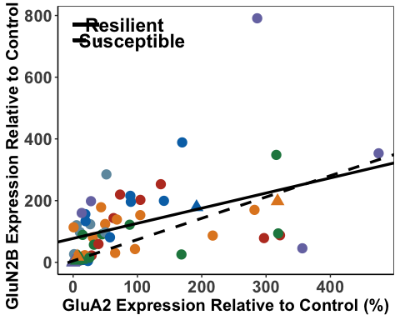

PLResilient3 <- lm(PLGluA1 ~ PLGluA2, data = resilientPL, na.action=na.omit)  
PLResilient3

##   
## Call:  
## lm(formula = PLGluA1 ~ PLGluA2, data = resilientPL, na.action = na.omit)  
##   
## Coefficients:  
## (Intercept) PLGluA2   
## 59.8977 0.5895

#y = 0.3216x + 30.6209  
  
PLSusceptible3 <- lm(PLGluA1 ~ PLGluA2, data = susceptiblePL, na.action=na.omit)  
PLSusceptible3

##   
## Call:  
## lm(formula = PLGluA1 ~ PLGluA2, data = susceptiblePL, na.action = na.omit)  
##   
## Coefficients:  
## (Intercept) PLGluA2   
## 1.4621 0.6834

#y = -0.2378x + 35.9742  
  
PLA2_A1<- ggplot(PLData,  
 aes(x = PLGluA2,  
 y = PLGluA1, color = Shock, shape = SEFL)) +  
 geom_point(aes(color = PLData$Shock), size = 4) +  
 scale_fill_nejm() +  
 scale_color_nejm() +  
 theme(panel.grid.major = element_blank(), panel.grid.minor = element_blank(),  
 panel.background = element_rect(colour = "black", fill = "white"),   
 axis.line = element_line(colour = "black")) + theme(legend.title = element_blank()) +  
 geom_abline(intercept = 50.11, slope = 0.63, size = 1.2) +  
 geom_abline(intercept = 1.46, slope = 0.68, linetype = "dashed", size = 1.2) +  
theme(legend.position = c(0.87, 0.27), legend.key.size = unit(1, 'cm')) +  
 theme(axis.text.x=element_text(size = 15, face = "bold"),axis.text.y=element_text(size = 15, face = "bold"), axis.title =element_text(size=15,face="bold")) +   
 theme(legend.text=element_text(size=12, face = "bold")) +  
 labs(x="GluA2 Expression Relative to Control (%)", y="GluA1 Expression Relative to Control (%)")  
 PLA2_A1

## Warning: Use of `PLData$Shock` is discouraged.  
## ℹ Use `Shock` instead.

## Warning: Removed 10 rows containing missing values or values outside the scale range  
## (`geom_point()`).

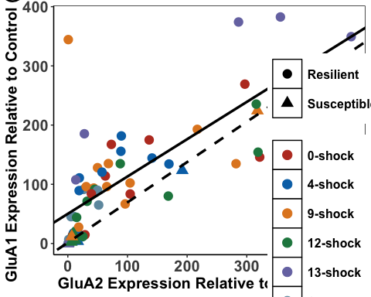

PLsubunits <- ggarrange(PLA2_A1, PLA1_N2B, PLA2_N2B,  
 labels = c("a", "b", "c"),  
 font.label = list(size = 24, face = "bold"),  
 ncol = 3, nrow = 1) +  
 theme(plot.margin = margin(1,1,1,1, "cm"))

## Warning: Use of `PLData$Shock` is discouraged.  
## ℹ Use `Shock` instead.

## Warning: Removed 10 rows containing missing values or values outside the scale range  
## (`geom_point()`).

## Warning: Use of `PLData$Shock` is discouraged.  
## ℹ Use `Shock` instead.

## Warning: Removed 10 rows containing missing values or values outside the scale range  
## (`geom_point()`).

## Warning: Use of `PLData$Shock` is discouraged.  
## ℹ Use `Shock` instead.

## Warning: Removed 10 rows containing missing values or values outside the scale range  
## (`geom_point()`).

PLsubunits

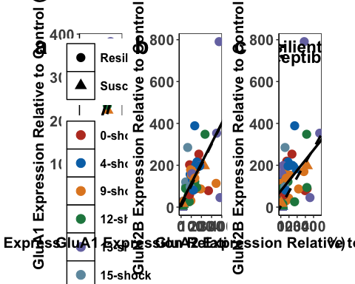

ggsave('PLsubunits', PLsubunits, width=25, height=9, units='in', device = "tiff", dpi = 600)

Comparing the regressions

PLA1_A2<- PLData %>%   
 group_by(SEFL) %>%  
 cor_test(PLGluA2, PLGluA1, method="pearson")  
  
#resilient - r=0.81, p <.0001  
#susceptible = r=0.99, p<.0001

PLA1_N2B<- PLData %>%   
 group_by(SEFL) %>%  
 cor_test(PLGluN2B, PLGluA1, method="pearson")  
  
#resilient - r=0.65, p <.0001  
#susceptible = r=0.97, p<.0001

PLA2_N2B <- PLData %>%   
 group_by(SEFL) %>%  
 cor_test(PLGluN2B, PLGluA2, method="pearson")  
  
#resilient - r=0.42, p<0.0001  
#susceptible = r=0.97, p<0.001

Fisher’s Z-Scores

PLResilientA1_A2 <- FisherZ(0.81)  
PLSusceptibleA1_A2 <- FisherZ(0.99)  
  
PLResilientA1_N2B <- FisherZ(0.65)  
PLSusceptibleA1_N2B <- FisherZ(0.97)  
  
PLResilientA2_N2B <- FisherZ(0.42)  
PLSusceptibleA2_N2B <- FisherZ(0.97)

#n resilient = 50  
#n susceptible = 21  
  
  
N1 <- 1/(50-3)  
N2 <- 1/(21-3)  
  
N <- N1 + N2  
  
Z1 <- (PLResilientA1_A2 -PLSusceptibleA1_A2)  
  
PLZdiffA1_A2 <- Z1/sqrt(N)  
PLZdiffA1_A2

## [1] -5.482321

#=-5.48  
#significant

#n resilient = 49  
#n susceptible = 21  
  
  
N1b <- 1/(49-3)  
N2b <- 1/(21-3)  
  
Nb <- N1b + N2b  
  
Z2 <- (PLResilientA1_N2B -PLSusceptibleA1_N2B)  
  
PLZdiffA1_N2B <- Z2/sqrt(Nb)  
PLZdiffA1_N2B

## [1] -4.737072

#=-4.74  
#significant

#n resilient = 51  
#n susceptible = 22  
  
  
N1c <- 1/(51-3)  
N2c <- 1/(22-3)  
  
Nc <- N1c + N2c  
Z3 <- (PLResilientA2_N2B -PLSusceptibleA2_N2B)  
  
PLZdiffA2_N2B <- Z3/sqrt(Nc)  
PLZdiffA2_N2B

## [1] -6.067661

#=-6.07  
#greater than z crit = significant

Behavioural Correlations with PL Data

#first we work out the correlations  
  
  
PLResGluN2B <- lm(Average_Freezing_Extinction_Session ~ PLGluN2B, data = resilientPL)  
PLResGluN2B

##   
## Call:  
## lm(formula = Average_Freezing_Extinction_Session ~ PLGluN2B,   
## data = resilientPL)  
##   
## Coefficients:  
## (Intercept) PLGluN2B   
## 4.40280 0.02314

PLSusGluN2B <- lm(Average_Freezing_Extinction_Session ~ PLGluN2B, data = susceptiblePL)  
PLSusGluN2B

##   
## Call:  
## lm(formula = Average_Freezing_Extinction_Session ~ PLGluN2B,   
## data = susceptiblePL)  
##   
## Coefficients:  
## (Intercept) PLGluN2B   
## 33.19691 -0.04191

PLResGluA1 <- lm(Average_Freezing_Extinction_Session ~ PLGluA1, data = resilientPL)  
PLResGluA1

##   
## Call:  
## lm(formula = Average_Freezing_Extinction_Session ~ PLGluA1, data = resilientPL)  
##   
## Coefficients:  
## (Intercept) PLGluA1   
## 3.09081 0.03705

PLSusGluA1 <- lm(Average_Freezing_Extinction_Session ~ PLGluA1, data = susceptiblePL)  
PLSusGluA1

##   
## Call:  
## lm(formula = Average_Freezing_Extinction_Session ~ PLGluA1, data = susceptiblePL)  
##   
## Coefficients:  
## (Intercept) PLGluA1   
## 33.23003 -0.05043

PLResGluA2 <- lm(Average_Freezing_Extinction_Session~ PLGluA2, data = resilientPL)  
PLResGluA2

##   
## Call:  
## lm(formula = Average_Freezing_Extinction_Session ~ PLGluA2, data = resilientPL)  
##   
## Coefficients:  
## (Intercept) PLGluA2   
## 4.54095 0.02979

PLSusGluA2 <- lm(Average_Freezing_Extinction_Session ~ PLGluA2, data = susceptiblePL)  
PLSusGluA2

##   
## Call:  
## lm(formula = Average_Freezing_Extinction_Session ~ PLGluA2, data = susceptiblePL)  
##   
## Coefficients:  
## (Intercept) PLGluA2   
## 33.14087 -0.03391

PLFF_A1 <- ggplot(PLData,  
 aes(x = PLGluA1,  
 y = Average_Freezing_Extinction_Session, color = Shock, shape = SEFL)) +  
 geom_point(aes(color = Shock), size = 4) +  
 scale_fill_nejm() +  
 scale_color_nejm() +  
 theme(panel.grid.major = element_blank(), panel.grid.minor = element_blank(),  
 panel.background = element_rect(colour = "black", fill = "white"),   
 axis.line = element_line(colour = "black")) + theme(legend.title = element_blank()) +   
 geom_abline(intercept = 2.6, slope = 0.042, size = 1.2) +  
 geom_abline(intercept = 33.2, slope = -0.05, linetype = "dashed", size = 1.2) +  
 theme(legend.position="none") +  
 theme(axis.text.x=element_text(size = 12, face = "bold"),axis.text.y=element_text(size = 12, face = "bold"), axis.title =element_text(size=15,face="bold")) +  
 labs(x="GluA1 Expression Relative to Control (%)", y="Mean Freezing During Extinction Session (%)") +  
 scale_x_continuous(limits=c(0, 420), breaks = c(0,100,200,300,400), expand = c(0,0))  
  
PLFF_N2B <- ggplot(PLData,  
 aes(x = PLGluN2B,  
 y = Average_Freezing_Extinction_Session, color = Shock, shape = SEFL)) +  
 geom_point(aes(color = Shock), size = 4) +  
 scale_fill_nejm() +  
 scale_color_nejm() +  
 theme(panel.grid.major = element_blank(), panel.grid.minor = element_blank(),  
 panel.background = element_rect(colour = "black", fill = "white"),   
 axis.line = element_line(colour = "black")) + theme(legend.title = element_blank()) +   
 geom_abline(intercept = 4.58, slope = 0.02, size = 1.2) +  
 geom_abline(intercept = 33.2, slope = -0.042, linetype = "dashed", size = 1.2) +  
 theme(axis.text.x=element_text(size = 12, face = "bold"),axis.text.y=element_text(size = 12, face = "bold"), axis.title =element_text(size=15,face="bold")) +  
 labs(x="GluN2B Expression Relative to Control (%)", y="Mean Freezing During Extinction Session (%)") +  
 geom_segment(aes(x=50, xend=120,y=50,yend=50), size = 1.3, color = "black") +  
 geom_segment(aes(x=50, xend=120,y=47,yend=47), size = 1.3, color = "black", linetype = "dashed") +  
 annotate(geom="text", x=180, y=50, label="Resilient",  
 color="black", size = 6, fontface = "bold") +  
 annotate(geom="text", x=195, y=47, label="Susceptible",  
 color="black", size = 6, fontface = "bold") +  
 scale_x_continuous(limits=c(0, 820), breaks = c(0,200,400,600,800), expand = c(0,0)) +   
 theme(legend.position = c(0.85, 0.78), legend.key.size = unit(1, 'cm'), legend.text = element_text(size=14, face = "bold"))   
  
PLFF_A2 <- ggplot(PLData,  
 aes(x = PLGluA2,  
 y = Average_Freezing_Extinction_Session, color = Shock, shape = SEFL)) +  
 geom_point(aes(color = Shock), size = 4) +  
 scale_fill_nejm() +  
 scale_color_nejm() +  
 theme(panel.grid.major = element_blank(), panel.grid.minor = element_blank(),  
 panel.background = element_rect(colour = "black", fill = "white"),   
 axis.line = element_line(colour = "black")) + theme(legend.title = element_blank()) +   
 geom_abline(intercept = 4.54, slope = 0.03, size = 1.2) +  
 geom_abline(intercept = 33.14, slope = -0.034, linetype = "dashed", size = 1.2) +  
 theme(legend.position="none") +  
 theme(axis.text.x=element_text(size = 12, face = "bold"),axis.text.y=element_text(size = 12, face = "bold"), axis.title =element_text(size=15,face="bold")) +  
 labs(x="GluA2 Expression Relative to Control (%)", y="Mean Freezing During Extinction Session (%)") +   
 theme(legend.position="none") +  
 scale_x_continuous(limits=c(0, 520), breaks = c(0,100,200,300,400,500), expand = c(0,0))  
  
  
PLFF_A2

## Warning: Removed 10 rows containing missing values or values outside the scale range  
## (`geom_point()`).

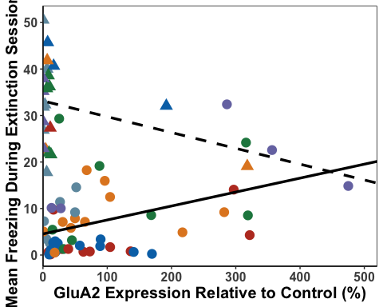

PLFF_A1

## Warning: Removed 10 rows containing missing values or values outside the scale range  
## (`geom_point()`).

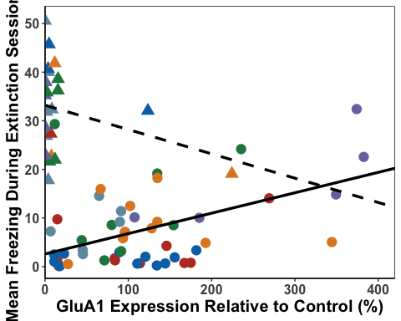

PLFF_N2B

## Warning: Removed 10 rows containing missing values or values outside the scale range  
## (`geom_point()`).

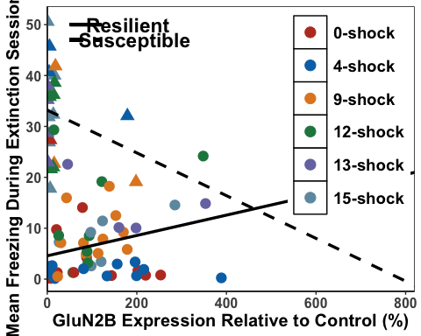

PLFF_A1cor<- PLData %>%   
 group_by(SEFL) %>%  
 cor_test(Average_Freezing_Extinction_Session, PLGluA1, method="pearson")  
  
#resilient - r=0.50, p<0.0001  
#susceptible = r=-0.29, p=0.19  
  
PLFF_A2cor<- PLData %>%   
 group_by(SEFL) %>%  
 cor_test(Average_Freezing_Extinction_Session, PLGluA2, method="pearson")  
  
#resilient - r=0.44, p<0.01  
#susceptible = r=-0.29, p=0.20  
  
PLFF_N2Bcor<- PLData %>%   
 group_by(SEFL) %>%  
 cor_test(Average_Freezing_Extinction_Session, PLGluN2B, method="pearson")  
  
#resilient - r=0.33, p<0.05  
#susceptible = r=-0.25, p=0.26  
  
PLResilientFF_A1 <- FisherZ(0.50)  
PLSusceptibleFF_A1 <- FisherZ(-0.29)  
  
PLResilientFF_A2 <- FisherZ(0.44)  
PLSusceptibleFF_A2 <- FisherZ(-0.29)  
  
PLResilientFF_N2B <- FisherZ(0.33)  
PLSusceptibleFF_N2B <- FisherZ(-0.25)  
  
#Zdiff for A1  
#n resilient = 51  
#n susceptible = 20  
  
N1 <- 1/(51-3)  
N2 <- 1/(20-3)  
  
N <- N1 + N2  
  
Z1 <- (PLResilientFF_A1 -PLSusceptibleFF_A1)  
  
PLZdiffFF_A1 <- Z1/sqrt(N)  
PLZdiffFF_A1

## [1] 3.004131

# 3.00 significant  
  
# 0.29 not significant  
  
#Z diff for A2  
  
#n resilient = 53  
#n susceptible = 21  
  
N1b <- 1/(53-3)  
N2b <- 1/(21-3)  
  
Nb <- N1b + N2b  
  
Z2 <- (PLResilientFF_A2 -PLSusceptibleFF_A2)  
  
PLZdiffFF_A2 <- Z2/sqrt(Nb)  
PLZdiffFF_A2

## [1] 2.804186

#2.80 significant  
  
#Z diff for N2B  
  
#n resilient = 52  
#n susceptible = 21  
  
N1c <- 1/(52-3)  
N2c <- 1/(21-3)  
  
Nc <- N1c + N2c  
  
Z3 <- (PLResilientFF_N2B -PLSusceptibleFF_N2B)  
  
PLZdiffFF_N2B <- Z3/sqrt(Nc)  
PLZdiffFF_N2B

## [1] 2.170567

#2.17 significant

PLRes3GluN2B <- lm(Average_Freezing_Last_3_mins_Extinction ~ PLGluN2B, data = resilientPL)  
PLRes3GluN2B

##   
## Call:  
## lm(formula = Average_Freezing_Last_3_mins_Extinction ~ PLGluN2B,   
## data = resilientPL)  
##   
## Coefficients:  
## (Intercept) PLGluN2B   
## 0.73980 0.02317

PLSus3GluN2B <- lm(Average_Freezing_Last_3_mins_Extinction ~ PLGluN2B, data = susceptiblePL)  
PLSus3GluN2B

##   
## Call:  
## lm(formula = Average_Freezing_Last_3_mins_Extinction ~ PLGluN2B,   
## data = susceptiblePL)  
##   
## Coefficients:  
## (Intercept) PLGluN2B   
## 14.33707 -0.07437

PLRes3GluA1 <- lm(Average_Freezing_Last_3_mins_Extinction ~ PLGluA1, data = resilientPL)  
PLRes3GluA1

##   
## Call:  
## lm(formula = Average_Freezing_Last_3_mins_Extinction ~ PLGluA1,   
## data = resilientPL)  
##   
## Coefficients:  
## (Intercept) PLGluA1   
## 1.51754 0.01922

PLSus3GluA1 <- lm(Average_Freezing_Last_3_mins_Extinction ~ PLGluA1, data = susceptiblePL)  
PLSus3GluA1

##   
## Call:  
## lm(formula = Average_Freezing_Last_3_mins_Extinction ~ PLGluA1,   
## data = susceptiblePL)  
##   
## Coefficients:  
## (Intercept) PLGluA1   
## 13.99037 -0.06988

PLRes3GluA2 <- lm(Average_Freezing_Last_3_mins_Extinction ~ PLGluA2, data = resilientPL)  
PLRes3GluA2

##   
## Call:  
## lm(formula = Average_Freezing_Last_3_mins_Extinction ~ PLGluA2,   
## data = resilientPL)  
##   
## Coefficients:  
## (Intercept) PLGluA2   
## 2.40019 0.01411

PLSus3GluA2 <- lm(Average_Freezing_Last_3_mins_Extinction ~ PLGluA2, data = susceptiblePL)  
PLSus3GluA2

##   
## Call:  
## lm(formula = Average_Freezing_Last_3_mins_Extinction ~ PLGluA2,   
## data = susceptiblePL)  
##   
## Coefficients:  
## (Intercept) PLGluA2   
## 13.8558 -0.0466

PLE3_A1 <- ggplot(PLData,  
 aes(x = PLGluA1,  
 y = Average_Freezing_Last_3_mins_Extinction, color = Shock, shape = SEFL)) +  
 geom_point(aes(color = Shock), size = 4) +  
 scale_fill_nejm() +  
 scale_color_nejm() +  
 theme(panel.grid.major = element_blank(), panel.grid.minor = element_blank(),  
 panel.background = element_rect(colour = "black", fill = "white"),   
 axis.line = element_line(colour = "black")) + theme(legend.title = element_blank()) +   
 geom_abline(intercept = 4.95, slope = -0.022, size = 1.2) +  
 geom_abline(intercept = 17.69, slope = -0.15, linetype = "dashed", size = 1.2) +  
 theme(legend.position="none") +  
 theme(axis.text.x=element_text(size = 12), axis.title =element_text(size=15,face="bold")) +  
 labs(x="GluA1 Expression Relative to Control (%)", y="Mean Freezing During Final 3 mins Extinction (%)") +  
 scale_x_continuous(limits=c(0, 420), breaks = c(0,100,200,300,400), expand = c(0,0))  
  
PLE3_N2B <- ggplot(PLData,  
 aes(x = PLGluN2B,  
 y = Average_Freezing_Last_3_mins_Extinction, color = Shock, shape = SEFL)) +  
 geom_point(aes(color = Shock), size = 4) +  
 scale_fill_nejm() +  
 scale_color_nejm() +  
 theme(panel.grid.major = element_blank(), panel.grid.minor = element_blank(),  
 panel.background = element_rect(colour = "black", fill = "white"),   
 axis.line = element_line(colour = "black")) + theme(legend.title = element_blank()) +   
 geom_abline(intercept = 4.89, slope = -0.020, size = 1.2) +  
 geom_abline(intercept = 17.84, slope = -0.12, linetype = "dashed", size = 1.2) +  
 theme(legend.position="none") +  
 theme(axis.text.x=element_text(size = 12), axis.title =element_text(size=15,face="bold")) +  
 labs(x="GluN2B Expression Relative to Control (%)", y="Mean Freezing During Final 3 mins Extinction (%)") +  
 scale_x_continuous(limits=c(0, 820), breaks = c(0,200,400,600,800), expand = c(0,0))  
  
PLE3_A2 <- ggplot(PLData,  
 aes(x = PLGluA2,  
 y = Average_Freezing_Last_3_mins_Extinction, color = Shock, shape = SEFL)) +  
 geom_point(aes(color = Shock), size = 4) +  
 scale_fill_nejm() +  
 scale_color_nejm() +  
 theme(panel.grid.major = element_blank(), panel.grid.minor = element_blank(),  
 panel.background = element_rect(colour = "black", fill = "white"),   
 axis.line = element_line(colour = "black")) + theme(legend.title = element_blank()) +   
 geom_abline(intercept = 4.75, slope = -0.018, size = 1.2) +  
 geom_abline(intercept = 26.21, slope = 0.38, linetype = "dashed", size = 1.2) +  
 theme(legend.position="none") +  
 theme(axis.text.x=element_text(size = 12), axis.title =element_text(size=15,face="bold")) +  
 labs(x="GluA2 Expression Relative to Control (%)", y="Mean Freezing During Final 3 mins Extinction (%)") +  
 scale_x_continuous(limits=c(0, 520), breaks = c(0,100,200,300,400,500), expand = c(0,0)) +  
 theme(legend.position="none")  
  
  
PLE3_A2

## Warning: Removed 10 rows containing missing values or values outside the scale range  
## (`geom_point()`).

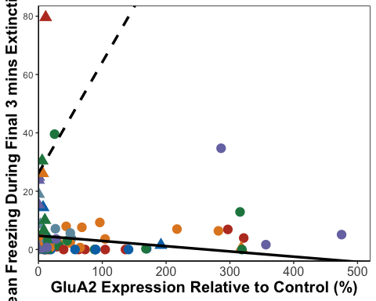

PLE3_A1

## Warning: Removed 10 rows containing missing values or values outside the scale range  
## (`geom_point()`).

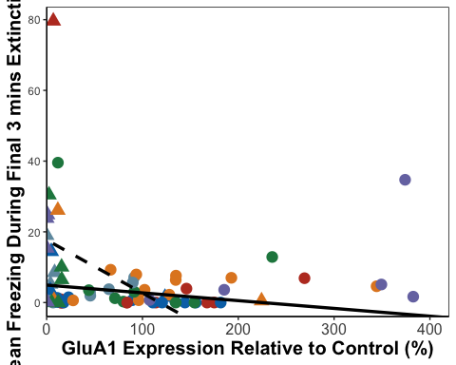

PLE3_N2B

## Warning: Removed 10 rows containing missing values or values outside the scale range  
## (`geom_point()`).

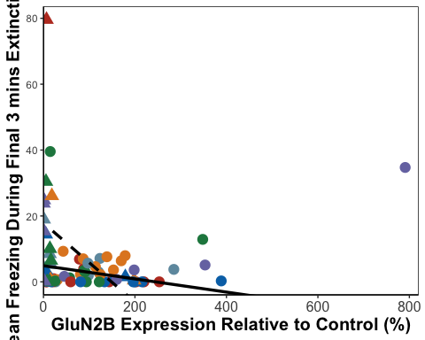

PLTF_A1<- PLData %>%   
 group_by(SEFL) %>%  
 cor_test(Average_Freezing_Last_3_mins_Extinction, PLGluA1, method="pearson")  
  
#resilient - r=0.34, p<0.05  
#susceptible = r=-0.25, p=0.28  
  
PLTF_A2<- PLData %>%   
 group_by(SEFL) %>%  
 cor_test(Average_Freezing_Last_3_mins_Extinction, PLGluA2, method="pearson")  
  
#resilient - r=0.21, p=0.13  
#susceptible = r=-0.06, p=0.79  
  
PLTF_N2B<- PLData %>%   
 group_by(SEFL) %>%  
 cor_test(Average_Freezing_Last_3_mins_Extinction, PLGluN2B, method="pearson")  
  
#resilient - r=0.53, p<0.001  
#susceptible = r=-0.25, p=0.27  
  
PLResilientTF_A1 <- FisherZ(0.34)  
PLSusceptibleTF_A1 <- FisherZ(-0.25)  
  
PLResilientTF_A2 <- FisherZ(0.21)  
PLSusceptibleTF_A2 <- FisherZ(-0.06)  
  
PLResilientTF_N2B <- FisherZ(0.53)  
PLSusceptibleTF_N2B <- FisherZ(-0.25)  
  
#A1  
  
#n resilient = 51  
#n susceptible = 20  
  
N1 <- 1/(51-3)  
N2 <- 1/(20-3)  
  
N <- N1 + N2  
  
Z3_1 <- (PLResilientTF_A1 -PLSusceptibleTF_A1)  
  
PLZdiffTF_A1 <- Z3_1/sqrt(N)  
PLZdiffTF_A1

## [1] 2.159563

# 2.16 = significant  
  
#A2  
  
#n resilient = 53  
#n susceptible = 21  
  
N1b <- 1/(53-3)  
N2b <- 1/(21-3)  
  
Nb <- N1b + N2b  
  
Z3_2 <- (PLResilientTF_A2 -PLSusceptibleTF_A2)  
  
PLZdiffTF_A2 <- Z3_2/sqrt(Nb)  
PLZdiffTF_A2

## [1] 0.9940693

#0.99 not significant  
  
#N2B  
  
#n resilient = 52  
#n susceptible = 21  
  
N1c <- 1/(52-3)  
N2c <- 1/(21-3)  
  
Nc <- N1c + N2c  
Z3_3 <- (PLResilientTF_N2B -PLSusceptibleTF_N2B)  
  
PLZdiffTF_N2B <- Z3_3/sqrt(Nc)  
PLZdiffTF_N2B

## [1] 3.067894

# 3.07 significant

PLResTGluN2B <- lm(Total_Freezing_During_Test ~ PLGluN2B, data = resilientPL)  
PLResTGluN2B

##   
## Call:  
## lm(formula = Total_Freezing_During_Test ~ PLGluN2B, data = resilientPL)  
##   
## Coefficients:  
## (Intercept) PLGluN2B   
## -0.18941 0.01696

#y = 0.02 - 0.12  
  
PLSusTGluN2B <- lm(Total_Freezing_During_Test ~ PLGluN2B, data = susceptiblePL)  
PLSusTGluN2B

##   
## Call:  
## lm(formula = Total_Freezing_During_Test ~ PLGluN2B, data = susceptiblePL)  
##   
## Coefficients:  
## (Intercept) PLGluN2B   
## 21.52311 -0.04978

#y = -0.05x + 21.52  
  
  
PLResTGluA1 <- lm(Total_Freezing_During_Test ~ PLGluA1, data = resilientPL)  
PLResTGluA1

##   
## Call:  
## lm(formula = Total_Freezing_During_Test ~ PLGluA1, data = resilientPL)  
##   
## Coefficients:  
## (Intercept) PLGluA1   
## 0.11026 0.01638

#y = 0.018x + 0.005  
  
PLSusTGluA1 <- lm(Total_Freezing_During_Test ~ PLGluA1, data = susceptiblePL)  
PLSusTGluA1

##   
## Call:  
## lm(formula = Total_Freezing_During_Test ~ PLGluA1, data = susceptiblePL)  
##   
## Coefficients:  
## (Intercept) PLGluA1   
## 21.62640 -0.06299

#y = -0.063 + 21.63  
  
PLResTGluA2 <- lm(Total_Freezing_During_Test ~ PLGluA2, data = resilientPL)  
PLResTGluA2

##   
## Call:  
## lm(formula = Total_Freezing_During_Test ~ PLGluA2, data = resilientPL)  
##   
## Coefficients:  
## (Intercept) PLGluA2   
## 1.135506 0.009195

#y = 0.009x + 1.14  
  
PLSusTGluA2 <- lm(Total_Freezing_During_Test ~ PLGluA2, data = susceptiblePL)  
PLSusTGluA2

##   
## Call:  
## lm(formula = Total_Freezing_During_Test ~ PLGluA2, data = susceptiblePL)  
##   
## Coefficients:  
## (Intercept) PLGluA2   
## 21.52706 -0.04279

#y = -0.04x + 21.53  
  
PLTest_A1 <- ggplot(PLData,  
 aes(x = PLGluA1,  
 y = Total_Freezing_During_Test, color = Shock, shape = SEFL)) +  
 geom_point(aes(color = Shock), size = 4) +  
 scale_fill_nejm() +  
 scale_color_nejm() +  
 theme(panel.grid.major = element_blank(), panel.grid.minor = element_blank(),  
 panel.background = element_rect(colour = "black", fill = "white"),   
 axis.line = element_line(colour = "black")) + theme(legend.title = element_blank()) +   
 geom_abline(intercept = 0.005, slope = 0.018, size = 1.2) +  
 geom_abline(intercept = 21.63, slope = -0.063, linetype = "dashed", size = 1.2) +  
 theme(legend.position="none") +  
 theme(axis.text.x=element_text(size = 12, face = "bold"), axis.text.y=element_text(size = 12, face = "bold"),axis.title =element_text(size=15,face="bold")) +  
 labs(x="GluA1 Expression Relative to Control (%)", y="Mean Freezing During Test (%)") +  
 theme(legend.position = "none") +  
 scale_x_continuous(limits=c(0, 420), breaks = c(0,100,200,300,400), expand = c(0,0))  
  
PLTest_N2B <- ggplot(PLData,  
 aes(x = PLGluN2B,  
 y = Total_Freezing_During_Test, color = Shock, shape = SEFL)) +  
 geom_point(aes(color = Shock), size = 4) +  
 scale_fill_nejm() +  
 scale_color_nejm() +  
 theme(panel.grid.major = element_blank(), panel.grid.minor = element_blank(),  
 panel.background = element_rect(colour = "black", fill = "white"),   
 axis.line = element_line(colour = "black")) + theme(legend.title = element_blank()) +   
 geom_abline(intercept = -0.12, slope = 0.02, size = 1.2) +  
 geom_abline(intercept = 21.52, slope = -0.05, linetype = "dashed", size = 1.2) +  
 theme(legend.position="none") +  
 theme(axis.text.x=element_text(size = 12, face = "bold"), axis.text.y=element_text(size = 12, face = "bold"),axis.title =element_text(size=15,face="bold")) +  
 labs(x="GluN2B Expression Relative to Control (%)", y="Mean Freezing During Test (%)") +  
 scale_x_continuous(limits=c(0, 820), breaks = c(0,100,200,300,400,500,600,700,800), expand = c(0,0))  
  
  
PLTest_A2 <- ggplot(PLData,  
 aes(x = PLGluA2,  
 y = Total_Freezing_During_Test, color = Shock, shape = SEFL)) +  
 geom_point(aes(color = Shock), size = 4) +  
 scale_fill_nejm() +  
 scale_color_nejm() +  
 theme(panel.grid.major = element_blank(), panel.grid.minor = element_blank(),  
 panel.background = element_rect(colour = "black", fill = "white"),   
 axis.line = element_line(colour = "black")) + theme(legend.title = element_blank()) +   
 geom_abline(intercept = 1.14, slope = 0.009, size = 1.2) +  
 geom_abline(intercept = 21.53, slope = -0.04, linetype = "dashed", size = 1.2) +  
 theme(legend.position="none") +  
 theme(axis.text.x=element_text(size = 12), axis.title =element_text(size=15,face="bold")) +  
 labs(x="GluA2 Expression Relative to Control (%)", y="Mean Freezing During Test (%)") +  
 scale_x_continuous(limits=c(0, 520), breaks = c(0,100,200,300,400,500), expand = c(0,0))  
  
  
PLTest_A2

## Warning: Removed 10 rows containing missing values or values outside the scale range  
## (`geom_point()`).

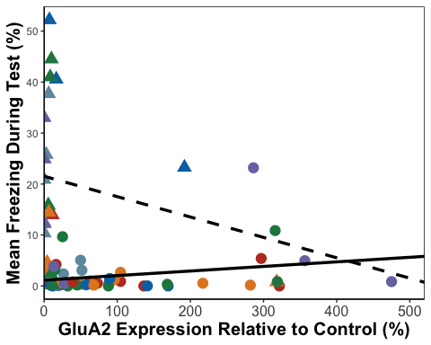

PLTest_A1

## Warning: Removed 10 rows containing missing values or values outside the scale range  
## (`geom_point()`).

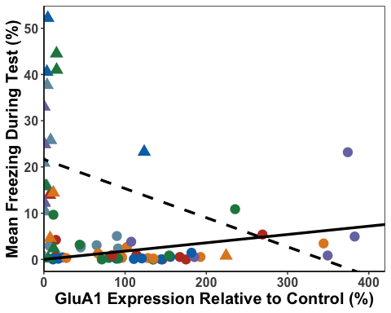

PLTest_N2B

## Warning: Removed 10 rows containing missing values or values outside the scale range  
## (`geom_point()`).

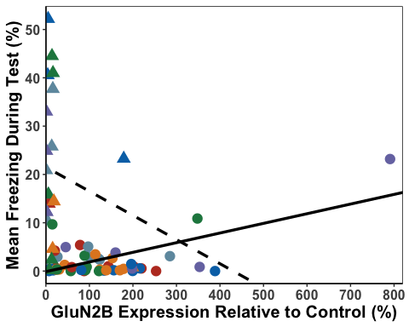

PLT_A1<- PLData %>%   
 group_by(SEFL) %>%  
 cor_test(Total_Freezing_During_Test, PLGluA1, method="pearson")  
  
#resilient - r=0.41, p<0.01  
#susceptible = r=-0.21, p=0.34  
  
PLT_A2<- PLData %>%   
 group_by(SEFL) %>%  
 cor_test(Total_Freezing_During_Test, PLGluA2, method="pearson")  
  
#resilient - r=0.28, p<0.05  
#susceptible = r=-0.21, p=0.35  
  
PLT_N2B<- PLData %>%   
 group_by(SEFL) %>%  
 cor_test(Total_Freezing_During_Test, PLGluN2B, method="pearson")  
  
#resilient - r=0.56, p<0.05  
#susceptible = r=-0.17, p=0.35  
  
  
  
PLResilientT_A1 <- FisherZ(0.41)  
PLSusceptibleT_A1 <- FisherZ(-0.21)  
  
PLResilientT_A2 <- FisherZ(0.28)  
PLSusceptibleT_A2 <- FisherZ(-0.21)  
  
PLResilientT_N2B <- FisherZ(0.56)  
PLSusceptibleT_N2B <- FisherZ(-0.17)  
  
#A1  
  
#n resilient = 51  
#n susceptible = 20  
  
N1 <- 1/(51-3)  
N2 <- 1/(20-3)  
  
N <- N1 + N2  
  
ZT_1 <- (PLResilientT_A1 -PLSusceptibleT_A1)  
  
PLZdiffT_A1 <- ZT_1/sqrt(N)  
PLZdiffT_A1

## [1] 2.298728

# 2.30 = significant  
  
#A2  
  
#n resilient = 53  
#n susceptible = 21  
  
N1b <- 1/(53-3)  
N2b <- 1/(21-3)  
  
Nb <- N1b + N2b  
  
ZT_2 <- (PLResilientT_A2 -PLSusceptibleT_A2)  
  
PLZdiffT_A2 <- ZT_2/sqrt(Nb)  
PLZdiffT_A2

## [1] 1.822122

#1.82 not significant  
  
#N2B  
  
#n resilient = 52  
#n susceptible = 21  
  
N1c <- 1/(52-3)  
N2c <- 1/(21-3)  
  
Nc <- N1c + N2c  
ZT_3 <- (PLResilientT_N2B -PLSusceptibleT_N2B)  
  
PLZdiffT_N2B <- ZT_3/sqrt(Nc)  
PLZdiffT_N2B

## [1] 2.918924

# 2.92 significant

PLResRGluN2B <- lm(Recovery_Index ~ PLGluN2B, data = resilientPL)  
PLResRGluN2B

##   
## Call:  
## lm(formula = Recovery_Index ~ PLGluN2B, data = resilientPL)  
##   
## Coefficients:  
## (Intercept) PLGluN2B   
## 3.04246 -0.04403

#y = -0.0053x - 2.17  
  
PLSusRGluN2B <- lm(Recovery_Index ~ PLGluN2B, data = susceptiblePL)  
PLSusRGluN2B

##   
## Call:  
## lm(formula = Recovery_Index ~ PLGluN2B, data = susceptiblePL)  
##   
## Coefficients:  
## (Intercept) PLGluN2B   
## 13.15004 -0.05529

#y = 0.008x + 11.62  
  
PLResRGluA1 <- lm(Recovery_Index ~ PLGluA1, data = resilientPL)  
PLResRGluA1

##   
## Call:  
## lm(formula = Recovery_Index ~ PLGluA1, data = resilientPL)  
##   
## Coefficients:  
## (Intercept) PLGluA1   
## 0.62122 -0.02847

#y = -0.002x - 2.45  
  
PLSusRGluA1 <- lm(Recovery_Index ~ PLGluA1, data = susceptiblePL)  
PLSusRGluA1

##   
## Call:  
## lm(formula = Recovery_Index ~ PLGluA1, data = susceptiblePL)  
##   
## Coefficients:  
## (Intercept) PLGluA1   
## 12.95207 -0.05484

#y = 0.03x + 11.30  
  
PLResRGluA2 <- lm(Recovery_Index ~ PLGluA2, data = resilientPL)  
PLResRGluA2

##   
## Call:  
## lm(formula = Recovery_Index ~ PLGluA2, data = resilientPL)  
##   
## Coefficients:  
## (Intercept) PLGluA2   
## -1.21040 -0.01547

#y = 0.006x - 3.28  
  
PLSusRGluA2 <- lm(Recovery_Index ~ PLGluA2, data = susceptiblePL)  
PLSusRGluA2

##   
## Call:  
## lm(formula = Recovery_Index ~ PLGluA2, data = susceptiblePL)  
##   
## Coefficients:  
## (Intercept) PLGluA2   
## 13.14024 -0.04702

#y = 0.023x + 11.17  
  
PLRec_A2 <- ggplot(PLData,  
 aes(x = PLGluA2,  
 y = Recovery_Index, color = Shock, shape = SEFL)) +  
 geom_point(aes(color = Shock), size = 4) +  
 scale_fill_nejm() +  
 scale_color_nejm() +  
 theme(panel.grid.major = element_blank(), panel.grid.minor = element_blank(),  
 panel.background = element_rect(colour = "black", fill = "white"),   
 axis.line = element_line(colour = "black")) + theme(legend.title = element_blank()) +   
 geom_abline(intercept = -3.28, slope = 0.006, size = 1.2) +  
 geom_abline(intercept = 11.17, slope = -0.023, linetype = "dashed", size = 1.2) +  
 theme(legend.position="none") +  
 theme(axis.text.x=element_text(size = 12, face = "bold"), axis.text.y=element_text(size = 12, face = "bold"),axis.title =element_text(size=15,face="bold")) +  
 labs(x="GluA2 Expression Relative to Control (%)", y="Recovery Index (%)") +  
 scale_x_continuous(limits=c(0, 520), breaks = c(0,100,200,300,400,500), expand = c(0,0))  
  
PLRec_N2B <- ggplot(PLData,  
 aes(x = PLGluN2B,  
 y = Recovery_Index, color = Shock, shape = SEFL)) +  
 geom_point(aes(color = Shock), size = 4) +  
 scale_fill_nejm() +  
 scale_color_nejm() +  
 theme(panel.grid.major = element_blank(), panel.grid.minor = element_blank(),  
 panel.background = element_rect(colour = "black", fill = "white"),   
 axis.line = element_line(colour = "black")) + theme(legend.title = element_blank()) +   
 geom_abline(intercept = -2.17, slope = -0.0053, size = 1.2) +  
 geom_abline(intercept = 11.62, slope = 0.008, linetype = "dashed", size = 1.2) +  
 theme(legend.position="none") +  
 theme(axis.text.x=element_text(size = 12, face = "bold"), axis.text.y=element_text(size = 12, face = "bold"),axis.title =element_text(size=15,face="bold")) +  
 labs(x="GluN2B Expression Relative to Control (%)", y="Recovery Index (%)") +  
 scale_x_continuous(limits=c(0, 820), breaks = c(0,100,200,300,400,500,600,700,800), expand = c(0,0))  
  
PLRec_A1 <- ggplot(PLData,  
 aes(x = PLGluA1,  
 y = Recovery_Index, color = Shock, shape = SEFL)) +  
 geom_point(aes(color = Shock), size = 4) +  
 scale_fill_nejm() +  
 scale_color_nejm() +  
 theme(panel.grid.major = element_blank(), panel.grid.minor = element_blank(),  
 panel.background = element_rect(colour = "black", fill = "white"),   
 axis.line = element_line(colour = "black")) + theme(legend.title = element_blank()) +   
 geom_abline(intercept = -2.45, slope = -0.002, size = 1.2) +  
 geom_abline(intercept = 11.3, slope = 0.03, linetype = "dashed", size = 1.2) +  
 theme(legend.position="none") +  
 theme(axis.text.x=element_text(size = 12, face = "bold"), axis.text.y=element_text(size = 12, face = "bold"),axis.title =element_text(size=15,face="bold")) +  
 labs(x="GluA1 Expression Relative to Control (%)", y="Recovery Index (%)") +  
 theme(legend.position = "none") +  
 scale_x_continuous(limits=c(0, 420), breaks = c(0,100,200,300,400), expand = c(0,0))  
  
  
PLRec_A2

## Warning: Removed 10 rows containing missing values or values outside the scale range  
## (`geom_point()`).

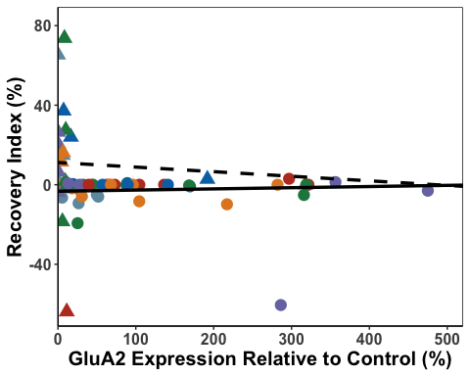

PLRec_A1

## Warning: Removed 10 rows containing missing values or values outside the scale range  
## (`geom_point()`).

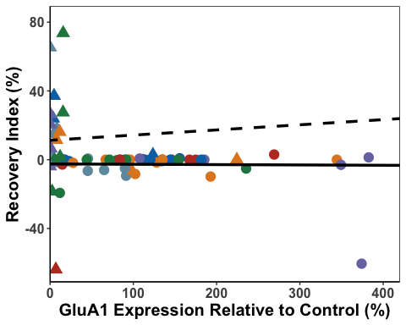

PLRec_N2B

## Warning: Removed 10 rows containing missing values or values outside the scale range  
## (`geom_point()`).

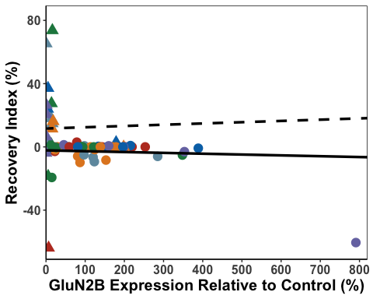

PLR_A1<- PLData %>%   
 group_by(SEFL) %>%  
 cor_test(Recovery_Index, PLGluA1, method="pearson")  
  
#resilient - r=-0.33, p<0.05  
#susceptible = r=-0.10, p=0.65  
  
PLR_A2<- PLData %>%   
 group_by(SEFL) %>%  
 cor_test(Recovery_Index, PLGluA2, method="pearson")  
  
#resilient - r=-0.20, p=0.16  
#susceptible = r=-0.13, p=0.56  
  
PLR_N2B<- PLData %>%   
 group_by(SEFL) %>%  
 cor_test(Recovery_Index, PLGluN2B, method="pearson")  
  
#resilient - r=-0.66, p<0.0001  
#susceptible = r=-0.11, p=0.63  
  
PLResilientR_A1 <- FisherZ(-0.33)  
PLSusceptibleR_A1 <- FisherZ(-0.10)  
  
PLResilientR_A2 <- FisherZ(-0.20)  
PLSusceptibleR_A2 <- FisherZ(-0.13)  
  
PLResilientR_N2B <- FisherZ(-0.66)  
PLSusceptibleR_N2B <- FisherZ(-0.11)  
  
#A1  
  
#n resilient = 51  
#n susceptible = 20  
  
N1 <- 1/(51-3)  
N2 <- 1/(20-3)  
  
N <- N1 + N2  
  
ZR_1 <- (PLResilientR_A1 -PLSusceptibleR_A1)  
  
PLZdiffR_A1 <- ZR_1/sqrt(N)  
PLZdiffR_A1

## [1] -0.8591865

# -0.86 not significant  
  
#A2  
  
#n resilient = 53  
#n susceptible = 21  
  
N1b <- 1/(53-3)  
N2b <- 1/(21-3)  
  
Nb <- N1b + N2b  
  
ZR_2 <- (PLResilientR_A2 -PLSusceptibleR_A2)  
  
PLZdiffR_A2 <- ZR_2/sqrt(Nb)  
PLZdiffR_A2

## [1] -0.2619119

# -0.26 not significant  
  
#N2B  
  
#n resilient = 52  
#n susceptible = 21  
  
N1c <- 1/(52-3)  
N2c <- 1/(21-3)  
  
Nc <- N1c + N2c  
ZR_3 <- (PLResilientR_N2B -PLSusceptibleR_N2B)  
  
PLZdiffR_N2B <- ZR_3/sqrt(Nc)  
PLZdiffR_N2B

## [1] -2.475795

# -2.48 significant

PLcorGraph <- ggarrange(PLFF_N2B, PLFF_A1, PLFF_A2, PLE3_N2B, PLE3_A1, PLE3_A2, PLTest_N2B, PLTest_A1, PLTest_A2, PLRec_N2B, PLRec_A1, PLRec_A2,  
 labels = c("a", "", "","b", "", "","c", "", "","d", "", ""),  
 font.label = list(size = 24, face = "bold"),  
 ncol = 3, nrow = 4) +  
 theme(plot.margin = margin(0.1,1.5,0.1,1.5, "cm"))

## Warning: Removed 10 rows containing missing values or values outside the scale range  
## (`geom_point()`).  
## Removed 10 rows containing missing values or values outside the scale range  
## (`geom_point()`).  
## Removed 10 rows containing missing values or values outside the scale range  
## (`geom_point()`).  
## Removed 10 rows containing missing values or values outside the scale range  
## (`geom_point()`).  
## Removed 10 rows containing missing values or values outside the scale range  
## (`geom_point()`).  
## Removed 10 rows containing missing values or values outside the scale range  
## (`geom_point()`).  
## Removed 10 rows containing missing values or values outside the scale range  
## (`geom_point()`).  
## Removed 10 rows containing missing values or values outside the scale range  
## (`geom_point()`).  
## Removed 10 rows containing missing values or values outside the scale range  
## (`geom_point()`).  
## Removed 10 rows containing missing values or values outside the scale range  
## (`geom_point()`).  
## Removed 10 rows containing missing values or values outside the scale range  
## (`geom_point()`).  
## Removed 10 rows containing missing values or values outside the scale range  
## (`geom_point()`).

PLcorGraph

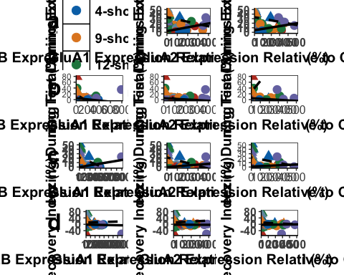

ggsave('PLcorGraph', PLcorGraph, width=25, height=36, units='in', device = "tiff", dpi = 300)

dHpc Analysis

dHpcGluN2BData <- select(AllData, c("Rat","SEFL","Shock", "dHpcGluN2B"))  
#remove outlier  
dHpcGluN2BData <- dHpcGluN2BData[-c(3), ]  
  
#first we visualise the data  
  
ggplot(dHpcGluN2BData,  
 aes( x = Shock, y = dHpcGluN2B)) +  
 geom_boxplot()

## Warning: Removed 9 rows containing non-finite outside the scale range  
## (`stat_boxplot()`).

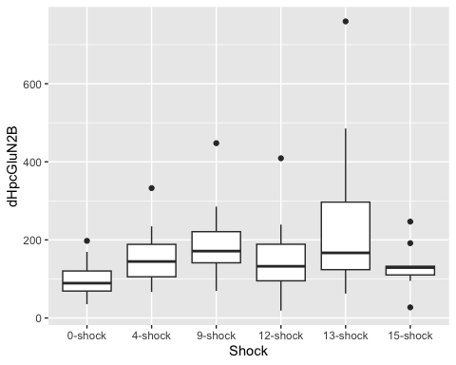

ggplot(dHpcGluN2BData,  
 aes( x = SEFL, y = dHpcGluN2B)) +  
 geom_boxplot()

## Warning: Removed 9 rows containing non-finite outside the scale range  
## (`stat_boxplot()`).

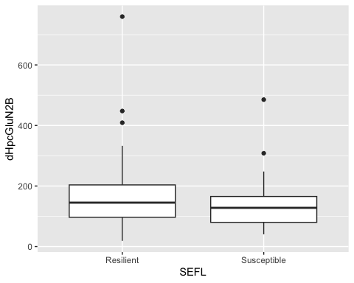

ggplot(dHpcGluN2BData,  
 aes( x = Shock, y = dHpcGluN2B, fill = SEFL)) +  
 geom_boxplot()

## Warning: Removed 9 rows containing non-finite outside the scale range  
## (`stat_boxplot()`).

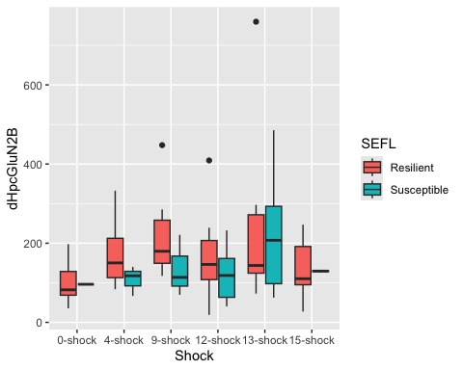

#Linear model for GluN2B data  
  
lm_dHpcGluN2B <- lm(dHpcGluN2B ~ Shock + SEFL + Shock:SEFL,  
 data = dHpcGluN2BData)  
  
#check assumptions  
  
resid_panel(lm_dHpcGluN2B,  
 plots = c("resid", "qq", "ls", "cookd"),  
 smoother = TRUE)

## Warning in sqrt((n - p - sr^2)/(n - p - 1)): NaNs produced

## `geom_smooth()` using formula = 'y ~ x'  
## `geom_smooth()` using formula = 'y ~ x'

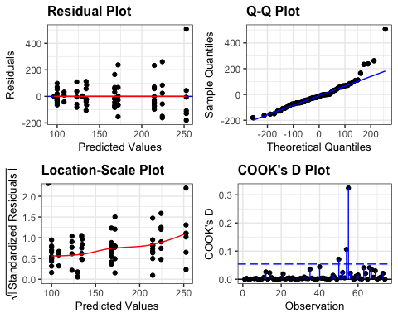

resid_dHpcGluN2B <- residuals(lm_dHpcGluN2B)  
  
shapiro.test(resid_dHpcGluN2B)

##   
## Shapiro-Wilk normality test  
##   
## data: resid_dHpcGluN2B  
## W = 0.86241, p-value = 9.719e-07

levene_test(dHpcGluN2BData, dHpcGluN2B ~ Shock * SEFL)

## # A tibble: 1 × 4  
## df1 df2 statistic p  
## <int> <int> <dbl> <dbl>  
## 1 11 62 1.13 0.353

#data is not normal (shapiro test = significant)  
#but ANOVA is robust to these issues and we have homogeneity of variance  
  
anova(lm_dHpcGluN2B)

## Analysis of Variance Table  
##   
## Response: dHpcGluN2B  
## Df Sum Sq Mean Sq F value Pr(>F)   
## Shock 5 153486 30697.2 2.3907 0.04776 *  
## SEFL 1 23554 23554.1 1.8344 0.18053   
## Shock:SEFL 5 9262 1852.4 0.1443 0.98103   
## Residuals 62 796107 12840.4   
## ---  
## Signif. codes: 0 '***' 0.001 '**' 0.01 '*' 0.05 '.' 0.1 ' ' 1

options(es.use_symbols = TRUE)   
  
eta_squared(lm_dHpcGluN2B, partial = FALSE)

## # Effect Size for ANOVA (Type I)  
##   
## Parameter | η² | 95% CI  
## ------------------------------------  
## Shock | 0.16 | [0.00, 1.00]  
## SEFL | 0.02 | [0.00, 1.00]  
## Shock:SEFL | 9.43e-03 | [0.00, 1.00]  
##   
## - One-sided CIs: upper bound fixed at [1.00].

#significant effect of Shock * Shock: F(5,62) = 2.39, p < 0.05, eta = 0.16  
  
#we now do pairwise comparisons  
tukdHpcGluN2B <- tukey_hsd(lm_dHpcGluN2B)  
print(tukdHpcGluN2B, n=82)

## # A tibble: 82 × 9  
## term group1 group2 null.value estimate conf.low conf.high p.adj  
## * <chr> <chr> <chr> <dbl> <dbl> <dbl> <dbl> <dbl>  
## 1 Shock 0-shock 4-sho… 0 55.5 -72.9 184. 0.8   
## 2 Shock 0-shock 9-sho… 0 96.6 -34.1 227. 0.265   
## 3 Shock 0-shock 12-sh… 0 51.9 -81.4 185. 0.86   
## 4 Shock 0-shock 13-sh… 0 140. 9.11 271. 0.0292  
## 5 Shock 0-shock 15-sh… 0 32.4 -112. 177. 0.986   
## 6 Shock 4-shock 9-sho… 0 41.1 -87.2 169. 0.934   
## 7 Shock 4-shock 12-sh… 0 -3.51 -135. 128. 1   
## 8 Shock 4-shock 13-sh… 0 84.3 -44.0 213. 0.393   
## 9 Shock 4-shock 15-sh… 0 -23.0 -165. 119. 0.997   
## 10 Shock 9-shock 12-sh… 0 -44.6 -178. 88.8 0.921   
## 11 Shock 9-shock 13-sh… 0 43.2 -87.5 174. 0.925   
## 12 Shock 9-shock 15-sh… 0 -64.2 -209. 80.3 0.781   
## 13 Shock 12-shock 13-sh… 0 87.9 -45.5 221. 0.39   
## 14 Shock 12-shock 15-sh… 0 -19.5 -166. 127. 0.999   
## 15 Shock 13-shock 15-sh… 0 -107. -252. 37.1 0.259   
## 16 SEFL Resilient Susce… 0 -37.1 -94.7 20.5 0.203   
## 17 Shock:SEFL 0-shock:Resi… 4-sho… 0 68.0 -92.6 229. 0.951   
## 18 Shock:SEFL 0-shock:Resi… 9-sho… 0 115. -50.0 280. 0.444   
## 19 Shock:SEFL 0-shock:Resi… 12-sh… 0 72.0 -111. 255. 0.971   
## 20 Shock:SEFL 0-shock:Resi… 13-sh… 0 153. -30.4 336. 0.193   
## 21 Shock:SEFL 0-shock:Resi… 15-sh… 0 34.2 -171. 239. 1   
## 22 Shock:SEFL 0-shock:Resi… 0-sho… 0 -3.81 -404. 397. 1   
## 23 Shock:SEFL 0-shock:Resi… 4-sho… 0 8.15 -240. 257. 1   
## 24 Shock:SEFL 0-shock:Resi… 9-sho… 0 34.8 -214. 283. 1   
## 25 Shock:SEFL 0-shock:Resi… 12-sh… 0 23.2 -182. 228. 1   
## 26 Shock:SEFL 0-shock:Resi… 13-sh… 0 124. -68.2 317. 0.561   
## 27 Shock:SEFL 0-shock:Resi… 15-sh… 0 29.6 -193. 252. 1   
## 28 Shock:SEFL 4-shock:Resi… 9-sho… 0 46.8 -121. 215. 0.998   
## 29 Shock:SEFL 4-shock:Resi… 12-sh… 0 4.00 -182. 190. 1   
## 30 Shock:SEFL 4-shock:Resi… 13-sh… 0 84.6 -101. 271. 0.922   
## 31 Shock:SEFL 4-shock:Resi… 15-sh… 0 -33.8 -241. 174. 1   
## 32 Shock:SEFL 4-shock:Resi… 0-sho… 0 -71.8 -474. 330. 1   
## 33 Shock:SEFL 4-shock:Resi… 4-sho… 0 -59.8 -310. 191. 1   
## 34 Shock:SEFL 4-shock:Resi… 9-sho… 0 -33.2 -284. 217. 1   
## 35 Shock:SEFL 4-shock:Resi… 12-sh… 0 -44.8 -252. 163. 1   
## 36 Shock:SEFL 4-shock:Resi… 13-sh… 0 56.3 -139. 252. 0.998   
## 37 Shock:SEFL 4-shock:Resi… 15-sh… 0 -38.4 -263. 186. 1   
## 38 Shock:SEFL 9-shock:Resi… 12-sh… 0 -42.8 -232. 147. 1   
## 39 Shock:SEFL 9-shock:Resi… 13-sh… 0 37.8 -152. 227. 1   
## 40 Shock:SEFL 9-shock:Resi… 15-sh… 0 -80.6 -291. 130. 0.976   
## 41 Shock:SEFL 9-shock:Resi… 0-sho… 0 -119. -522. 285. 0.997   
## 42 Shock:SEFL 9-shock:Resi… 4-sho… 0 -107. -360. 147. 0.953   
## 43 Shock:SEFL 9-shock:Resi… 9-sho… 0 -80.0 -333. 173. 0.995   
## 44 Shock:SEFL 9-shock:Resi… 12-sh… 0 -91.6 -302. 119. 0.942   
## 45 Shock:SEFL 9-shock:Resi… 13-sh… 0 9.48 -189. 208. 1   
## 46 Shock:SEFL 9-shock:Resi… 15-sh… 0 -85.2 -313. 142. 0.98   
## 47 Shock:SEFL 12-shock:Res… 13-sh… 0 80.6 -125. 286. 0.972   
## 48 Shock:SEFL 12-shock:Res… 15-sh… 0 -37.8 -263. 188. 1   
## 49 Shock:SEFL 12-shock:Res… 0-sho… 0 -75.8 -487. 336. 1   
## 50 Shock:SEFL 12-shock:Res… 4-sho… 0 -63.8 -329. 202. 1   
## 51 Shock:SEFL 12-shock:Res… 9-sho… 0 -37.2 -303. 228. 1   
## 52 Shock:SEFL 12-shock:Res… 12-sh… 0 -48.8 -274. 177. 1   
## 53 Shock:SEFL 12-shock:Res… 13-sh… 0 52.3 -162. 266. 0.999   
## 54 Shock:SEFL 12-shock:Res… 15-sh… 0 -42.4 -284. 199. 1   
## 55 Shock:SEFL 13-shock:Res… 15-sh… 0 -118. -344. 107. 0.82   
## 56 Shock:SEFL 13-shock:Res… 0-sho… 0 -156. -568. 255. 0.977   
## 57 Shock:SEFL 13-shock:Res… 4-sho… 0 -144. -410. 121. 0.786   
## 58 Shock:SEFL 13-shock:Res… 9-sho… 0 -118. -383. 148. 0.933   
## 59 Shock:SEFL 13-shock:Res… 12-sh… 0 -129. -355. 95.9 0.723   
## 60 Shock:SEFL 13-shock:Res… 13-sh… 0 -28.4 -242. 186. 1   
## 61 Shock:SEFL 13-shock:Res… 15-sh… 0 -123. -364. 118. 0.846   
## 62 Shock:SEFL 15-shock:Res… 0-sho… 0 -38.0 -460. 384. 1   
## 63 Shock:SEFL 15-shock:Res… 4-sho… 0 -26.0 -307. 255. 1   
## 64 Shock:SEFL 15-shock:Res… 9-sho… 0 0.563 -280. 282. 1   
## 65 Shock:SEFL 15-shock:Res… 12-sh… 0 -11.0 -254. 232. 1   
## 66 Shock:SEFL 15-shock:Res… 13-sh… 0 90.1 -143. 323. 0.974   
## 67 Shock:SEFL 15-shock:Res… 15-sh… 0 -4.61 -263. 254. 1   
## 68 Shock:SEFL 0-shock:Susc… 4-sho… 0 12.0 -432. 456. 1   
## 69 Shock:SEFL 0-shock:Susc… 9-sho… 0 38.6 -406. 483. 1   
## 70 Shock:SEFL 0-shock:Susc… 12-sh… 0 27.0 -395. 449. 1   
## 71 Shock:SEFL 0-shock:Susc… 13-sh… 0 128. -288. 544. 0.996   
## 72 Shock:SEFL 0-shock:Susc… 15-sh… 0 33.4 -397. 464. 1   
## 73 Shock:SEFL 4-shock:Susc… 9-sho… 0 26.6 -288. 341. 1   
## 74 Shock:SEFL 4-shock:Susc… 12-sh… 0 15.0 -266. 296. 1   
## 75 Shock:SEFL 4-shock:Susc… 13-sh… 0 116. -156. 388. 0.948   
## 76 Shock:SEFL 4-shock:Susc… 15-sh… 0 21.4 -272. 315. 1   
## 77 Shock:SEFL 9-shock:Susc… 12-sh… 0 -11.6 -293. 269. 1   
## 78 Shock:SEFL 9-shock:Susc… 13-sh… 0 89.5 -183. 362. 0.993   
## 79 Shock:SEFL 9-shock:Susc… 15-sh… 0 -5.17 -299. 289. 1   
## 80 Shock:SEFL 12-shock:Sus… 13-sh… 0 101. -132. 334. 0.942   
## 81 Shock:SEFL 12-shock:Sus… 15-sh… 0 6.39 -252. 265. 1   
## 82 Shock:SEFL 13-shock:Sus… 15-sh… 0 -94.7 -343. 154. 0.977   
## # ℹ 1 more variable: p.adj.signif <chr>

# 0-shock - 13-shock p.adj < 0.05  
  
dHpcsummaryGluN2B <- dHpcGluN2BData %>%  
 group_by(Shock, SEFL) %>%  
 get_summary_stats(type = "common")

## Warning: There was 1 warning in `mutate()`.  
## ℹ In argument: `ci = abs(stats::qt(alpha/2, .data$n - 1) * .data$se)`.  
## Caused by warning:  
## ! There was 1 warning in `mutate()`.  
## ℹ In argument: `ci = abs(stats::qt(alpha/2, .data$n - 1) * .data$se)`.  
## Caused by warning in `stats::qt()`:  
## ! NaNs produced

#first we visualise the data  
  
dHpcGluA1Data <- select(AllData, c("Rat","SEFL","Shock", "dHpcGluA1"))  
#remove otulier  
dHpcGluA1Data <- dHpcGluA1Data[-c(25), ]  
  
ggplot(dHpcGluA1Data,  
 aes( x = Shock, y = dHpcGluA1)) +  
 geom_boxplot()

## Warning: Removed 9 rows containing non-finite outside the scale range  
## (`stat_boxplot()`).

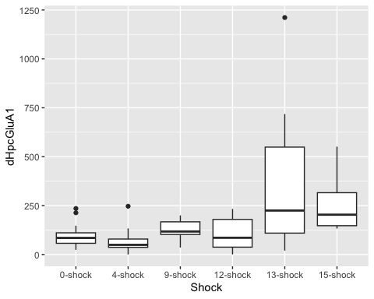

ggplot(dHpcGluA1Data,  
 aes( x = SEFL, y = dHpcGluA1)) +  
 geom_boxplot()

## Warning: Removed 9 rows containing non-finite outside the scale range  
## (`stat_boxplot()`).

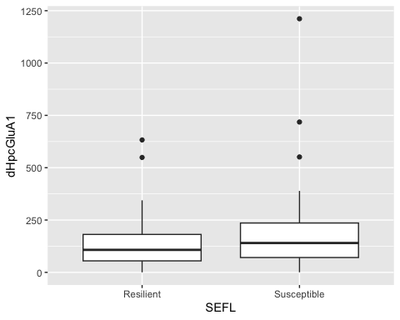

ggplot(dHpcGluA1Data,  
 aes( x = Shock, y = dHpcGluA1, fill = SEFL)) +  
 geom_boxplot()

## Warning: Removed 9 rows containing non-finite outside the scale range  
## (`stat_boxplot()`).

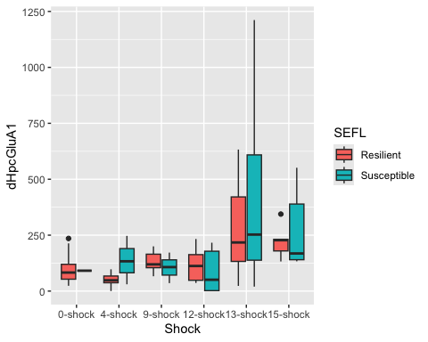

#Linear model for GluA1 data  
  
lm_dHpcGluA1 <- lm(dHpcGluA1 ~ Shock + SEFL + Shock:SEFL,  
 data = dHpcGluA1Data)  
  
#check assumptions  
  
resid_panel(lm_dHpcGluA1,  
 plots = c("resid", "qq", "ls", "cookd"),  
 smoother = TRUE)

## Warning in sqrt((n - p - sr^2)/(n - p - 1)): NaNs produced

## `geom_smooth()` using formula = 'y ~ x'  
## `geom_smooth()` using formula = 'y ~ x'

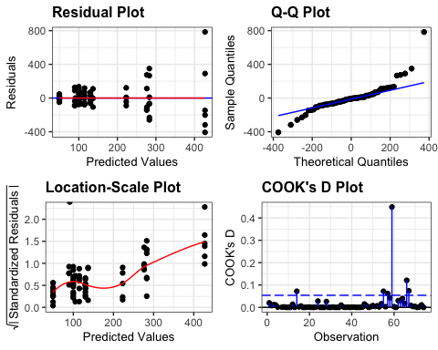

resid_dHpcGluA1 <- residuals(lm_dHpcGluA1)  
  
shapiro.test(resid_dHpcGluA1)

##   
## Shapiro-Wilk normality test  
##   
## data: resid_dHpcGluA1  
## W = 0.83467, p-value = 1.236e-07

levene_test(dHpcGluA1Data, dHpcGluA1 ~ Shock * SEFL)

## # A tibble: 1 × 4  
## df1 df2 statistic p  
## <int> <int> <dbl> <dbl>  
## 1 11 62 2.68 0.00690

#data is normal and we have homogeneity of variance  
  
anova(lm_dHpcGluA1)

## Analysis of Variance Table  
##   
## Response: dHpcGluA1  
## Df Sum Sq Mean Sq F value Pr(>F)   
## Shock 5 754458 150892 5.5069 0.000294 ***  
## SEFL 1 30839 30839 1.1255 0.292854   
## Shock:SEFL 5 64711 12942 0.4723 0.795460   
## Residuals 62 1698822 27400   
## ---  
## Signif. codes: 0 '***' 0.001 '**' 0.01 '*' 0.05 '.' 0.1 ' ' 1

eta_squared(lm_dHpcGluA1, partial = FALSE)

## # Effect Size for ANOVA (Type I)  
##   
## Parameter | η² | 95% CI  
## --------------------------------  
## Shock | 0.30 | [0.11, 1.00]  
## SEFL | 0.01 | [0.00, 1.00]  
## Shock:SEFL | 0.03 | [0.00, 1.00]  
##   
## - One-sided CIs: upper bound fixed at [1.00].

#significant effect of Shock *** Shock: F(5,62) = 5.51, p < 0.001, eta = 0.30  
  
tukdHpcA1 <- tukey_hsd(lm_dHpcGluA1)  
print(tukdHpcA1, n=82)

## # A tibble: 82 × 9  
## term group1 group2 null.value estimate conf.low conf.high p.adj  
## * <chr> <chr> <chr> <dbl> <dbl> <dbl> <dbl> <dbl>  
## 1 Shock 0-shock 4-sho… 0 -29.7 -221. 161. 9.97e-1  
## 2 Shock 0-shock 9-sho… 0 25.0 -166. 216. 9.99e-1  
## 3 Shock 0-shock 12-sh… 0 4.99 -190. 200. 1 e+0  
## 4 Shock 0-shock 13-sh… 0 250. 59.3 441. 3.62e-3  
## 5 Shock 0-shock 15-sh… 0 150. -54.4 355. 2.72e-1  
## 6 Shock 4-shock 9-sho… 0 54.7 -136. 246. 9.58e-1  
## 7 Shock 4-shock 12-sh… 0 34.7 -160. 230. 9.95e-1  
## 8 Shock 4-shock 13-sh… 0 280. 89.0 471. 8.08e-4  
## 9 Shock 4-shock 15-sh… 0 180. -24.7 385. 1.16e-1  
## 10 Shock 9-shock 12-sh… 0 -20.0 -215. 175. 1 e+0  
## 11 Shock 9-shock 13-sh… 0 225. 34.3 416. 1.18e-2  
## 12 Shock 9-shock 15-sh… 0 125. -79.4 330. 4.73e-1  
## 13 Shock 12-shock 13-sh… 0 245. 50.4 440. 5.84e-3  
## 14 Shock 12-shock 15-sh… 0 145. -63.1 354. 3.26e-1  
## 15 Shock 13-shock 15-sh… 0 -99.9 -305. 105. 7.06e-1  
## 16 SEFL Resilient Susce… 0 41.7 -41.4 125. 3.19e-1  
## 17 Shock:SEFL 0-shock:Res… 4-sho… 0 -50.5 -291. 190. 1 e+0  
## 18 Shock:SEFL 0-shock:Res… 9-sho… 0 30.2 -211. 271. 1 e+0  
## 19 Shock:SEFL 0-shock:Res… 12-sh… 0 14.9 -252. 282. 1 e+0  
## 20 Shock:SEFL 0-shock:Res… 13-sh… 0 183. -84.4 450. 4.72e-1  
## 21 Shock:SEFL 0-shock:Res… 15-sh… 0 123. -176. 422. 9.6 e-1  
## 22 Shock:SEFL 0-shock:Res… 0-sho… 0 -8.82 -594. 576. 1 e+0  
## 23 Shock:SEFL 0-shock:Res… 4-sho… 0 36.8 -326. 400. 1 e+0  
## 24 Shock:SEFL 0-shock:Res… 9-sho… 0 5.00 -358. 368. 1 e+0  
## 25 Shock:SEFL 0-shock:Res… 12-sh… 0 -10.5 -310. 289. 1 e+0  
## 26 Shock:SEFL 0-shock:Res… 13-sh… 0 327. 46.3 608. 9.92e-3  
## 27 Shock:SEFL 0-shock:Res… 15-sh… 0 176. -123. 476. 6.9 e-1  
## 28 Shock:SEFL 4-shock:Res… 9-sho… 0 80.7 -171. 332. 9.94e-1  
## 29 Shock:SEFL 4-shock:Res… 12-sh… 0 65.4 -212. 342. 1 e+0  
## 30 Shock:SEFL 4-shock:Res… 13-sh… 0 233. -43.6 510. 1.81e-1  
## 31 Shock:SEFL 4-shock:Res… 15-sh… 0 173. -134. 481. 7.46e-1  
## 32 Shock:SEFL 4-shock:Res… 0-sho… 0 41.7 -548. 631. 1 e+0  
## 33 Shock:SEFL 4-shock:Res… 4-sho… 0 87.3 -283. 457. 1 e+0  
## 34 Shock:SEFL 4-shock:Res… 9-sho… 0 55.5 -315. 426. 1 e+0  
## 35 Shock:SEFL 4-shock:Res… 12-sh… 0 40.0 -268. 348. 1 e+0  
## 36 Shock:SEFL 4-shock:Res… 13-sh… 0 378. 87.6 668. 2.21e-3  
## 37 Shock:SEFL 4-shock:Res… 15-sh… 0 227. -81.0 535. 3.58e-1  
## 38 Shock:SEFL 9-shock:Res… 12-sh… 0 -15.3 -292. 262. 1 e+0  
## 39 Shock:SEFL 9-shock:Res… 13-sh… 0 153. -124. 430. 7.71e-1  
## 40 Shock:SEFL 9-shock:Res… 15-sh… 0 92.8 -215. 401. 9.97e-1  
## 41 Shock:SEFL 9-shock:Res… 0-sho… 0 -39.0 -629. 551. 1 e+0  
## 42 Shock:SEFL 9-shock:Res… 4-sho… 0 6.64 -363. 377. 1 e+0  
## 43 Shock:SEFL 9-shock:Res… 9-sho… 0 -25.2 -395. 345. 1 e+0  
## 44 Shock:SEFL 9-shock:Res… 12-sh… 0 -40.7 -349. 267. 1 e+0  
## 45 Shock:SEFL 9-shock:Res… 13-sh… 0 297. 6.94 587. 4.02e-2  
## 46 Shock:SEFL 9-shock:Res… 15-sh… 0 146. -162. 454. 8.98e-1  
## 47 Shock:SEFL 12-shock:Re… 13-sh… 0 168. -132. 468. 7.55e-1  
## 48 Shock:SEFL 12-shock:Re… 15-sh… 0 108. -221. 437. 9.93e-1  
## 49 Shock:SEFL 12-shock:Re… 0-sho… 0 -23.7 -625. 577. 1 e+0  
## 50 Shock:SEFL 12-shock:Re… 4-sho… 0 21.9 -366. 410. 1 e+0  
## 51 Shock:SEFL 12-shock:Re… 9-sho… 0 -9.89 -398. 378. 1 e+0  
## 52 Shock:SEFL 12-shock:Re… 12-sh… 0 -25.4 -355. 304. 1 e+0  
## 53 Shock:SEFL 12-shock:Re… 13-sh… 0 312. -0.240 625. 5.03e-2  
## 54 Shock:SEFL 12-shock:Re… 15-sh… 0 161. -168. 491. 8.76e-1  
## 55 Shock:SEFL 13-shock:Re… 15-sh… 0 -60.0 -389. 269. 1 e+0  
## 56 Shock:SEFL 13-shock:Re… 0-sho… 0 -192. -793. 409. 9.94e-1  
## 57 Shock:SEFL 13-shock:Re… 4-sho… 0 -146. -534. 242. 9.79e-1  
## 58 Shock:SEFL 13-shock:Re… 9-sho… 0 -178. -566. 210. 9.17e-1  
## 59 Shock:SEFL 13-shock:Re… 12-sh… 0 -193. -523. 136. 6.94e-1  
## 60 Shock:SEFL 13-shock:Re… 13-sh… 0 144. -168. 457. 9.14e-1  
## 61 Shock:SEFL 13-shock:Re… 15-sh… 0 -6.55 -336. 323. 1 e+0  
## 62 Shock:SEFL 15-shock:Re… 0-sho… 0 -132. -748. 484. 1 e+0  
## 63 Shock:SEFL 15-shock:Re… 4-sho… 0 -86.2 -497. 324. 1 e+0  
## 64 Shock:SEFL 15-shock:Re… 9-sho… 0 -118. -528. 293. 9.98e-1  
## 65 Shock:SEFL 15-shock:Re… 12-sh… 0 -133. -489. 222. 9.79e-1  
## 66 Shock:SEFL 15-shock:Re… 13-sh… 0 204. -136. 545. 6.66e-1  
## 67 Shock:SEFL 15-shock:Re… 15-sh… 0 53.4 -302. 409. 1 e+0  
## 68 Shock:SEFL 0-shock:Sus… 4-sho… 0 45.6 -603. 695. 1 e+0  
## 69 Shock:SEFL 0-shock:Sus… 9-sho… 0 13.8 -635. 663. 1 e+0  
## 70 Shock:SEFL 0-shock:Sus… 12-sh… 0 -1.67 -617. 614. 1 e+0  
## 71 Shock:SEFL 0-shock:Sus… 13-sh… 0 336. -271. 943. 7.66e-1  
## 72 Shock:SEFL 0-shock:Sus… 15-sh… 0 185. -431. 801. 9.97e-1  
## 73 Shock:SEFL 4-shock:Sus… 9-sho… 0 -31.8 -491. 427. 1 e+0  
## 74 Shock:SEFL 4-shock:Sus… 12-sh… 0 -47.3 -458. 363. 1 e+0  
## 75 Shock:SEFL 4-shock:Sus… 13-sh… 0 291. -107. 688. 3.7 e-1  
## 76 Shock:SEFL 4-shock:Sus… 15-sh… 0 140. -271. 550. 9.91e-1  
## 77 Shock:SEFL 9-shock:Sus… 12-sh… 0 -15.5 -426. 395. 1 e+0  
## 78 Shock:SEFL 9-shock:Sus… 13-sh… 0 322. -75.1 720. 2.26e-1  
## 79 Shock:SEFL 9-shock:Sus… 15-sh… 0 171. -239. 582. 9.56e-1  
## 80 Shock:SEFL 12-shock:Su… 13-sh… 0 338. -2.50 678. 5.34e-2  
## 81 Shock:SEFL 12-shock:Su… 15-sh… 0 187. -169. 542. 8.2 e-1  
## 82 Shock:SEFL 13-shock:Su… 15-sh… 0 -151. -491. 189. 9.33e-1  
## # ℹ 1 more variable: p.adj.signif <chr>

#0-shock - 13-shock p.adj < 0.01  
#4-shock - 13-shock p.adj < 0.001  
#9-shock - 13-shock p.adj < 0.001  
#12-shock - 13-shock p.adj <0.01  
  
dHpcsummaryGluA1 <- dHpcGluA1Data %>%  
 group_by(Shock, SEFL) %>%  
 get_summary_stats(type = "common")

## Warning: There was 1 warning in `mutate()`.  
## ℹ In argument: `ci = abs(stats::qt(alpha/2, .data$n - 1) * .data$se)`.  
## Caused by warning:  
## ! There was 1 warning in `mutate()`.  
## ℹ In argument: `ci = abs(stats::qt(alpha/2, .data$n - 1) * .data$se)`.  
## Caused by warning in `stats::qt()`:  
## ! NaNs produced

dHpcGluA2Data <- select(AllData, c("Rat","SEFL","Shock", "dHpcGluA2"))  
  
#first we visualise the data  
ggplot(dHpcGluA2Data,  
 aes( x = Shock, y = dHpcGluA2)) +  
 geom_boxplot()

## Warning: Removed 9 rows containing non-finite outside the scale range  
## (`stat_boxplot()`).

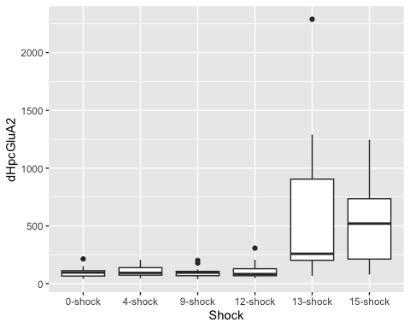

ggplot(dHpcGluA2Data,  
 aes( x = SEFL, y = dHpcGluA2)) +  
 geom_boxplot()

## Warning: Removed 9 rows containing non-finite outside the scale range  
## (`stat_boxplot()`).

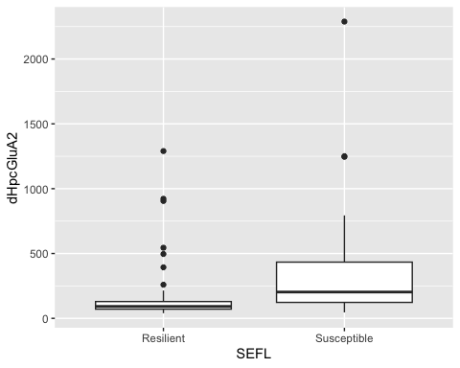

ggplot(dHpcGluA2Data,  
 aes( x = Shock, y = dHpcGluA2, fill = SEFL)) +  
 geom_boxplot()

## Warning: Removed 9 rows containing non-finite outside the scale range  
## (`stat_boxplot()`).

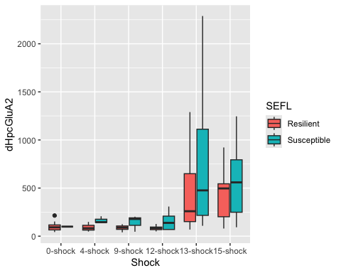

#Linear model for GluN2B data  
  
lm_dHpcGluA2 <- lm(dHpcGluA2 ~ Shock + SEFL + Shock:SEFL,  
 data = dHpcGluA2Data)  
  
#check assumptions  
  
resid_panel(lm_dHpcGluA2,  
 plots = c("resid", "qq", "ls", "cookd"),  
 smoother = TRUE)

## `geom_smooth()` using formula = 'y ~ x'  
## `geom_smooth()` using formula = 'y ~ x'

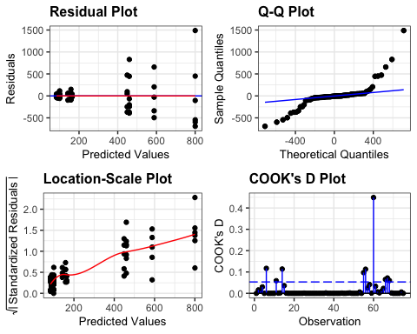

resid_dHpcGluA2 <- residuals(lm_dHpcGluA2)  
  
shapiro.test(resid_dHpcGluA2)

##   
## Shapiro-Wilk normality test  
##   
## data: resid_dHpcGluA2  
## W = 0.7416, p-value = 3.579e-10

levene_test(dHpcGluA2Data, dHpcGluA2 ~ Shock * SEFL)

## # A tibble: 1 × 4  
## df1 df2 statistic p  
## <int> <int> <dbl> <dbl>  
## 1 11 63 4.23 0.000108

#data is not normal (shapiro test = significant)  
#but ANOVA is robust to these issues and we have homogeneity of variance  
  
anova(lm_dHpcGluA2)

## Analysis of Variance Table  
##   
## Response: dHpcGluA2  
## Df Sum Sq Mean Sq F value Pr(>F)   
## Shock 5 3566979 713396 7.2271 2.109e-05 ***  
## SEFL 1 271765 271765 2.7531 0.102   
## Shock:SEFL 5 187258 37452 0.3794 0.861   
## Residuals 63 6218771 98711   
## ---  
## Signif. codes: 0 '***' 0.001 '**' 0.01 '*' 0.05 '.' 0.1 ' ' 1

eta_squared(lm_dHpcGluA2, partial = FALSE)

## # Effect Size for ANOVA (Type I)  
##   
## Parameter | η² | 95% CI  
## --------------------------------  
## Shock | 0.35 | [0.16, 1.00]  
## SEFL | 0.03 | [0.00, 1.00]  
## Shock:SEFL | 0.02 | [0.00, 1.00]  
##   
## - One-sided CIs: upper bound fixed at [1.00].

#significant effect of Shock **** Shock: F(5,63) = 7.23, p < 0.0001, eta = 0.35  
  
tukdHpcA2 <- tukey_hsd(lm_dHpcGluA2)  
print(tukdHpcA2, n=82)

## # A tibble: 82 × 9  
## term group1 group2 null.value estimate conf.low conf.high p.adj  
## * <chr> <chr> <chr> <dbl> <dbl> <dbl> <dbl> <dbl>  
## 1 Shock 0-shock 4-sho… 0 5.88 -350. 362. 1   
## 2 Shock 0-shock 9-sho… 0 0.209 -362. 362. 1   
## 3 Shock 0-shock 12-sh… 0 14.8 -355. 384. 1   
## 4 Shock 0-shock 13-sh… 0 517. 155. 879. 0.00117  
## 5 Shock 0-shock 15-sh… 0 418. 30.0 807. 0.0275   
## 6 Shock 4-shock 9-sho… 0 -5.67 -361. 350. 1   
## 7 Shock 4-shock 12-sh… 0 8.87 -354. 372. 1   
## 8 Shock 4-shock 13-sh… 0 511. 156. 867. 0.00107  
## 9 Shock 4-shock 15-sh… 0 413. 30.2 795. 0.0271   
## 10 Shock 9-shock 12-sh… 0 14.5 -355. 384. 1   
## 11 Shock 9-shock 13-sh… 0 517. 155. 879. 0.00118  
## 12 Shock 9-shock 15-sh… 0 418. 29.8 807. 0.0276   
## 13 Shock 12-shock 13-sh… 0 502. 133. 872. 0.00229  
## 14 Shock 12-shock 15-sh… 0 404. 8.31 799. 0.0427   
## 15 Shock 13-shock 15-sh… 0 -98.6 -487. 290. 0.975   
## 16 SEFL Resilient Susce… 0 123. -33.9 281. 0.122   
## 17 Shock:SEFL 0-shock:Res… 4-sho… 0 -10.1 -455. 435. 1   
## 18 Shock:SEFL 0-shock:Res… 9-sho… 0 -12.5 -469. 444. 1   
## 19 Shock:SEFL 0-shock:Res… 12-sh… 0 -16.5 -524. 491. 1   
## 20 Shock:SEFL 0-shock:Res… 13-sh… 0 360. -147. 867. 0.416   
## 21 Shock:SEFL 0-shock:Res… 15-sh… 0 349. -219. 916. 0.634   
## 22 Shock:SEFL 0-shock:Res… 0-sho… 0 -0.751 -1111. 1109. 1   
## 23 Shock:SEFL 0-shock:Res… 4-sho… 0 64.1 -624. 752. 1   
## 24 Shock:SEFL 0-shock:Res… 9-sho… 0 42.5 -646. 731. 1   
## 25 Shock:SEFL 0-shock:Res… 12-sh… 0 58.3 -509. 626. 1   
## 26 Shock:SEFL 0-shock:Res… 13-sh… 0 700. 167. 1233. 0.00192  
## 27 Shock:SEFL 0-shock:Res… 15-sh… 0 488. -79.5 1056. 0.16   
## 28 Shock:SEFL 4-shock:Res… 9-sho… 0 -2.46 -468. 463. 1   
## 29 Shock:SEFL 4-shock:Res… 12-sh… 0 -6.37 -522. 509. 1   
## 30 Shock:SEFL 4-shock:Res… 13-sh… 0 370. -146. 886. 0.398   
## 31 Shock:SEFL 4-shock:Res… 15-sh… 0 359. -216. 934. 0.612   
## 32 Shock:SEFL 4-shock:Res… 0-sho… 0 9.33 -1104. 1123. 1   
## 33 Shock:SEFL 4-shock:Res… 4-sho… 0 74.2 -620. 769. 1   
## 34 Shock:SEFL 4-shock:Res… 9-sho… 0 52.5 -642. 747. 1   
## 35 Shock:SEFL 4-shock:Res… 12-sh… 0 68.4 -507. 643. 1   
## 36 Shock:SEFL 4-shock:Res… 13-sh… 0 710. 169. 1252. 0.00193  
## 37 Shock:SEFL 4-shock:Res… 15-sh… 0 498. -77.0 1073. 0.152   
## 38 Shock:SEFL 9-shock:Res… 12-sh… 0 -3.91 -529. 522. 1   
## 39 Shock:SEFL 9-shock:Res… 13-sh… 0 372. -153. 898. 0.418   
## 40 Shock:SEFL 9-shock:Res… 15-sh… 0 361. -223. 945. 0.625   
## 41 Shock:SEFL 9-shock:Res… 0-sho… 0 11.8 -1107. 1130. 1   
## 42 Shock:SEFL 9-shock:Res… 4-sho… 0 76.7 -625. 779. 1   
## 43 Shock:SEFL 9-shock:Res… 9-sho… 0 55.0 -647. 757. 1   
## 44 Shock:SEFL 9-shock:Res… 12-sh… 0 70.8 -513. 655. 1   
## 45 Shock:SEFL 9-shock:Res… 13-sh… 0 713. 162. 1263. 0.00238  
## 46 Shock:SEFL 9-shock:Res… 15-sh… 0 501. -83.5 1085. 0.163   
## 47 Shock:SEFL 12-shock:Re… 13-sh… 0 376. -194. 946. 0.527   
## 48 Shock:SEFL 12-shock:Re… 15-sh… 0 365. -259. 990. 0.701   
## 49 Shock:SEFL 12-shock:Re… 0-sho… 0 15.7 -1124. 1156. 1   
## 50 Shock:SEFL 12-shock:Re… 4-sho… 0 80.6 -655. 816. 1   
## 51 Shock:SEFL 12-shock:Re… 9-sho… 0 58.9 -677. 795. 1   
## 52 Shock:SEFL 12-shock:Re… 12-sh… 0 74.8 -550. 699. 1   
## 53 Shock:SEFL 12-shock:Re… 13-sh… 0 717. 124. 1310. 0.00622  
## 54 Shock:SEFL 12-shock:Re… 15-sh… 0 504. -120. 1129. 0.231   
## 55 Shock:SEFL 13-shock:Re… 15-sh… 0 -11.1 -635. 613. 1   
## 56 Shock:SEFL 13-shock:Re… 0-sho… 0 -361. -1501. 779. 0.995   
## 57 Shock:SEFL 13-shock:Re… 4-sho… 0 -296. -1032. 440. 0.966   
## 58 Shock:SEFL 13-shock:Re… 9-sho… 0 -317. -1053. 418. 0.945   
## 59 Shock:SEFL 13-shock:Re… 12-sh… 0 -302. -926. 323. 0.887   
## 60 Shock:SEFL 13-shock:Re… 13-sh… 0 340. -253. 934. 0.725   
## 61 Shock:SEFL 13-shock:Re… 15-sh… 0 128. -496. 752. 1   
## 62 Shock:SEFL 15-shock:Re… 0-sho… 0 -350. -1518. 818. 0.997   
## 63 Shock:SEFL 15-shock:Re… 4-sho… 0 -285. -1063. 494. 0.983   
## 64 Shock:SEFL 15-shock:Re… 9-sho… 0 -306. -1085. 472. 0.971   
## 65 Shock:SEFL 15-shock:Re… 12-sh… 0 -290. -965. 384. 0.945   
## 66 Shock:SEFL 15-shock:Re… 13-sh… 0 352. -294. 997. 0.785   
## 67 Shock:SEFL 15-shock:Re… 15-sh… 0 139. -535. 814. 1   
## 68 Shock:SEFL 0-shock:Sus… 4-sho… 0 64.9 -1166. 1296. 1   
## 69 Shock:SEFL 0-shock:Sus… 9-sho… 0 43.2 -1188. 1274. 1   
## 70 Shock:SEFL 0-shock:Sus… 12-sh… 0 59.1 -1109. 1227. 1   
## 71 Shock:SEFL 0-shock:Sus… 13-sh… 0 701. -451. 1853. 0.648   
## 72 Shock:SEFL 0-shock:Sus… 15-sh… 0 489. -679. 1657. 0.955   
## 73 Shock:SEFL 4-shock:Sus… 9-sho… 0 -21.7 -892. 849. 1   
## 74 Shock:SEFL 4-shock:Sus… 12-sh… 0 -5.82 -784. 773. 1   
## 75 Shock:SEFL 4-shock:Sus… 13-sh… 0 636. -118. 1390. 0.18   
## 76 Shock:SEFL 4-shock:Sus… 15-sh… 0 424. -355. 1203. 0.786   
## 77 Shock:SEFL 9-shock:Sus… 12-sh… 0 15.8 -763. 795. 1   
## 78 Shock:SEFL 9-shock:Sus… 13-sh… 0 658. -96.1 1412. 0.145   
## 79 Shock:SEFL 9-shock:Sus… 15-sh… 0 446. -333. 1224. 0.729   
## 80 Shock:SEFL 12-shock:Su… 13-sh… 0 642. -3.63 1288. 0.0526   
## 81 Shock:SEFL 12-shock:Su… 15-sh… 0 430. -245. 1104. 0.582   
## 82 Shock:SEFL 13-shock:Su… 15-sh… 0 -212. -858. 433. 0.993   
## # ℹ 1 more variable: p.adj.signif <chr>

#Shock:  
#0-shock - 13-shock p < 0.01  
#0-shock - 15-shock p < 0.05  
#4-shock - 13-shock p < 0.05  
#4-shock - 15-shock p < 0.01  
#9-shock - 13-shock p < 0.01  
#9-shock - 15-shock p < 0.05  
#12-shock - 13-shock p < 0.01  
#12-shock - 15-shock p < 0.05   
  
dHpcsummaryGluA2 <- dHpcGluA2Data %>%  
 group_by(Shock, SEFL) %>%  
 get_summary_stats(type = "common")

## Warning: There was 1 warning in `mutate()`.  
## ℹ In argument: `ci = abs(stats::qt(alpha/2, .data$n - 1) * .data$se)`.  
## Caused by warning:  
## ! There was 1 warning in `mutate()`.  
## ℹ In argument: `ci = abs(stats::qt(alpha/2, .data$n - 1) * .data$se)`.  
## Caused by warning in `stats::qt()`:  
## ! NaNs produced

dHpcN2B <- ggplot(dHpcsummaryGluN2B, aes(y = mean, x=Shock, pattern = SEFL, fill = Shock)) +  
 geom_bar_pattern(stat = "identity",   
 pattern_density = .2,  
 pattern_spacing = .02,  
 pattern_fill = 'white',  
 pattern_color = "white",  
 aes(pattern = SEFL),   
 position = position_dodge(preserve = "single"),  
 width = 0.7,  
 show.legend = TRUE)+  
 scale_fill_nejm() +  
 scale_color_nejm() +  
 scale_pattern_manual(guide = "legend", values = c(Susceptible = "stripe", Resilient = "none")) +  
 labs(x="", y="GluN2B Expression Relative to Control (%)", pattern = "SEFL", subtitle = "GluN2B") +   
 guides(fill = guide_legend(override.aes = list(pattern = "none"))) +  
 scale_y_continuous(limits=c(0, 800), breaks = c(0,100,200,300,400,500,600,700,800), expand = c(0,0)) +   
 theme(axis.text.x=element_text(angle = 45, vjust = 1, hjust =1, size = 15, face="bold"), axis.text.y=element_text(size = 15, face="bold"), axis.title =element_text(size=18,face="bold"), title=element_text(size = 18, face = "bold"),plot.subtitle =element_text(size = 18), strip.text = element_text(size = 15, face = "bold")) +  
 theme(panel.grid.major = element_blank(), panel.grid.minor = element_blank(),  
 panel.background = element_rect(colour = "black", fill = "white"),   
 axis.line = element_line(colour = "black")) + theme(legend.title = element_blank())+  
 geom_signif(comparisons = list(c("0-shock","13-shock")),  
 map_signif_level = TRUE,  
 annotations = c("*"),  
 y_position = c(500),  
 color = c("black","black","black"),  
 size = .7, textsize = 10) +  
 geom_errorbar(aes(ymin=mean-se, ymax=mean+se),  
 width= .5,   
 position=position_dodge(0.7),  
 color = "black") +  
 geom_point(data = dHpcGluN2BData, aes(x = Shock, y = dHpcGluN2B), position = position_jitterdodge(jitter.width = 0)) +  
 theme(legend.position = c(0.87, 0.78), legend.key.size = unit(.8, 'cm')) +   
 theme(legend.text=element_text(size=14, face = "bold"))  
  
dHpcN2B

## Warning: Removed 9 rows containing missing values or values outside the scale range  
## (`geom_point()`).

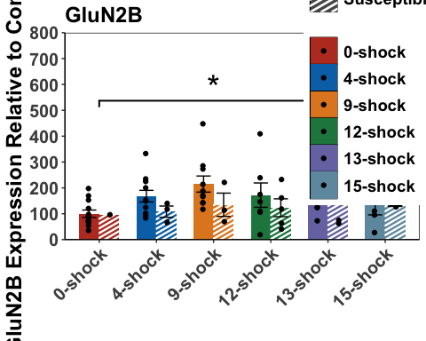

dHpcA1 <- ggplot(dHpcsummaryGluA1, aes(y = mean, x=Shock, pattern = SEFL, fill = Shock)) +  
 geom_bar_pattern(stat = "identity",   
 pattern_density = .2,  
 pattern_spacing = .02,  
 pattern_fill = 'white',  
 pattern_color = "white",  
 aes(pattern = SEFL),   
 position = position_dodge(preserve = "single"),  
 width = 0.7,  
 show.legend = TRUE)+  
 scale_fill_nejm() +  
 scale_color_nejm() +  
 scale_pattern_manual(guide = "legend", values = c(Susceptible = "stripe", Resilient = "none")) +  
 labs(x="", y="GluA1 Expression Relative to Control (%)", pattern = "SEFL", subtitle = "GluA1") +   
 guides(fill = guide_legend(override.aes = list(pattern = "none"))) +  
 scale_y_continuous(limits=c(0, 1250), breaks = c(0,200,400,600,800,1000,1200), expand = c(0,0)) +   
 theme(axis.text.x=element_text(angle = 45, vjust = 1, hjust =1, size = 15, face="bold"), axis.text.y=element_text(size = 15, face="bold"), axis.title =element_text(size=18,face="bold"), title=element_text(size = 18, face = "bold"),plot.subtitle =element_text(size = 18), strip.text = element_text(size = 15, face = "bold")) +  
 theme(panel.grid.major = element_blank(), panel.grid.minor = element_blank(),  
 panel.background = element_rect(colour = "black", fill = "white"),   
 axis.line = element_line(colour = "black")) + theme(legend.title = element_blank()) +  
 theme(legend.position="none") +  
 geom_signif(comparisons = list(c("0-shock","13-shock")),  
 map_signif_level = TRUE,  
 annotations = c("**"),  
 y_position = c(1000),  
 color = c("black","black","black"),  
 size = .7, textsize = 10) +  
 geom_signif(comparisons = list(c("4-shock","13-shock")),  
 map_signif_level = TRUE,  
 annotations = c("***"),  
 y_position = c(900),  
 color = c("black","black","black"),  
 size = .7, textsize = 10) +  
 geom_signif(comparisons = list(c("9-shock","13-shock")),  
 map_signif_level = TRUE,  
 annotations = c("***"),  
 y_position = c(800),  
 color = c("black","black","black"),  
 size = .7, textsize = 10) +  
 geom_signif(comparisons = list(c("12-shock","13-shock")),  
 map_signif_level = TRUE,  
 annotations = c("**"),  
 y_position = c(700),  
 color = c("black","black","black"),  
 size = .7, textsize = 10) +  
 geom_errorbar(aes(ymin=mean-se, ymax=mean+se),  
 width= .5,   
 position=position_dodge(0.7),  
 color = "black") +  
 theme(legend.position="none") +  
 geom_point(data = dHpcGluA1Data, aes(x = Shock, y = dHpcGluA1), position = position_jitterdodge(jitter.width = 0))  
  
dHpcA1

## Warning: Removed 9 rows containing missing values or values outside the scale range  
## (`geom_point()`).

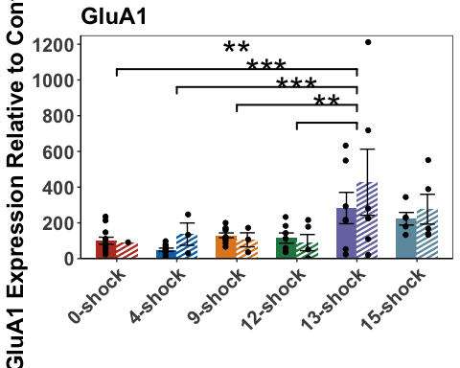

dHpcA2 <- ggplot(dHpcsummaryGluA2, aes(y = mean, x=Shock, pattern = SEFL, fill = Shock)) +  
 geom_bar_pattern(stat = "identity",   
 pattern_density = .2,  
 pattern_spacing = .02,  
 pattern_fill = 'white',  
 pattern_color = "white",  
 aes(pattern = SEFL),   
 position = position_dodge(preserve = "single"),  
 width = 0.7,  
 show.legend = TRUE)+  
 scale_fill_nejm() +  
 scale_color_nejm() +  
 scale_pattern_manual(guide = "legend", values = c(Susceptible = "stripe", Resilient = "none")) +   
 labs(x="", y="GluA2 Expression Relative to Control (%)", pattern = "SEFL", subtitle = "GluA2") +   
 guides(fill = guide_legend(override.aes = list(pattern = "none"))) +  
 scale_y_continuous(limits=c(0, 2350),breaks = c(0,300,600,900,1200,1500,1800,2100), expand = c(0,0)) +   
 theme(axis.text.x=element_text(angle = 45, vjust = 1, hjust =1, size = 15, face="bold"), axis.text.y=element_text(size = 15, face="bold"), axis.title =element_text(size=18,face="bold"), title=element_text(size = 18, face = "bold"),plot.subtitle =element_text(size = 18), strip.text = element_text(size = 15, face = "bold")) +  
 theme(panel.grid.major = element_blank(), panel.grid.minor = element_blank(),  
 panel.background = element_rect(colour = "black", fill = "white"),   
 axis.line = element_line(colour = "black")) + theme(legend.title = element_blank()) +  
 geom_errorbar(aes(ymin=mean-se, ymax=mean+se),  
 width= .5,   
 position=position_dodge(0.7),  
 color = "black") +  
 geom_point(data = dHpcGluA2Data, aes(x = Shock, y = dHpcGluA2), position = position_jitterdodge(jitter.width = 0)) +  
 geom_signif(comparisons = list(c("0-shock","13-shock")),  
 map_signif_level = TRUE,  
 annotations = c("**"),  
 y_position = c(1200),  
 color = c("black","black","black"),  
 size = .7, textsize = 10) +  
 geom_signif(comparisons = list(c("0-shock","15-shock")),  
 map_signif_level = TRUE,  
 annotations = c("*"),  
 y_position = c(2000),  
 color = c("black","black","black"),  
 size = .7, textsize = 10) +  
 geom_signif(comparisons = list(c("4-shock","13-shock")),  
 map_signif_level = TRUE,  
 annotations = c("*"),  
 y_position = c(1000),  
 color = c("black","black","black"),  
 size = .7, textsize = 10) +  
 geom_signif(comparisons = list(c("4-shock","15-shock")),  
 map_signif_level = TRUE,  
 annotations = c("**"),  
 y_position = c(1800),  
 color = c("black","black","black"),  
 size = .7, textsize = 10) +  
 geom_signif(comparisons = list(c("9-shock","13-shock")),  
 map_signif_level = TRUE,  
 annotations = c("**"),  
 y_position = c(800),  
 color = c("black","black","black"),  
 size = .7, textsize = 10) +  
 geom_signif(comparisons = list(c("9-shock","15-shock")),  
 map_signif_level = TRUE,  
 annotations = c("*"),  
 y_position = c(1600),  
 color = c("black","black","black"),  
 size = .7, textsize = 10) +  
 geom_signif(comparisons = list(c("12-shock","13-shock")),  
 map_signif_level = TRUE,  
 annotations = c("**"),  
 y_position = c(600),  
 color = c("black","black","black"),  
 size = .7, textsize = 10) +  
 geom_signif(comparisons = list(c("12-shock","15-shock")),  
 map_signif_level = TRUE,  
 annotations = c("*"),  
 y_position = c(1400),  
 color = c("black","black","black"),  
 size = .7, textsize = 10) +  
 theme(legend.position="none")   
  
dHpcA2

## Warning: Removed 9 rows containing missing values or values outside the scale range  
## (`geom_point()`).

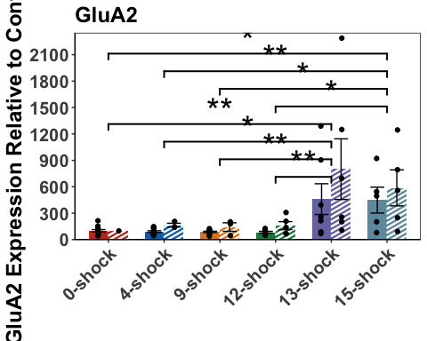

dHpcN2B_SEFL <- ggplot(dHpcGluN2BData,  
 aes( x = SEFL, y = dHpcGluN2B)) +  
 geom_boxplot() +  
 geom_jitter(color= c("#636363"), size=.7, alpha=.7) +   
 theme(panel.grid.major = element_blank(), panel.grid.minor = element_blank(),  
 panel.background = element_rect(colour = "black", fill = "white"),   
 axis.line = element_line(colour = "black")) + theme(legend.title = element_blank()) +  
 labs(X = "", y="GluN2B Expression Relative to Control (%)") +  
 geom_signif(comparisons = list(c("Resilient","Susceptible")),  
 map_signif_level = TRUE,  
 annotations = c("NS"),  
 y_position = c(600),  
 color = c("black","black","black"),  
 size = 1, textsize = 5) +   
 theme(axis.text.x=element_text(size = 15, face="bold"), axis.text.y=element_text(size = 15, face="bold"), axis.title =element_text(size=18,face="bold"), title=element_text(size = 18, face = "bold"),plot.subtitle =element_text(size = 18), strip.text = element_text(size = 15, face = "bold")) +  
 scale_y_continuous(limits=c(0, 800)) +  
 theme(legend.position="none")  
  
dHpcN2B_SEFL

## Warning: Removed 9 rows containing non-finite outside the scale range  
## (`stat_boxplot()`).

## Warning: Removed 9 rows containing non-finite outside the scale range  
## (`stat_signif()`).

## Warning: Removed 9 rows containing missing values or values outside the scale range  
## (`geom_point()`).

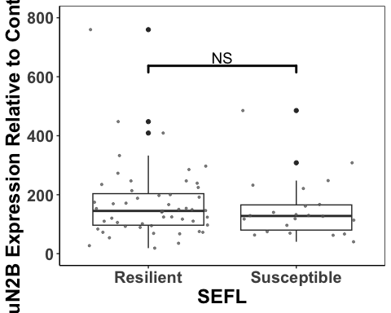

dHpcA1_SEFL <- ggplot(dHpcGluA1Data,  
 aes( x = SEFL, y = dHpcGluA1)) +  
 geom_boxplot() +  
 geom_jitter(color= c("#636363"), size=.7, alpha=.7) +   
 theme(panel.grid.major = element_blank(), panel.grid.minor = element_blank(),  
 panel.background = element_rect(colour = "black", fill = "white"),   
 axis.line = element_line(colour = "black")) + theme(legend.title = element_blank()) +  
 labs(X = "",y="GluA1 Expression Relative to Control (%)") +  
 geom_signif(comparisons = list(c("Resilient","Susceptible")),  
 map_signif_level = TRUE,  
 annotations = c("NS"),  
 y_position = c(900),  
 color = c("black","black","black"),  
 size = 1, textsize = 5) +   
 theme(axis.text.x=element_text(size = 15, face="bold"), axis.text.y=element_text(size = 15, face="bold"), axis.title =element_text(size=18,face="bold"), title=element_text(size = 18, face = "bold"),plot.subtitle =element_text(size = 18), strip.text = element_text(size = 15, face = "bold")) +  
 scale_y_continuous(limits=c(0, 1200)) +  
 theme(legend.position="none")  
dHpcA1_SEFL

## Warning: Removed 10 rows containing non-finite outside the scale range  
## (`stat_boxplot()`).

## Warning: Removed 10 rows containing non-finite outside the scale range  
## (`stat_signif()`).

## Warning: Removed 10 rows containing missing values or values outside the scale range  
## (`geom_point()`).

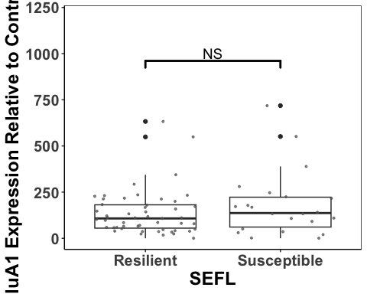

dHpcA2_SEFL <- ggplot(dHpcGluA2Data,  
 aes( x = SEFL, y = dHpcGluA2)) +  
 geom_boxplot() +  
 geom_jitter(color= c("#636363"), size=.7, alpha=.7) +   
 theme(panel.grid.major = element_blank(), panel.grid.minor = element_blank(),  
 panel.background = element_rect(colour = "black", fill = "white"),   
 axis.line = element_line(colour = "black")) + theme(legend.title = element_blank()) +  
 labs(X = "",y="GluA2 Expression Relative to Control (%)") +  
 geom_signif(comparisons = list(c("Resilient","Susceptible")),  
 map_signif_level = TRUE,  
 annotations = c("NS"),  
 y_position = c(1750),  
 color = c("black","black","black"),  
 size = 1, textsize = 5) +   
 theme(axis.text.x=element_text(size = 15, face="bold"), axis.text.y=element_text(size = 15, face="bold"), axis.title =element_text(size=18,face="bold"), title=element_text(size = 18, face = "bold"),plot.subtitle =element_text(size = 18), strip.text = element_text(size = 15, face = "bold")) +  
 scale_y_continuous(limits=c(0, 2300))  
dHpcA2_SEFL

## Warning: Removed 9 rows containing non-finite outside the scale range  
## (`stat_boxplot()`).

## Warning: Removed 9 rows containing non-finite outside the scale range  
## (`stat_signif()`).

## Warning: Removed 9 rows containing missing values or values outside the scale range  
## (`geom_point()`).

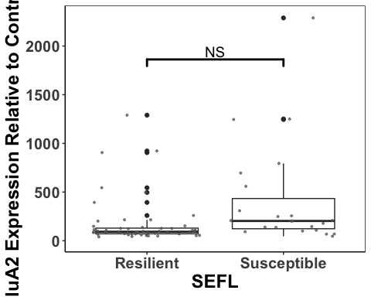

dHpcplot <- ggarrange(dHpcN2B, dHpcA1, dHpcA2, dHpcN2B_SEFL,dHpcA1_SEFL, dHpcA2_SEFL,  
 labels = c("a", "", "", "b", "", ""),  
 font.label = list(size = 26, face = "bold"),  
 ncol = 3, nrow = 2) +  
 theme(plot.margin = margin(0.1,1.5,0.1,1.5, "cm"))

## Warning: Removed 9 rows containing missing values or values outside the scale range  
## (`geom_point()`).  
## Removed 9 rows containing missing values or values outside the scale range  
## (`geom_point()`).  
## Removed 9 rows containing missing values or values outside the scale range  
## (`geom_point()`).

## Warning: Removed 9 rows containing non-finite outside the scale range  
## (`stat_boxplot()`).

## Warning: Removed 9 rows containing non-finite outside the scale range  
## (`stat_signif()`).

## Warning: Removed 9 rows containing missing values or values outside the scale range  
## (`geom_point()`).

## Warning: Removed 10 rows containing non-finite outside the scale range  
## (`stat_boxplot()`).

## Warning: Removed 10 rows containing non-finite outside the scale range  
## (`stat_signif()`).

## Warning: Removed 10 rows containing missing values or values outside the scale range  
## (`geom_point()`).

## Warning: Removed 9 rows containing non-finite outside the scale range  
## (`stat_boxplot()`).

## Warning: Removed 9 rows containing non-finite outside the scale range  
## (`stat_signif()`).

## Warning: Removed 9 rows containing missing values or values outside the scale range  
## (`geom_point()`).

dHpcplot

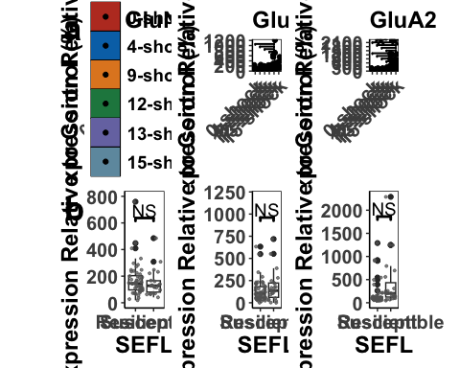

ggsave('dHpcplot', dHpcplot, width=23, height=18, units='in', device = "tiff", dpi = 600)

Correlations between subunit expression in the dHpc

resilientdHpc <- select(dHpcData, c("Rat","SEFL","Shock", "Average_Freezing_Extinction_Session","Average_Freezing_Last_3_mins_Extinction", "Recovery_Index","Total_Freezing_During_Test","dHpcGluN2B", "dHpcGluA1", "dHpcGluA2"))  
resilientdHpc <- resilientdHpc[ which(resilientdHpc$SEFL=="Resilient"), ]  
  
susceptibledHpc <- select(dHpcData, c("Rat","SEFL","Shock", "Average_Freezing_Extinction_Session","Average_Freezing_Last_3_mins_Extinction", "Recovery_Index","Total_Freezing_During_Test","dHpcGluN2B", "dHpcGluA1", "dHpcGluA2"))  
susceptibledHpc <- susceptibledHpc[ which(susceptibledHpc$SEFL=="Susceptible"), ]  
  
dHpcResilient1 <- lm(dHpcGluN2B ~ dHpcGluA1, data = resilientdHpc)  
dHpcResilient1

##   
## Call:  
## lm(formula = dHpcGluN2B ~ dHpcGluA1, data = resilientdHpc)  
##   
## Coefficients:  
## (Intercept) dHpcGluA1   
## 79.2759 0.6521

#y = 0.64X + 79.86  
  
dHpcSusceptible1 <- lm(dHpcGluN2B ~ dHpcGluA1, data = susceptibledHpc)  
dHpcSusceptible1

##   
## Call:  
## lm(formula = dHpcGluN2B ~ dHpcGluA1, data = susceptibledHpc)  
##   
## Coefficients:  
## (Intercept) dHpcGluA1   
## 113.6423 0.1843

#y = 0.18x + 111.73  
  
dHpcA1_N2B <- ggplot(dHpcData,  
 aes(x = dHpcGluA1,  
 y = dHpcGluN2B, color = Shock, shape = SEFL)) +  
 geom_point(aes(color = dHpcData$Shock), size = 4) +  
 scale_fill_nejm() +  
 scale_color_nejm() +  
 theme(panel.grid.major = element_blank(), panel.grid.minor = element_blank(),  
 panel.background = element_rect(colour = "black", fill = "white"),   
 axis.line = element_line(colour = "black")) + theme(legend.title = element_blank()) +  
 geom_abline(intercept = 79.86, slope = 0.64, size = 1.2) +  
 geom_abline(intercept = 111.73, slope = 0.18, linetype = "dashed", size = 1.2) +  
 theme(legend.position="none") +  
 theme(axis.text.x=element_text(size = 15, face = "bold"),axis.text.y=element_text(size = 15, face = "bold"), axis.title =element_text(size=15,face="bold")) +  
 labs(x="GluA1 Expression Relative to Control (%)", y="GluN2B Expression Relative to Control (%)") +  
 scale_x_continuous(limits=c(0, 1300), breaks = c(0,200,400,600,800,1000,1200), expand = c(0,0))  
dHpcA1_N2B

## Warning: Use of `dHpcData$Shock` is discouraged.  
## ℹ Use `Shock` instead.

## Warning: Removed 9 rows containing missing values or values outside the scale range  
## (`geom_point()`).

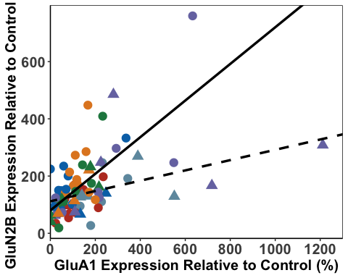

dHpcResilient2 <- lm(dHpcGluN2B ~ dHpcGluA2, data = resilientdHpc)  
dHpcResilient2

##   
## Call:  
## lm(formula = dHpcGluN2B ~ dHpcGluA2, data = resilientdHpc)  
##   
## Coefficients:  
## (Intercept) dHpcGluA2   
## 125.3886 0.2544

#y = 0.25X + 125.39  
  
dHpcSusceptible2 <- lm(dHpcGluN2B ~ dHpcGluA2, data = susceptibledHpc)  
dHpcSusceptible2

##   
## Call:  
## lm(formula = dHpcGluN2B ~ dHpcGluA2, data = susceptibledHpc)  
##   
## Coefficients:  
## (Intercept) dHpcGluA2   
## 126.66031 0.06915

#y = 0.07X + 124.91  
  
dHpcA2_N2B<- ggplot(dHpcData,  
 aes(x = dHpcGluA2,  
 y = dHpcGluN2B, color = Shock, shape = SEFL)) +  
 geom_point(aes(color = dHpcData$Shock), size = 4) +  
 scale_fill_nejm() +  
 scale_color_nejm() +  
 theme(panel.grid.major = element_blank(), panel.grid.minor = element_blank(),  
 panel.background = element_rect(colour = "black", fill = "white"),   
 axis.line = element_line(colour = "black")) + theme(legend.title = element_blank()) +  
 geom_abline(intercept = 125.39, slope = 0.25, size = 1.2) +  
 geom_abline(intercept = 124.91, slope = 0.07, linetype = "dashed",size = 1.2) +  
 geom_segment(aes(x=0, xend=150,y=750,yend=750), size = 1.3, color = "black") +  
 geom_segment(aes(x=0, xend=150,y=700,yend=700), size = 1.3, color = "black", linetype = "dashed") +   
 annotate(geom="text", x=400, y=750, label="Resilient",  
 color="black", size = 6,fontface = "bold" ) +  
 annotate(geom="text", x=450, y=700, label="Susceptible",  
 color="black", size =6, fontface = "bold") +  
 theme(axis.text.x=element_text(size = 15, face = "bold"),axis.text.y=element_text(size = 15, face = "bold"), axis.title =element_text(size=15,face="bold")) +  
 theme(legend.position="none") +  
 labs(x="GluA2 Expression Relative to Control (%)", y="GluN2B Expression Relative to Control (%)")  
dHpcA2_N2B

## Warning: Use of `dHpcData$Shock` is discouraged.  
## ℹ Use `Shock` instead.

## Warning: Removed 9 rows containing missing values or values outside the scale range  
## (`geom_point()`).

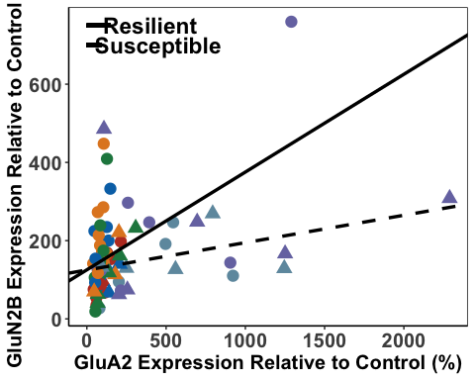

dHpcResilient3 <- lm(dHpcGluA1 ~ dHpcGluA2, data = resilientdHpc, na.action=na.omit)  
dHpcResilient3

##   
## Call:  
## lm(formula = dHpcGluA1 ~ dHpcGluA2, data = resilientdHpc, na.action = na.omit)  
##   
## Coefficients:  
## (Intercept) dHpcGluA2   
## 77.8009 0.3498

#y = 0.35X + 73.41  
  
dHpcSusceptible3 <- lm(dHpcGluA1 ~ dHpcGluA2, data = susceptibledHpc, na.action=na.omit)  
dHpcSusceptible3

##   
## Call:  
## lm(formula = dHpcGluA1 ~ dHpcGluA2, data = susceptibledHpc, na.action = na.omit)  
##   
## Coefficients:  
## (Intercept) dHpcGluA2   
## 23.6139 0.4886

#y = 0.49X + 23.61  
  
dHpcA2_A1<- ggplot(dHpcData,  
 aes(x = dHpcGluA2,  
 y = dHpcGluA1, color = Shock, shape = SEFL)) +  
 geom_point(aes(color = dHpcData$Shock), size = 4) +  
 scale_fill_nejm() +  
 scale_color_nejm() +  
 theme(panel.grid.major = element_blank(), panel.grid.minor = element_blank(),  
 panel.background = element_rect(colour = "black", fill = "white"),   
 axis.line = element_line(colour = "black")) + theme(legend.title = element_blank()) +  
 geom_abline(intercept = 73.41, slope = 0.35, size = 1.2) +  
 geom_abline(intercept = 23.61, slope = 0.49, linetype = "dashed", size = 1.2) +  
theme(legend.position = c(0.13, 0.73), legend.key.size = unit(1, 'cm')) +  
 theme(axis.text.x=element_text(size = 15, face = "bold"),axis.text.y=element_text(size = 15, face = "bold"), axis.title =element_text(size=15,face="bold")) +   
 theme(legend.text=element_text(size=12, face = "bold")) +  
 labs(x="GluA2 Expression Relative to Control (%)", y="GluA1 Expression Relative to Control (%)")  
 dHpcA2_A1

## Warning: Use of `dHpcData$Shock` is discouraged.  
## ℹ Use `Shock` instead.

## Warning: Removed 9 rows containing missing values or values outside the scale range  
## (`geom_point()`).

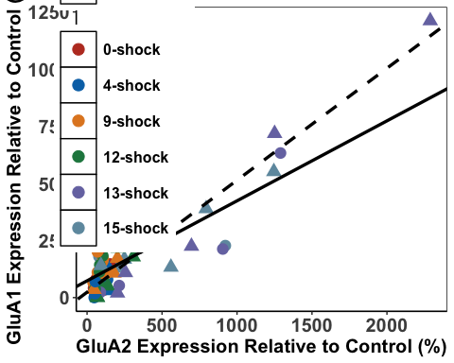

dHpcsubunits <- ggarrange(dHpcA2_A1, dHpcA1_N2B, dHpcA2_N2B,  
 labels = c("a", "b", "c"),  
 font.label = list(size = 24, face = "bold"),  
 ncol = 3, nrow = 1) +  
 theme(plot.margin = margin(1,1,1,1, "cm"))

## Warning: Use of `dHpcData$Shock` is discouraged.  
## ℹ Use `Shock` instead.

## Warning: Removed 9 rows containing missing values or values outside the scale range  
## (`geom_point()`).

## Warning: Use of `dHpcData$Shock` is discouraged.  
## ℹ Use `Shock` instead.

## Warning: Removed 9 rows containing missing values or values outside the scale range  
## (`geom_point()`).

## Warning: Use of `dHpcData$Shock` is discouraged.  
## ℹ Use `Shock` instead.

## Warning: Removed 9 rows containing missing values or values outside the scale range  
## (`geom_point()`).

dHpcsubunits

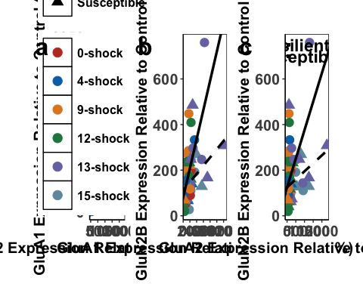

ggsave('dHpcsubunits', dHpcsubunits, width=25, height=9, units='in', device = "tiff", dpi = 600)

Comparing the regressions

dHpcA1_A2<- dHpcData %>%   
 group_by(SEFL) %>%  
 cor_test(dHpcGluA2, dHpcGluA1, method="pearson")  
  
#resilient - r=0.71, p <.0001  
#susceptible = r=0.95, p<.0001

dHpcA1_N2B<- dHpcData %>%   
 group_by(SEFL) %>%  
 cor_test(dHpcGluN2B, dHpcGluA1, method="pearson")  
  
#resilient - r=0.64, p <.0001  
#susceptible = r=0.49, p<.05

dHpcA2_N2B <- dHpcData %>%   
 group_by(SEFL) %>%  
 cor_test(dHpcGluN2B, dHpcGluA2, method="pearson")  
  
#resilient - r=0.50, p<.001  
#susceptible = r=0.34, p= .12

Fisher’s Z-Scores

dHpcResilientA1_A2 <- FisherZ(0.71)  
dHpcSusceptibleA1_A2 <- FisherZ(0.95)  
  
dHpcResilientA1_N2B <- FisherZ(0.64)  
dHpcSusceptibleA1_N2B <- FisherZ(0.49)  
  
dHpcResilientA2_N2B <- FisherZ(0.50)  
dHpcSusceptibleA2_N2B <- FisherZ(0.34)

#n resilient = 51  
#n susceptible = 23  
  
  
N1 <- 1/(51-3)  
N2 <- 1/(23-3)  
  
N <- N1 + N2  
  
Z1 <- (dHpcResilientA1_A2 -dHpcSusceptibleA1_A2)  
  
dHpcZdiffA1_A2 <- Z1/sqrt(N)  
dHpcZdiffA1_A2

## [1] -3.549177

#=-3.55  
#signiicant

#n resilient = 51  
#n susceptible = 22  
  
N2b <- 1/(22-3)  
  
Nb <- N1 + N2b  
  
Z2 <- (dHpcResilientA1_N2B -dHpcSusceptibleA1_N2B)  
  
dHpcZdiffA1_N2B <- Z2/sqrt(Nb)  
dHpcZdiffA1_N2B

## [1] 0.8194733

#=0.82  
#not significant

#n resilient = 52  
#n susceptible = 22  
  
  
N1c <- 1/(52-3)  
  
Nc <- N1c + N2b  
Z3 <- (dHpcResilientA2_N2B -dHpcSusceptibleA2_N2B)  
  
dHpcZdiffA2_N2B <- Z3/sqrt(Nc)  
dHpcZdiffA2_N2B

## [1] 0.7223214

#=0.72  
#= not significant

Behavioural Correlations with dHpc Data

#first we work out the correlations  
  
  
dHpcResGluN2B <- lm(Average_Freezing_Extinction_Session ~ dHpcGluN2B, data = resilientdHpc)  
dHpcResGluN2B

##   
## Call:  
## lm(formula = Average_Freezing_Extinction_Session ~ dHpcGluN2B,   
## data = resilientdHpc)  
##   
## Coefficients:  
## (Intercept) dHpcGluN2B   
## 3.37896 0.02451

dHpcSusGluN2B <- lm(Average_Freezing_Extinction_Session ~ dHpcGluN2B, data = susceptibledHpc)  
dHpcSusGluN2B

##   
## Call:  
## lm(formula = Average_Freezing_Extinction_Session ~ dHpcGluN2B,   
## data = susceptibledHpc)  
##   
## Coefficients:  
## (Intercept) dHpcGluN2B   
## 38.75047 -0.04163

dHpcResGluA1 <- lm(Average_Freezing_Extinction_Session ~ dHpcGluA1, data = resilientdHpc)  
dHpcResGluA1

##   
## Call:  
## lm(formula = Average_Freezing_Extinction_Session ~ dHpcGluA1,   
## data = resilientdHpc)  
##   
## Coefficients:  
## (Intercept) dHpcGluA1   
## 3.15502 0.03156

dHpcSusGluA1 <- lm(Average_Freezing_Extinction_Session ~ dHpcGluA1, data = susceptibledHpc)  
dHpcSusGluA1

##   
## Call:  
## lm(formula = Average_Freezing_Extinction_Session ~ dHpcGluA1,   
## data = susceptibledHpc)  
##   
## Coefficients:  
## (Intercept) dHpcGluA1   
## 32.652408 -0.001637

dHpcResGluA2 <- lm(Average_Freezing_Extinction_Session~ dHpcGluA2, data = resilientdHpc)  
dHpcResGluA2

##   
## Call:  
## lm(formula = Average_Freezing_Extinction_Session ~ dHpcGluA2,   
## data = resilientdHpc)  
##   
## Coefficients:  
## (Intercept) dHpcGluA2   
## 5.55976 0.01132

dHpcSusGluA2 <- lm(Average_Freezing_Extinction_Session ~ dHpcGluA2, data = susceptibledHpc)  
dHpcSusGluA2

##   
## Call:  
## lm(formula = Average_Freezing_Extinction_Session ~ dHpcGluA2,   
## data = susceptibledHpc)  
##   
## Coefficients:  
## (Intercept) dHpcGluA2   
## 32.4409007 -0.0003835

dHpcFF_A1 <- ggplot(dHpcData,  
 aes(x = dHpcGluA1,  
 y = Average_Freezing_Extinction_Session, color = Shock, shape = SEFL)) +  
 geom_point(aes(color = Shock), size = 4) +  
 scale_fill_nejm() +  
 scale_color_nejm() +  
 theme(panel.grid.major = element_blank(), panel.grid.minor = element_blank(),  
 panel.background = element_rect(colour = "black", fill = "white"),   
 axis.line = element_line(colour = "black")) + theme(legend.title = element_blank()) +   
 geom_abline(intercept = 2.96, slope = 0.035, size = 1.2) +  
 geom_abline(intercept = 32.65, slope = -0.0016, linetype = "dashed", size = 1.2) +  
 theme(legend.position="none") +  
 theme(axis.text.x=element_text(size = 12, face = "bold"),axis.text.y=element_text(size = 12, face = "bold"), axis.title =element_text(size=15,face="bold")) +  
 labs(x="GluA1 Expression Relative to Control (%)", y="Mean Freezing During Extinction Session (%)") +  
 scale_x_continuous(limits=c(0, 1300), breaks = c(0,200,400,600,800,1000,1200), expand = c(0,0))  
  
dHpcFF_N2B <- ggplot(dHpcData,  
 aes(x = dHpcGluN2B,  
 y = Average_Freezing_Extinction_Session, color = Shock, shape = SEFL)) +  
 geom_point(aes(color = Shock), size = 4) +  
 scale_fill_nejm() +  
 scale_color_nejm() +  
 theme(panel.grid.major = element_blank(), panel.grid.minor = element_blank(),  
 panel.background = element_rect(colour = "black", fill = "white"),   
 axis.line = element_line(colour = "black")) + theme(legend.title = element_blank()) +   
 geom_abline(intercept = 3.38, slope = 0.025, size = 1.2) +  
 geom_abline(intercept = 38.73, slope = -0.041, linetype = "dashed", size = 1.2) +  
 theme(axis.text.x=element_text(size = 12, face = "bold"),axis.text.y=element_text(size = 12, face = "bold"), axis.title =element_text(size=15,face="bold")) +  
 labs(x="GluN2B Expression Relative to Control (%)", y="Mean Freezing During Extinction Session (%)") +  
 geom_segment(aes(x=550, xend=630,y=3,yend=3), size = 1.3, color = "black") +  
 geom_segment(aes(x=550, xend=630,y=0,yend=0), size = 1.3, color = "black", linetype = "dashed") +  
 annotate(geom="text", x=690, y=3, label="Resilient",  
 color="black", size = 6, fontface = "bold") +  
 annotate(geom="text", x=705, y=0, label="Susceptible",  
 color="black", size = 6, fontface = "bold") +  
 scale_x_continuous(limits=c(0, 820), breaks = c(0,200,400,600,800), expand = c(0,0)) +   
 theme(legend.position = c(0.82, 0.78), legend.key.size = unit(1, 'cm'), legend.text = element_text(size=14, face = "bold"))   
  
dHpcFF_A2 <- ggplot(dHpcData,  
 aes(x = dHpcGluA2,  
 y = Average_Freezing_Extinction_Session, color = Shock, shape = SEFL)) +  
 geom_point(aes(color = Shock), size = 4) +  
 scale_fill_nejm() +  
 scale_color_nejm() +  
 theme(panel.grid.major = element_blank(), panel.grid.minor = element_blank(),  
 panel.background = element_rect(colour = "black", fill = "white"),   
 axis.line = element_line(colour = "black")) + theme(legend.title = element_blank()) +   
 geom_abline(intercept = 5.56, slope = 0.011, size = 1.2) +  
 geom_abline(intercept = 32.44, slope = -0.00038, linetype = "dashed", size = 1.2) +  
 theme(legend.position="none") +  
 theme(axis.text.x=element_text(size = 12, face = "bold"),axis.text.y=element_text(size = 12, face = "bold"), axis.title =element_text(size=15,face="bold")) +  
 labs(x="GluA2 Expression Relative to Control (%)", y="Mean Freezing During Extinction Session (%)") +   
 theme(legend.position="none") +  
 scale_x_continuous(limits=c(0, 2300), breaks = c(0,300,600,900,1200,1500,1800,2100), expand = c(0,0))  
  
  
dHpcFF_A2

## Warning: Removed 9 rows containing missing values or values outside the scale range  
## (`geom_point()`).

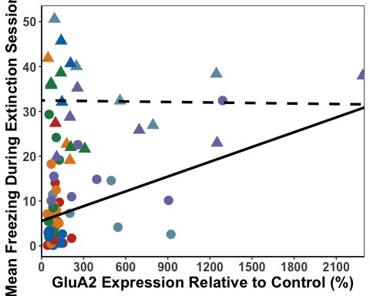

dHpcFF_A1

## Warning: Removed 9 rows containing missing values or values outside the scale range  
## (`geom_point()`).

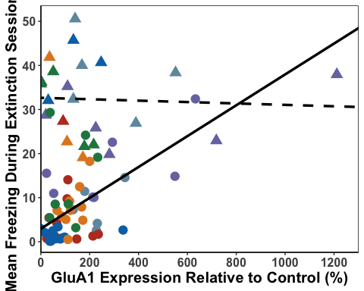

dHpcFF_N2B

## Warning: Removed 9 rows containing missing values or values outside the scale range  
## (`geom_point()`).

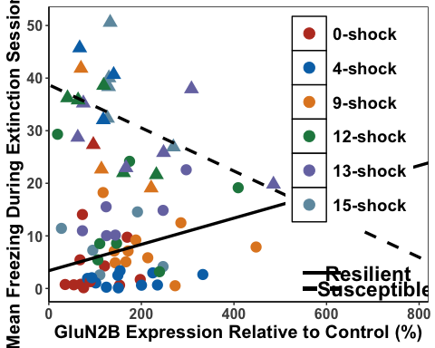

dHpcFF_A1cor<- dHpcData %>%   
 group_by(SEFL) %>%  
 cor_test(Average_Freezing_Extinction_Session, dHpcGluA1, method="pearson")  
  
#resilient - r= 0.54, p < .0001  
#susceptible = r=-0.051, p=0.8  
  
dHpcFF_A2cor<- dHpcData %>%   
 group_by(SEFL) %>%  
 cor_test(Average_Freezing_Extinction_Session, dHpcGluA2, method="pearson")  
  
#resilient - r=0.36, p<.01  
#susceptible = r=-0.023, p=0.92  
  
dHpcFF_N2Bcor<- dHpcData %>%   
 group_by(SEFL) %>%  
 cor_test(Average_Freezing_Extinction_Session, dHpcGluN2B, method="pearson")  
  
#resilient - r=0.39, p < .01  
#susceptible = r=-0.46, p < .05  
  
dHpcResilientFF_A1 <- FisherZ(0.54)  
dHpcSusceptibleFF_A1 <- FisherZ(-0.051)  
  
dHpcResilientFF_A2 <- FisherZ(0.36)  
dHpcSusceptibleFF_A2 <- FisherZ(-0.023)  
  
dHpcResilientFF_N2B <- FisherZ(0.39)  
dHpcSusceptibleFF_N2B <- FisherZ(-0.46)  
  
#Zdiff for A1  
#n resilient = 51  
#n susceptible = 23  
  
N1 <- 1/(51-3)  
N2 <- 1/(23-3)  
  
N <- N1 + N2  
  
Z1 <- (dHpcResilientFF_A1 -dHpcSusceptibleFF_A1)  
  
dHpcZdiffFF_A1 <- Z1/sqrt(N)  
dHpcZdiffFF_A1

## [1] 2.461813

# = 2.46 = significant  
  
#Zdiff for A2  
  
#n resilient = 52  
#n susceptible = 23  
  
N1b <- 1/(52-3)  
  
Nb <- N1b + N2  
  
Z2 <- (dHpcResilientFF_A2 -dHpcSusceptibleFF_A2)  
  
dHpcZdiffFF_A2 <- Z2/sqrt(Nb)  
dHpcZdiffFF_A2

## [1] 1.507055

# = 1.51 = not significant  
  
#Zdiff for N2B  
  
#n resilient = 52  
#n susceptible = 22  
  
N2c <- 1/(22-3)  
  
Nc <- N1b + N2c  
  
Z3 <- (dHpcResilientFF_N2B -dHpcSusceptibleFF_N2B)  
  
dHpcZdiffFF_N2B <- Z3/sqrt(Nc)  
dHpcZdiffFF_N2B

## [1] 3.363856

# = 3.36 = significant

dHpcRes3GluN2B <- lm(Average_Freezing_Last_3_mins_Extinction ~ dHpcGluN2B, data = resilientdHpc)  
dHpcRes3GluN2B

##   
## Call:  
## lm(formula = Average_Freezing_Last_3_mins_Extinction ~ dHpcGluN2B,   
## data = resilientdHpc)  
##   
## Coefficients:  
## (Intercept) dHpcGluN2B   
## 0.33992 0.01838

dHpcSus3GluN2B <- lm(Average_Freezing_Last_3_mins_Extinction ~ dHpcGluN2B, data = susceptibledHpc)  
dHpcSus3GluN2B

##   
## Call:  
## lm(formula = Average_Freezing_Last_3_mins_Extinction ~ dHpcGluN2B,   
## data = susceptibledHpc)  
##   
## Coefficients:  
## (Intercept) dHpcGluN2B   
## 19.54960 -0.04534

dHpcRes3GluA1 <- lm(Average_Freezing_Last_3_mins_Extinction ~ dHpcGluA1, data = resilientdHpc)  
dHpcRes3GluA1

##   
## Call:  
## lm(formula = Average_Freezing_Last_3_mins_Extinction ~ dHpcGluA1,   
## data = resilientdHpc)  
##   
## Coefficients:  
## (Intercept) dHpcGluA1   
## 0.53908 0.02103

dHpcSus3GluA1 <- lm(Average_Freezing_Last_3_mins_Extinction ~ dHpcGluA1, data = susceptibledHpc)  
dHpcSus3GluA1

##   
## Call:  
## lm(formula = Average_Freezing_Last_3_mins_Extinction ~ dHpcGluA1,   
## data = susceptibledHpc)  
##   
## Coefficients:  
## (Intercept) dHpcGluA1   
## 13.813772 -0.005778

dHpcRes3GluA2 <- lm(Average_Freezing_Last_3_mins_Extinction ~ dHpcGluA2, data = resilientdHpc)  
dHpcRes3GluA2

##   
## Call:  
## lm(formula = Average_Freezing_Last_3_mins_Extinction ~ dHpcGluA2,   
## data = resilientdHpc)  
##   
## Coefficients:  
## (Intercept) dHpcGluA2   
## 1.66271 0.01028

dHpcSus3GluA2 <- lm(Average_Freezing_Last_3_mins_Extinction ~ dHpcGluA2, data = susceptibledHpc)  
dHpcSus3GluA2

##   
## Call:  
## lm(formula = Average_Freezing_Last_3_mins_Extinction ~ dHpcGluA2,   
## data = susceptibledHpc)  
##   
## Coefficients:  
## (Intercept) dHpcGluA2   
## 13.705625 -0.002891

dHpcE3_A1 <- ggplot(dHpcData,  
 aes(x = dHpcGluA1,  
 y = Average_Freezing_Last_3_mins_Extinction, color = Shock, shape = SEFL)) +  
 geom_point(aes(color = Shock), size = 4) +  
 scale_fill_nejm() +  
 scale_color_nejm() +  
 theme(panel.grid.major = element_blank(), panel.grid.minor = element_blank(),  
 panel.background = element_rect(colour = "black", fill = "white"),   
 axis.line = element_line(colour = "black")) + theme(legend.title = element_blank()) +   
 geom_abline(intercept = 0.43, slope = 0.023, size = 1.2) +  
 geom_abline(intercept = 13.81, slope = -0.006, linetype = "dashed", size = 1.2) +  
 theme(legend.position="none") +  
 theme(axis.text.x=element_text(size = 12), axis.title =element_text(size=15,face="bold")) +  
 labs(x="GluA1 Expression Relative to Control (%)", y="Mean Freezing During Final 3 mins Extinction (%)") +  
 scale_x_continuous(limits=c(0, 1300), breaks = c(0,200,400,600,800,1000,1200), expand = c(0,0))  
  
dHpcE3_N2B <- ggplot(dHpcData,  
 aes(x = dHpcGluN2B,  
 y = Average_Freezing_Last_3_mins_Extinction, color = Shock, shape = SEFL)) +  
 geom_point(aes(color = Shock), size = 4) +  
 scale_fill_nejm() +  
 scale_color_nejm() +  
 theme(panel.grid.major = element_blank(), panel.grid.minor = element_blank(),  
 panel.background = element_rect(colour = "black", fill = "white"),   
 axis.line = element_line(colour = "black")) + theme(legend.title = element_blank()) +   
 geom_abline(intercept = 0.34, slope = 0.02, size = 1.2) +  
 geom_abline(intercept = 19.42, slope = -0.043, linetype = "dashed", size = 1.2) +  
 theme(legend.position="none") +  
 theme(axis.text.x=element_text(size = 12), axis.title =element_text(size=15,face="bold")) +  
 labs(x="GluN2B Expression Relative to Control (%)", y="Mean Freezing During Final 3 mins Extinction (%)") +  
 scale_x_continuous(limits=c(0, 820), breaks = c(0,200,400,600,800), expand = c(0,0))  
  
dHpcE3_A2 <- ggplot(dHpcData,  
 aes(x = dHpcGluA2,  
 y = Average_Freezing_Last_3_mins_Extinction, color = Shock, shape = SEFL)) +  
 geom_point(aes(color = Shock), size = 4) +  
 scale_fill_nejm() +  
 scale_color_nejm() +  
 theme(panel.grid.major = element_blank(), panel.grid.minor = element_blank(),  
 panel.background = element_rect(colour = "black", fill = "white"),   
 axis.line = element_line(colour = "black")) + theme(legend.title = element_blank()) +   
 geom_abline(intercept = 1.67, slope = 0.01, size = 1.2) +  
 geom_abline(intercept = 13.71, slope = -0.0029, linetype = "dashed", size = 1.2) +  
 theme(legend.position="none") +  
 theme(axis.text.x=element_text(size = 12), axis.title =element_text(size=15,face="bold")) +  
 labs(x="GluA2 Expression Relative to Control (%)", y="Mean Freezing During Final 3 mins Extinction (%)") +  
 scale_x_continuous(limits=c(0, 2300), breaks = c(0,300,600,900,1200,1500,1800,2100), expand = c(0,0)) +  
 theme(legend.position="none")  
  
  
dHpcE3_A2

## Warning: Removed 9 rows containing missing values or values outside the scale range  
## (`geom_point()`).

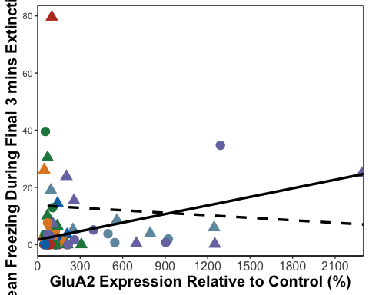

dHpcE3_A1

## Warning: Removed 9 rows containing missing values or values outside the scale range  
## (`geom_point()`).

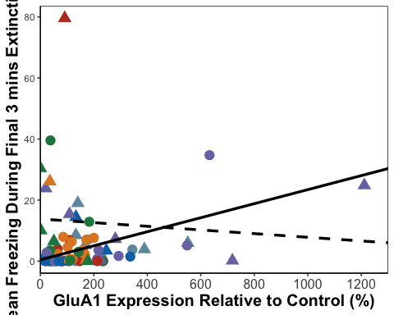

dHpcE3_N2B

## Warning: Removed 9 rows containing missing values or values outside the scale range  
## (`geom_point()`).

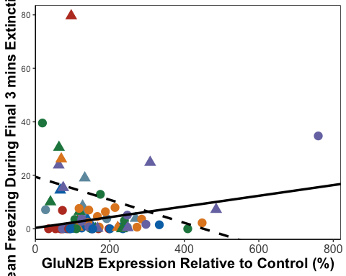

dHpcTF_A1<- dHpcData %>%   
 group_by(SEFL) %>%  
 cor_test(Average_Freezing_Last_3_mins_Extinction, dHpcGluA1, method="pearson")  
  
#resilient - r= 0.37, p < 0.01  
#susceptible = r=-0.091, p=0.68  
  
dHpcTF_A2<- dHpcData %>%   
 group_by(SEFL) %>%  
 cor_test(Average_Freezing_Last_3_mins_Extinction, dHpcGluA2, method="pearson")  
  
#resilient - r=0.34, p < 0.05  
#susceptible = r=-0.089, p=0.69  
  
dHpcTF_N2B<- dHpcData %>%   
 group_by(SEFL) %>%  
 cor_test(Average_Freezing_Last_3_mins_Extinction, dHpcGluN2B, method="pearson")  
  
#resilient - r=0.3, p < 0.05  
#susceptible = r=-0.25, p=0.27  
  
dHpcResilientTF_A1 <- FisherZ(0.37)  
dHpcSusceptibleTF_A1 <- FisherZ(-0.091)  
  
dHpcResilientTF_A2 <- FisherZ(0.34)  
dHpcSusceptibleTF_A2 <- FisherZ(-0.089)  
  
dHpcResilientTF_N2B <- FisherZ(0.3)  
dHpcSusceptibleTF_N2B <- FisherZ(-0.25)  
  
#A1  
  
#n resilient = 51  
#n susceptible = 23  
  
N1 <- 1/(51-3)  
N2 <- 1/(23-3)  
  
N <- N1 + N2  
  
Z13 <- (dHpcResilientTF_A1 -dHpcSusceptibleTF_A1)  
  
dHpcZdiffTF_A1 <- Z13/sqrt(N)  
dHpcZdiffTF_A1

## [1] 1.802307

# 1.80 not significant  
  
#A2  
  
#n resilient = 52  
#n susceptible = 23  
  
N1b <- 1/(52-3)  
  
Nb <- N1b + N2  
  
Z23 <- (dHpcResilientTF_A2 -dHpcSusceptibleTF_A2)  
  
dHpcZdiffTF_A2 <- Z23/sqrt(Nb)  
dHpcZdiffTF_A2

## [1] 1.670761

#1.67 not significant  
  
#N2B  
  
#n resilient = 52  
#n susceptible = 22  
  
  
N2c <- 1/(22-3)  
  
Nc <- N1b + N2c  
  
Z33 <- (dHpcResilientTF_N2B -dHpcSusceptibleTF_N2B)  
  
dHpcZdiffTF_N2B <- Z33/sqrt(Nc)  
dHpcZdiffTF_N2B

## [1] 2.09034

# = 2.09 = significant

dHpcResTGluN2B <- lm(Total_Freezing_During_Test ~ dHpcGluN2B, data = resilientdHpc)  
PLResTGluN2B

##   
## Call:  
## lm(formula = Total_Freezing_During_Test ~ PLGluN2B, data = resilientPL)  
##   
## Coefficients:  
## (Intercept) PLGluN2B   
## -0.18941 0.01696

#y = 0.01X - 0.17  
  
dHpcSusTGluN2B <- lm(Total_Freezing_During_Test ~ dHpcGluN2B, data = susceptibledHpc)  
dHpcSusTGluN2B

##   
## Call:  
## lm(formula = Total_Freezing_During_Test ~ dHpcGluN2B, data = susceptibledHpc)  
##   
## Coefficients:  
## (Intercept) dHpcGluN2B   
## 31.97899 -0.07526

#y = -0.07X + 31.93  
  
dHpcResTGluA1 <- lm(Total_Freezing_During_Test ~ dHpcGluA1, data = resilientdHpc)  
dHpcResTGluA1

##   
## Call:  
## lm(formula = Total_Freezing_During_Test ~ dHpcGluA1, data = resilientdHpc)  
##   
## Coefficients:  
## (Intercept) dHpcGluA1   
## 0.28999 0.01414

#y = 0.02X + 0.21  
  
dHpcSusTGluA1 <- lm(Total_Freezing_During_Test ~ dHpcGluA1, data = susceptibledHpc)  
dHpcSusTGluA1

##   
## Call:  
## lm(formula = Total_Freezing_During_Test ~ dHpcGluA1, data = susceptibledHpc)  
##   
## Coefficients:  
## (Intercept) dHpcGluA1   
## 20.985150 -0.003089

#y = -0.003X + 20.99  
  
dHpcResTGluA2 <- lm(Total_Freezing_During_Test ~ dHpcGluA2, data = resilientdHpc)  
dHpcResTGluA2

##   
## Call:  
## lm(formula = Total_Freezing_During_Test ~ dHpcGluA2, data = resilientdHpc)  
##   
## Coefficients:  
## (Intercept) dHpcGluA2   
## 0.56973 0.00963

#y = 0.009X + 0.57  
  
dHpcSusTGluA2 <- lm(Total_Freezing_During_Test ~ dHpcGluA2, data = susceptibledHpc)  
dHpcSusTGluA2

##   
## Call:  
## lm(formula = Total_Freezing_During_Test ~ dHpcGluA2, data = susceptibledHpc)  
##   
## Coefficients:  
## (Intercept) dHpcGluA2   
## 20.5416509 -0.0006172

#y = -0.0006X + 20.5  
  
dHpcTest_A1 <- ggplot(dHpcData,  
 aes(x = dHpcGluA1,  
 y = Total_Freezing_During_Test, color = Shock, shape = SEFL)) +  
 geom_point(aes(color = Shock), size = 4) +  
 scale_fill_nejm() +  
 scale_color_nejm() +  
 theme(panel.grid.major = element_blank(), panel.grid.minor = element_blank(),  
 panel.background = element_rect(colour = "black", fill = "white"),   
 axis.line = element_line(colour = "black")) + theme(legend.title = element_blank()) +   
 geom_abline(intercept = 0.21, slope = 0.02, size = 1.2) +  
 geom_abline(intercept = 20.99, slope = -0.003, linetype = "dashed", size = 1.2) +  
 theme(legend.position="none") +  
 theme(axis.text.x=element_text(size = 12, face = "bold"), axis.text.y=element_text(size = 12, face = "bold"),axis.title =element_text(size=15,face="bold")) +  
 labs(x="GluA1 Expression Relative to Control (%)", y="Mean Freezing During Test (%)") +  
 theme(legend.position = "none") +  
 scale_x_continuous(limits=c(0, 1300), breaks = c(0,200,400,600,800,1000,1200), expand = c(0,0))  
  
dHpcTest_N2B <- ggplot(dHpcData,  
 aes(x = dHpcGluN2B,  
 y = Total_Freezing_During_Test, color = Shock, shape = SEFL)) +  
 geom_point(aes(color = Shock), size = 4) +  
 scale_fill_nejm() +  
 scale_color_nejm() +  
 theme(panel.grid.major = element_blank(), panel.grid.minor = element_blank(),  
 panel.background = element_rect(colour = "black", fill = "white"),   
 axis.line = element_line(colour = "black")) + theme(legend.title = element_blank()) +   
 geom_abline(intercept = -0.17, slope = 0.01, size = 1.2) +  
 geom_abline(intercept = 31.93, slope = -0.07, linetype = "dashed", size = 1.2) +  
 theme(legend.position="none") +  
 theme(axis.text.x=element_text(size = 12, face = "bold"), axis.text.y=element_text(size = 12, face = "bold"),axis.title =element_text(size=15,face="bold")) +  
 labs(x="GluN2B Expression Relative to Control (%)", y="Mean Freezing During Test (%)") +  
 scale_x_continuous(limits=c(0, 820), breaks = c(0,200,400,600,800), expand = c(0,0))  
  
  
dHpcTest_A2 <- ggplot(dHpcData,  
 aes(x = dHpcGluA2,  
 y = Total_Freezing_During_Test, color = Shock, shape = SEFL)) +  
 geom_point(aes(color = Shock), size = 4) +  
 scale_fill_nejm() +  
 scale_color_nejm() +  
 theme(panel.grid.major = element_blank(), panel.grid.minor = element_blank(),  
 panel.background = element_rect(colour = "black", fill = "white"),   
 axis.line = element_line(colour = "black")) + theme(legend.title = element_blank()) +   
 geom_abline(intercept = 0.57, slope = 0.009, size = 1.2) +  
 geom_abline(intercept = 20.5, slope = -0.0006, linetype = "dashed", size = 1.2) +  
 theme(legend.position="none") +  
 theme(axis.text.x=element_text(size = 12), axis.title =element_text(size=15,face="bold")) +  
 labs(x="GluA2 Expression Relative to Control (%)", y="Mean Freezing During Test (%)") +  
 scale_x_continuous(limits=c(0, 2300), breaks = c(0,300,600,900,1200,1500,1800,2100), expand = c(0,0))  
  
  
dHpcTest_A2

## Warning: Removed 9 rows containing missing values or values outside the scale range  
## (`geom_point()`).

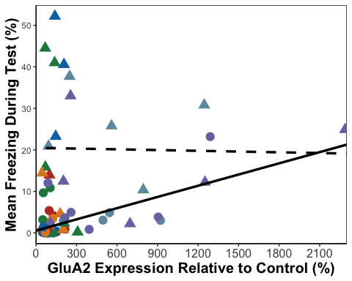

dHpcTest_A1

## Warning: Removed 9 rows containing missing values or values outside the scale range  
## (`geom_point()`).

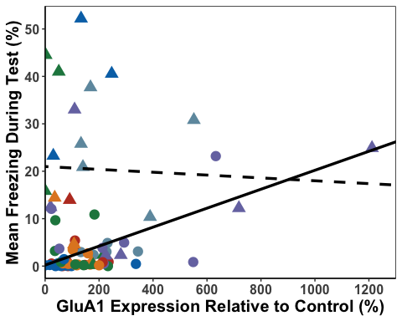

dHpcTest_N2B

## Warning: Removed 9 rows containing missing values or values outside the scale range  
## (`geom_point()`).

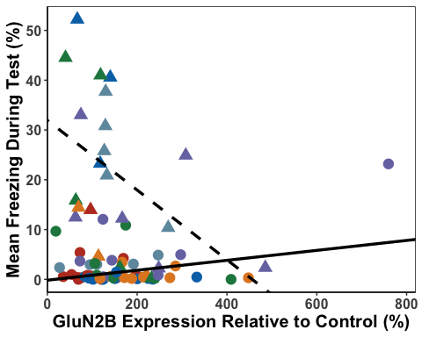

dHpcT_A1<- dHpcData %>%   
 group_by(SEFL) %>%  
 cor_test(Total_Freezing_During_Test, dHpcGluA1, method="pearson")  
  
#resilient - r= 0.46, p < 0.001  
#susceptible = r=-0.05, p=0.81  
  
dHpcT_A2<- dHpcData %>%   
 group_by(SEFL) %>%  
 cor_test(Total_Freezing_During_Test, dHpcGluA2, method="pearson")  
  
#resilient - r=0.58, p < 0.0001  
#susceptible = r=-0.02, p=0.92  
  
dHpcT_N2B<- dHpcData %>%   
 group_by(SEFL) %>%  
 cor_test(Total_Freezing_During_Test, dHpcGluN2B, method="pearson")  
  
#resilient - r=0.43, p < 0.01  
#susceptible = r=-0.47, p < 0.05  
  
  
dHpcResilientT_A1 <- FisherZ(0.46)  
dHpcSusceptibleT_A1 <- FisherZ(-0.05)  
  
dHpcResilientT_A2 <- FisherZ(0.58)  
dHpcSusceptibleT_A2 <- FisherZ(-0.02)  
  
dHpcResilientT_N2B <- FisherZ(0.43)  
dHpcSusceptibleT_N2B <- FisherZ(-0.47)  
  
  
#A1  
  
#n resilient = 51  
#n susceptible = 23  
  
N1 <- 1/(51-3)  
N2 <- 1/(23-3)  
  
N <- N1 + N2  
  
Z1F <- (dHpcResilientT_A1 -dHpcSusceptibleT_A1)  
  
dHpcZdiffT_A1 <- Z1F/sqrt(N)  
dHpcZdiffT_A1

## [1] 2.056595

# 2.06 = significant  
  
#A2  
  
N1b <- 1/(52-3)  
  
Nb <- N1b + N2  
  
Z2F <- (dHpcResilientT_A2 -dHpcSusceptibleT_A2)  
  
dHpcZdiffT_A2 <- Z2F/sqrt(Nb)  
dHpcZdiffT_A2

## [1] 2.571989

#2.57 = significant  
  
#N2B  
  
#n resilient = 52  
#n susceptible = 22  
  
  
N2c <- 1/(22-3)  
  
Nc <- N1b + N2c  
  
Z3F <- (dHpcResilientT_N2B -dHpcSusceptibleT_N2B)  
  
dHpcZdiffT_N2B <- Z3F/sqrt(Nc)  
dHpcZdiffT_N2B

## [1] 3.589032

#3.59 = significant

dHpcResRGluN2B <- lm(Recovery_Index ~ dHpcGluN2B, data = resilientdHpc)  
dHpcResRGluN2B

##   
## Call:  
## lm(formula = Recovery_Index ~ dHpcGluN2B, data = resilientdHpc)  
##   
## Coefficients:  
## (Intercept) dHpcGluN2B   
## 5.14833 -0.04398

#y = -0.04X + 5.15  
  
dHpcSusRGluN2B <- lm(Recovery_Index ~ dHpcGluN2B, data = susceptibledHpc)  
dHpcSusRGluN2B

##   
## Call:  
## lm(formula = Recovery_Index ~ dHpcGluN2B, data = susceptibledHpc)  
##   
## Coefficients:  
## (Intercept) dHpcGluN2B   
## 22.57306 -0.04906

#y = -0.04X + 22.29  
  
dHpcResRGluA1 <- lm(Recovery_Index ~ dHpcGluA1, data = resilientdHpc)  
dHpcResRGluA1

##   
## Call:  
## lm(formula = Recovery_Index ~ dHpcGluA1, data = resilientdHpc)  
##   
## Coefficients:  
## (Intercept) dHpcGluA1   
## 3.25988 -0.04017

#y = - 0.04X + 3.42  
  
dHpcSusRGluA1 <- lm(Recovery_Index ~ dHpcGluA1, data = susceptibledHpc)  
dHpcSusRGluA1

##   
## Call:  
## lm(formula = Recovery_Index ~ dHpcGluA1, data = susceptibledHpc)  
##   
## Coefficients:  
## (Intercept) dHpcGluA1   
## 12.44097 0.01107

#y = 0.01X + 12.44  
  
dHpcResRGluA2 <- lm(Recovery_Index ~ dHpcGluA2, data = resilientdHpc)  
dHpcResRGluA2

##   
## Call:  
## lm(formula = Recovery_Index ~ dHpcGluA2, data = resilientdHpc)  
##   
## Coefficients:  
## (Intercept) dHpcGluA2   
## 1.34984 -0.02098

#y = -0.02X + 1.35  
  
dHpcSusRGluA2 <- lm(Recovery_Index ~ dHpcGluA2, data = susceptibledHpc)  
dHpcSusRGluA2

##   
## Call:  
## lm(formula = Recovery_Index ~ dHpcGluA2, data = susceptibledHpc)  
##   
## Coefficients:  
## (Intercept) dHpcGluA2   
## 11.943292 0.007238

#y = 0.007X + 11.94  
  
dHpcRec_A2 <- ggplot(dHpcData,  
 aes(x = dHpcGluA2,  
 y = Recovery_Index, color = Shock, shape = SEFL)) +  
 geom_point(aes(color = Shock), size = 4) +  
 scale_fill_nejm() +  
 scale_color_nejm() +  
 theme(panel.grid.major = element_blank(), panel.grid.minor = element_blank(),  
 panel.background = element_rect(colour = "black", fill = "white"),   
 axis.line = element_line(colour = "black")) + theme(legend.title = element_blank()) +   
 geom_abline(intercept = 1.35, slope = -0.02, size = 1.2) +  
 geom_abline(intercept = 11.94, slope = -0.007, linetype = "dashed", size = 1.2) +  
 theme(legend.position="none") +  
 theme(axis.text.x=element_text(size = 12, face = "bold"), axis.text.y=element_text(size = 12, face = "bold"),axis.title =element_text(size=15,face="bold")) +  
 labs(x="GluA2 Expression Relative to Control (%)", y="Recovery Index (%)") +  
 scale_x_continuous(limits=c(0, 2300), breaks = c(0,300,600,900,1200,1500,1800,2100), expand = c(0,0))  
  
dHpcRec_N2B <- ggplot(dHpcData,  
 aes(x = dHpcGluN2B,  
 y = Recovery_Index, color = Shock, shape = SEFL)) +  
 geom_point(aes(color = Shock), size = 4) +  
 scale_fill_nejm() +  
 scale_color_nejm() +  
 theme(panel.grid.major = element_blank(), panel.grid.minor = element_blank(),  
 panel.background = element_rect(colour = "black", fill = "white"),   
 axis.line = element_line(colour = "black")) + theme(legend.title = element_blank()) +   
 geom_abline(intercept = 5.15, slope = -0.04, size = 1.2) +  
 geom_abline(intercept = 22.29, slope = -0.04, linetype = "dashed", size = 1.2) +  
 theme(legend.position="none") +  
 theme(axis.text.x=element_text(size = 12, face = "bold"), axis.text.y=element_text(size = 12, face = "bold"),axis.title =element_text(size=15,face="bold")) +  
 labs(x="GluN2B Expression Relative to Control (%)", y="Recovery Index (%)") +  
 scale_x_continuous(limits=c(0, 820), breaks = c(0,200,400,600,800), expand = c(0,0))  
  
dHpcRec_A1 <- ggplot(dHpcData,  
 aes(x = dHpcGluA1,  
 y = Recovery_Index, color = Shock, shape = SEFL)) +  
 geom_point(aes(color = Shock), size = 4) +  
 scale_fill_nejm() +  
 scale_color_nejm() +  
 theme(panel.grid.major = element_blank(), panel.grid.minor = element_blank(),  
 panel.background = element_rect(colour = "black", fill = "white"),   
 axis.line = element_line(colour = "black")) + theme(legend.title = element_blank()) +   
 geom_abline(intercept = 3.42, slope = -0.04, size = 1.2) +  
 geom_abline(intercept = 12.44, slope = 0.01, linetype = "dashed", size = 1.2) +  
 theme(legend.position="none") +  
 theme(axis.text.x=element_text(size = 12, face = "bold"), axis.text.y=element_text(size = 12, face = "bold"),axis.title =element_text(size=15,face="bold")) +  
 labs(x="GluA1 Expression Relative to Control (%)", y="Recovery Index (%)") +  
 theme(legend.position = "none") +  
 scale_x_continuous(limits=c(0, 1300), breaks = c(0,200,400,600,800,1000,1200), expand = c(0,0))  
  
  
dHpcRec_A2

## Warning: Removed 9 rows containing missing values or values outside the scale range  
## (`geom_point()`).

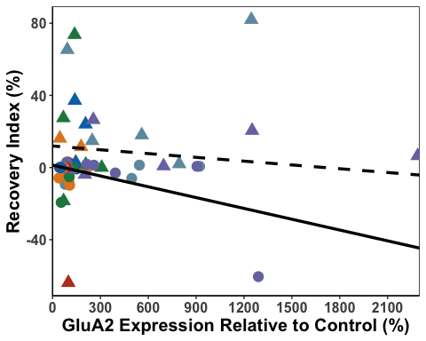

dHpcRec_A1

## Warning: Removed 9 rows containing missing values or values outside the scale range  
## (`geom_point()`).

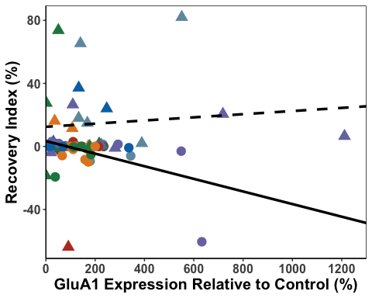

dHpcRec_N2B

## Warning: Removed 9 rows containing missing values or values outside the scale range  
## (`geom_point()`).

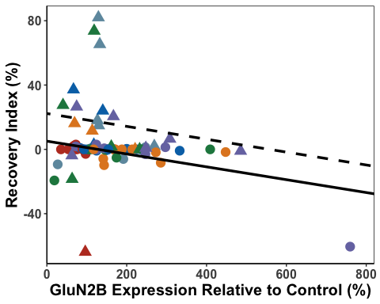

dHpcR_A1<- dHpcData %>%   
 group_by(SEFL) %>%  
 cor_test(Recovery_Index, dHpcGluA1, method="pearson")  
  
#resilient - r= -0.57, p < 0.0001  
#susceptible = r=0.10, p=0.65  
  
dHpcR_A2<- dHpcData %>%   
 group_by(SEFL) %>%  
 cor_test(Recovery_Index, dHpcGluA2, method="pearson")  
  
#resilient - r=0.01, p = 0.94  
#susceptible = r=-0.19, p=0.41  
  
dHpcR_N2B<- dHpcData %>%   
 group_by(SEFL) %>%  
 cor_test(Recovery_Index, dHpcGluN2B, method="pearson")  
  
#resilient - r=-0.6, p < 0.0001  
#susceptible = r=-0.15, p = 0.52  
  
dHpcResilientR_A1 <- FisherZ(-0.57)  
dHpcSusceptibleR_A1 <- FisherZ(0.10)  
  
dHpcResilientR_A2 <- FisherZ(0.01)  
dHpcSusceptibleR_A2 <- FisherZ(-0.19)  
  
dHpcResilientR_N2B <- FisherZ(-0.6)  
dHpcSusceptibleR_N2B <- FisherZ(-0.15)  
  
  
#A1  
  
#n resilient = 51  
#n susceptible = 23  
  
N1 <- 1/(51-3)  
N2 <- 1/(23-3)  
  
N <- N1 + N2  
  
Z1R <- (dHpcResilientR_A1 -dHpcSusceptibleR_A1)  
  
dHpcZdiffR_A1 <- Z1R/sqrt(N)  
dHpcZdiffR_A1

## [1] -2.809962

# -2.81 = significant  
  
#A2  
  
N1b <- 1/(52-3)  
  
Nb <- N1b + N2  
  
Z2R <- (dHpcResilientR_A2 -dHpcSusceptibleR_A2)  
  
dHpcZdiffR_A2 <- Z2R/sqrt(Nb)  
dHpcZdiffR_A2

## [1] 0.7625439

#0.76 = not significant  
  
#N2B  
  
#n resilient = 52  
#n susceptible = 22  
  
  
N2c <- 1/(22-3)  
  
Nc <- N1b + N2c  
  
Z3R <- (dHpcResilientR_N2B -dHpcSusceptibleR_N2B)  
  
dHpcZdiffR_N2B <- Z3R/sqrt(Nc)  
dHpcZdiffR_N2B

## [1] -2.005511

#-2.01 = significant

dHpccorGraph <- ggarrange(dHpcFF_N2B, dHpcFF_A1, dHpcFF_A2, dHpcE3_N2B, dHpcE3_A1, dHpcE3_A2, dHpcTest_N2B, dHpcTest_A1, dHpcTest_A2, dHpcRec_N2B, dHpcRec_A1, dHpcRec_A2,  
 labels = c("a", "", "","b", "", "","c", "", "","d", "", ""),  
 font.label = list(size = 24, face = "bold"),  
 ncol = 3, nrow = 4) +  
 theme(plot.margin = margin(0.1,1.5,0.1,1.5, "cm"))

## Warning: Removed 9 rows containing missing values or values outside the scale range  
## (`geom_point()`).  
## Removed 9 rows containing missing values or values outside the scale range  
## (`geom_point()`).  
## Removed 9 rows containing missing values or values outside the scale range  
## (`geom_point()`).  
## Removed 9 rows containing missing values or values outside the scale range  
## (`geom_point()`).  
## Removed 9 rows containing missing values or values outside the scale range  
## (`geom_point()`).  
## Removed 9 rows containing missing values or values outside the scale range  
## (`geom_point()`).  
## Removed 9 rows containing missing values or values outside the scale range  
## (`geom_point()`).  
## Removed 9 rows containing missing values or values outside the scale range  
## (`geom_point()`).  
## Removed 9 rows containing missing values or values outside the scale range  
## (`geom_point()`).  
## Removed 9 rows containing missing values or values outside the scale range  
## (`geom_point()`).  
## Removed 9 rows containing missing values or values outside the scale range  
## (`geom_point()`).  
## Removed 9 rows containing missing values or values outside the scale range  
## (`geom_point()`).

dHpccorGraph

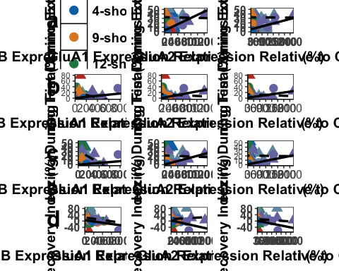

ggsave('dHpccorGraph', dHpccorGraph, width=25, height=36, units='in', device = "tiff", dpi = 300)